Tavistock Community Primary and Nursery School


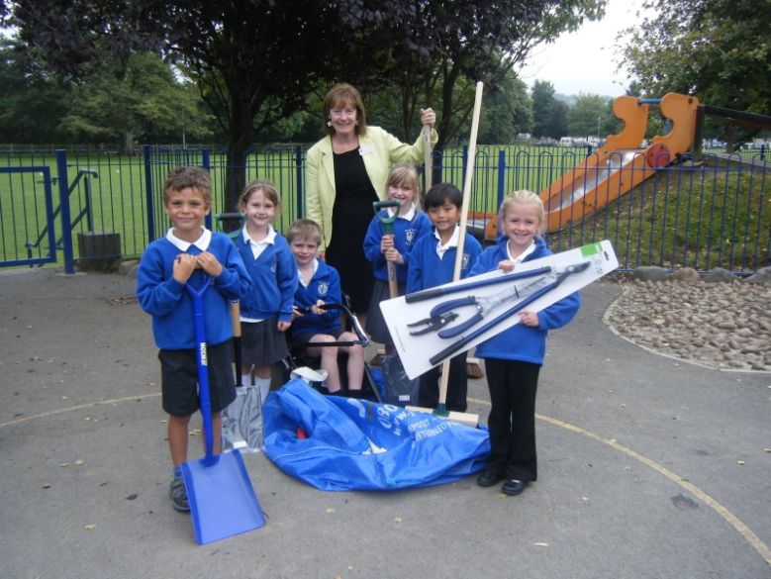

Behaviour Policy
DOCUMENT MANAGEMENT
Title: Homework
Version: 1
Committee: Curriculum
Date: 26th March 2019
Review Date: Spring 2020

Review Date: February 2013

Aims

- To promote a calm, purposeful and happy atmosphere within school

- To foster positive, caring attitudes towards everyone where achievements at all levels are valued

- To encourage increasing independence and self-discipline so that each child learns to accept responsibility for their own behaviour

- To have a consistent approach to behaviour throughout the school with parental co-operation and involvement

- To establish good learning behaviours through the promotion of the school’s Skills for Success

- To provide clear boundaries for acceptable behaviour to ensure physical and emotional safety

.
This policy is based on the rights and responsibilities all members of the school community have:

Rights:

- Of children to learn, to be and feel safe and be treated with respect.

- Of staff to work in a friendly, safe and supportive school and be treated with respect.

- Of parents and carers to feel welcome and know that their children work, play and learn in a safe, open and supportive school.

Responsibilities:

Staff Responsibilities

- To treat all children fairly and with respect
- To help all children to develop their full potential
- To provide a challenging, interesting and relevant curriculum
- To create a safe and pleasant environment both physically and emotionally
- To use consequences for unacceptable behaviour clearly and consistently
- To reward good behaviour clearly and consistently
- To be a good role model
- To form positive relationships with parents and children
- To offer a framework for teaching the skills for success and the personal, social and emotional skills and abilities that underpin the school’s behaviour policy

Parents’ Responsibilities

- To make children aware of appropriate behaviour
- To encourage independence and self-discipline
- To show an interest in all their child does in school
- To support the school in implementing this policy
- To be aware of the school rules

Children’s Responsibilities

- To do their best
- To contribute to their own learning
- To treat other people with respect

Skills for Success:

Our Skills for Success support and encourage good learning behaviours:

- Co-operation
- Responsibility
- Self-Belief
- Understanding Yourself
- Resilience
- Risk Taking

These skills are planned for and taught alongside the academic curriculum from Nursery to Year six.

Rules
- Rules are set to ensure everyone’s rights are met and all members of the school community are aware of their responsibilities.
- Class teachers agree a set of rules with their pupils at the beginning of the School Year
- These may be modified at any time during the School Year with the agreement of the class.
- The Rules are clearly and prominently displayed in each classroom.
- The Headteacher and school leadership team are responsible for setting any additional whole school rules to support the rights and responsibilities of everyone learning and working in the school.
- These rules are communicated to parents and carers when their child starts at Tavistock Primary School. The Home/school diaries contain a copy of this policy for all children and parents.

Rewards
At Tavistock Primary we believe that children should be encouraged to behave well and work hard. We use a number of positive consequences to do so. Whilst our core belief is that learning is a reward in itself, we recognise that rewards are sometimes necessary and appropriate. We use the following positive rewards:

- Five minutes of Green Time is earned every day and rewards good behaviour at the end of each week.
- Good behaviour is recognised at lunchtime with stickers, certificates and praise.
- Foundation & Key Stage 1 give praise, house points, ‘smileys’ and stickers, which are immediate. Work is rewarded with a praise symbol or sticker, comments are written by teachers and verbal feedback is given to children. A weekly reward assembly awards certificates for stars of the week and certificates for good work and learning attitudes.

- Key Stage 2 give praise, house points, merit marks and certificates, bronze award and badge for 50, silver award and special book mark for 100, pen and gold award for 150. A weekly reward assembly awards certificates for stars of the week and certificates for good work and learning attitudes.
- Cups are awarded at the end of each term in whole school assemblies and are given for good behaviour and academic achievement.
- Skills for Success medals and certificates are awarded half termly per class at a Monday whole school assembly.
- Children earning all their green time throughout the term will be entered into a raffle. A ticket for each key stage (FS, KS1, lower KS2 & upper KS2) will be pulled out on the first Monday assembly of each term. A £5.00 book token will be awarded to each ticket winner.

Sanctions
The School has high expectations of all children, but will occasionally need to apply sanctions when rules have been broken. To ensure a clear and consistent application of sanctions the school follows a specific scheme known as ‘Good to be Green’.


Good to be Green Behaviour Scheme

The ‘Good to be Green’ behaviour scheme supports positive behaviour and a good learning attitude, giving every child a visual representation of their behaviour.
- All staff in the school are responsible for using and applying the scheme. Each key stage adapts the scheme to ensure it is appropriate to the development of the children at that stage of their education. Children in the Nursery and Reception do not use this system as it is not appropriate for this age group. In order for the children to make a clear link between their behaviour and the sanction received, Foundation Stage staff use immediate consequences for infringements of rules (children spend time away from their peers). All KS1 and KS2 children then take part in green time at the end of the week.
- Each child starts every day with a GREEN card showing, if they stay that way all day they earn 5 minutes of Green Time.
- Green Time is an agreed choice of activities that children can take part in and influence the choice of on Friday afternoons (5 minutes earned each day = 25 minutes Green Time)
- If a child chooses to break a rule, infringe others’ rights or does not show respect for others then they are given a verbal reminder to change their behaviour.
- If they continue to make the wrong choice then they will be asked to turn their card to an amber warning card.
- Children then have the opportunity to change their behaviour and regain their green card.

- If the child continues to make the wrong choice with their behaviour then they will be asked to turn their card to a RED Consequence Card . This will mean a discussion after school with the child’s parents or carers about their behaviour. The child will not earn their green time that day.
- A child can be given a Red consequence card immediately for unacceptable behaviour such as:-
- Fighting and aggressive play where a child or adult is deliberately hurt.
- Disrespectful language and intentional rudeness to peers or adults.
- Significant deliberate damage to another child’s or school property.
- Act of physical or verbal behaviour that infringe others’ rights.
(Including bullying, stealing, verbal abuse or refusal to follow adult instructions)

The flow chart below explains this procedure. Copies of the behaviour policy are available in all classes and are made available to supply teachers by the school office.

If any member of staff wishes to refer a child’s behaviour, for whatever reason, to the SLT, SLT will always respond. Sanctions may include:

- A loss of playtime(s) and/or privileges as well as loss of Green Time.
- Send a formal letter home to the parents or carers requesting a meeting at school at the earliest possible opportunity.
- Send a warning letter home that the child may be excluded from school for any subsequent misbehaviour.
- In exceptional circumstances exclude the child from school for a fixed term or permanently.
- Parents are informed immediately and a letter is sent to parents or carers informing them of the decision to exclude their child, either for a fixed term or permanently and the reason for the exclusion.
- Parents are also informed of their rights and the procedure to be followed should they wish to appeal against the exclusion.
- The school sets work for an excluded pupil to complete while at home.
- Parent and child attend a reintegration meeting at the start of the first day back at school.

Children with Social, Emotional and Mental Health Needs
Where a child is identified as having, social, emotional and mental health needs, the school, acting in partnership with the parents and/or carers of the child concerned, will agree on the best way to manage their needs.
Having social, emotional and mental health needs does not exempt the child from sanctions for misbehaviour.

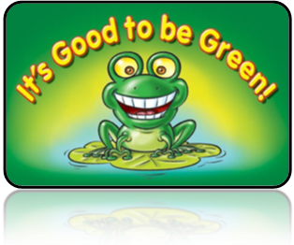

Behaviour Flow Chart
We believe that praise and encouragement is at the heart of all good behaviour, and have high expectations for children remembering their
RIGHTS and RESPONSIBILITIES.
Every child starts each day GREEN
If they make a wrong choice:-
Verbal warning given

If rule breaking continues warning amber card given

Change behaviour and go back to GREEN.

WARNING

Continue to make the wrong choice. Second Amber warning = RED

Serious infringement of rules = immediate red card

card

10 minutes green time not earned.
Parents informed at end of day.
SLT informed if staff member feels it is necessary.

CONSEQUENCE

CONSEQUENCE

Green time: Children who have earned 5 minutes every day receive 25 minutes of Green Time.
Red card: 10 mins of green time not earned
Amber card: 5 mins of green time not earned


Details of Cups Awarded at End of Term Assemblies
The names of the pupils nominated for these cups are discussed with staff at key stage meetings and recorded in the office. The teacher informs the parents or carers before the assembly so that they can attend. Cups are engraved with pupils’ names.

- The Brown’s Cups for Effort & Enthusiasm (2 cups KS1 & KS2) – awarded each term
- The Amey Cup for Endeavour – awarded each term
- The Jade Stokes’ Cup for being a Shining Star – awarded each term in FS
- MTA cup for good behaviour at lunchtime - awarded each term
- Sportsmanship Cup –awarded each term
- Striplin Cup for Expressive Arts – awarded each term
- Swimming Cup – awarded Autumn & Summer term
- Sporting Achievement – awarded at the end of the year
- Spirit of Devon – awarded at the end of the year
- The Post Office Cup for Achievement – awarded at the end of the year
- Cup recognising Contribution to School Life – awarded at the end of the year
- The Morshead Cup for the Environment –awarded at the end of the year

