Year 1 and 2 Project Homework
This term’s project homework allows you to choose from a range of subjects and create almost anything you like! Below is a list of what we will be studying next term in specific subjects with some suggestions of activities that you could do. Choose something from the list (or come up with your own idea) that is linked to the curriculum next term. If you would like to bring anything in to school to share, please do so by Monday 31st March.
In Geography we will be looking at map skills. We will look at navigating a map using simple compass directions.   | For your homework you could…  - Make your own compass  - Look at a map of a place and use the map to find certain places/items on the map  - Look closely a map on a brochure or a leaflet  - Make a map of a familiar area  - Go walk using a map to plot your route  - Look at maps on Google Earth  - Make a treasure/scavenger hunt with a map to show where items are.
In Science we will be studying habitats.  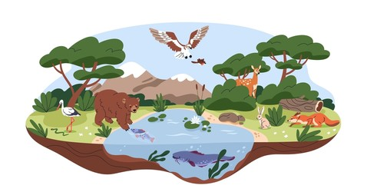 | For your homework you could…  - Go out into your local environment and look for habitats  - Design and make a habitat from recycled materials  - Research different animals and look specifically at their habitat and think about why they live there.  - Research different habitats around the world and look at how the animals change depending on where in the world they live.
In English we will be writing fiction and non-fiction.   | For your homework you could…  - Visit the library and choose some non-fiction books to share  - Read some information books about things you are interested in and design your own information poster on that topic  - Collect some facts about something you are interested in  - Create your own story  - Keep a diary of your week off school
In Design & Technology we will be looking at food preparation.   | For your homework you could…  - Try a piece of fruit or vegetable that you have never tried before  - With the help from an adult, prepare a meal  - Follow a recipe and do some baking  - Clean up after a meal  - Have an indoor picnic  - Write up a recipe that you have followed  - Look at where food comes from and think about the journey it has been on to make it to your house
In Maths we will be working on number and time.   | For your homework you could…  - Practice writing the numbers 1-20  - Practise counting in 2s, 5s and 10s  - Make a picture from 2D shapes  - Begin to explore telling the time using analogue clocks  - Learn and remember the months of the year  - Learn all the number facts that make 3, 4, 5, 6, 7, 8, 9 and 10. (For example, 3 + 4 = 7)

Please make sure you continue to read to your child and also listen to them read their reading book. Please record this in their reading diary.
Reading – Please read regularly with your child. This can look like your child reading to you or and adult reading to them.

