Year 6 Project Homework
This term’s project homework allows you to choose from a range of subjects and create almost anything you like! Below is a list of what we are studying this term in specific subjects, with some suggestions of activities that you could do. Choose something from the list (or come up with your own idea) that is linked to the curriculum and bring your project homework in by Monday 2nd March.
Have fun, we look forward to seeing what you create!

In History we are studying The Civil Rights Movement in both UK and USA   | For your homework you could…  - Create a biography of Martin Luther King or Paul Stephenson  - Create a poster celebrating equality  - Listen to Martin Luther King’s ‘’I have a dream’’ speech. What world change do you dream of? Write your own short version of the speech
In Science we are studying Light  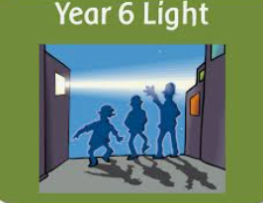 | For your homework you could…  - Draw a comic strip demonstrating how light travels in a straight line or how we see an object.  - Create a poster showing what you know about light  - Make a sundial and record what you see  - Do an experiment using mirrors, enabling you to see around corners and record it.
In Reading we have been studying ‘Wonder’ by RJ Palacio   | For your homework you could…  - Write your own book recommendation for Wonder  - Write a chapter when August joins your class  - Create your own epigraph with your own picture and quote.  - Create your own book cover and blurb for Wonder
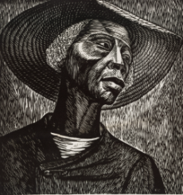In Art we studying Art as Protest and the work of Elizabeth Catlett | For your homework you could…  - Think of a worldwide issue that you feel is worth protesting for/against. Design a piece of artwork to support your view.  - Using carved potato or polystyrene or objects of your choice, create a printed pattern/picture.  - Research Elizabeth Catlett’s artwork. Create your own version of one of her pieces of art.
In Maths Year 6’s are working on long multiplication and long division  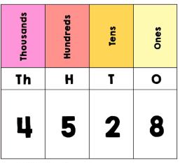 | For your homework you could…  - Create a word problem using long multiplication or long division and solve it  - Teach someone at home how to use the ‘chunking method’ to solve long division  - Learn your times tables with instant recall  - Demonstrate how you know that division is the inverse of multiplication.

