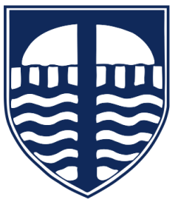

Tavistock Primary and Nursery School
Times Tables Guidance for Parents
Why does my child need to learn times tables?
Times tables are a key part of learning maths. When children know their tables confidently, they can:
- ✅ Solve problems more quickly
- ✅ Understand new maths concepts more easily
- ✅ Work confidently and independently
- ✅ Feel positive about their learning
Times tables are the foundation for many areas of maths, including division, fractions and problem solving.

Why do we practise times tables at home?
In school, children are taught multiplication facts and strategies. Practising at home helps to:
- 🧠 Build memory
Repeating tables regularly helps children remember them for the long term.
- ⚡ Improve speed and fluency
Children learn to recall answers quickly without counting on fingers.
- 🧩 Support problem solving
When basic facts are automatic, children can focus on understanding the maths problem.
- 🌱 Build confidence
Children who know their tables feel more successful and less anxious about maths.

What will my child be learning?
Children learn times tables in a structured way across school, including:
- Multiplication facts up to 12 × 12 (by the end of Year 4)
- Patterns within numbers (e.g. doubling, halving)
- Links between multiplication and division
Learning focuses on both understanding and quick recall.

How can I help at home?
You don’t need to be an expert—short, regular practice makes the biggest difference!
👍 Try these simple ideas:
- ✅ Chant times tables together (e.g. “6, 12, 18…”)
- ✅ Use quick-fire questions (“What’s 7 × 4?”)
- ✅ Practise little and often (5–10 minutes)
- ✅ Use TTRS (Times Tables Rock Stars) – each child has their own login
- ✅ Spot maths in real life (shopping, cooking, sharing)

Working together
Children make the best progress when school and home work together in partnership.
Your support—just a few minutes each week—makes a big difference to confidence and success.

