TAVISTOCK
PRIMARY & NURSERY
SCHOOL

SCHOOL PROSPECTUS

2020/21

Welcome

A very warm welcome to you and your child from everyone at Tavistock Primary & Nursery School.

We are a thriving and well situated school of approximately 400 children aged between 2 and 11 years.

Our school is large enough to provide the positive experiences required for a full and varied education for children whilst retaining a friendly and secure atmosphere for children, families and staff.

We hope that you find our prospectus interesting and informative, but should you have any further queries or would like to tour the school please do contact the school office on 01822 616044.

Mrs Lynnette Selbie
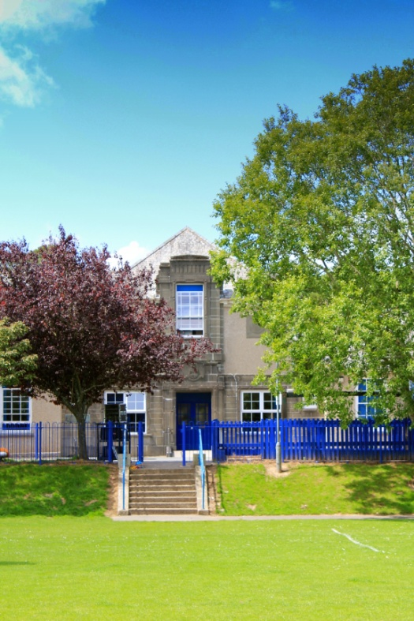
Headteacher

Mr Liam Cottrell
Chair of Governors

Contents

- Our Vision
- Our Values – Skills for Success
- Our Aims
- Governors
- Staffing
- Child Voice
- Brief Introduction to the School
- Admissions to the School
- Attendance and Punctuality
- Behaviour
- Safeguarding Children in School
- School Facilities
- Outdoor Spaces
- Nursery School Provision
- Curriculum Overview
- Children at Work
- Enhancing the Curriculum
- The School Day
- Homework
- Statutory Assessment Tests
- Special Educational Needs and Disability
- Able, Gifted and Talented
- Clubs
- Physical Activities
- Instrumental Lessons
- Wrap Around Care
- Community Events
- Transition to Secondary Education
- Uniform
- School Dinners
- Home School Association
- Parental Engagement
- What People Say...

- Our Vision
‘Excellence for All’

- Our Values – Skills for Success
- Self Belief – I know I can do it
- Responsibility – Think about how the things you do affect others
- Co-operation – We need to work together
- Risk Taking – Always have a go even if you’re not sure
- Understanding Yourself – I know how I feel
- Resilience – Keeping going even when it’s hard

- Our Aims

We aim to prepare children for the opportunities, responsibilities and experiences of adult life within society by:

- providing the learning environment in which each child will be able to achieve their full potential.
- promoting and encouraging children to adopt a healthy lifestyle.
- promoting tolerance and respect for others and their environment.
- promoting and reflecting on moral and spiritual values.
- promoting and safeguarding the welfare of our children.
- encouraging and welcoming parents, carers and visitors as valued partners in children’s education.

At Tavistock Primary and Nursery School we want all children to achieve the highest standards possible. We provide a secure, stimulating environment, which fosters high self-esteem and is a place where positive relationships can flourish. Through our policies and practice all children have equal opportunities and are able to develop to their full potential. Children are effectively assessed and progress is monitored to ensure children remain on track to achieve challenging targets for academic success. In recent years, attainment at the end of Foundation Stage, Key Stage 1 and Key Stage 2 has been in line with or above local and national results. We are confident that an upward trend is set to continue.

- Governors

The school has a board of governors made up of parents, staff and people from the local community with specific skills, all of whom give their time voluntarily to ensure that the school adheres to all the legal and statutory requirements. The responsibility of the governing body is to set the school’s aims and ethos, monitor the school budget and also challenge the head teacher and staff to ensure that the school continues to improve and meet the needs of every child in our care. For more information on our school policies, please ask at the school office or visit our website: http://www.tavistock-pri.devon.sch.uk

- Staffing

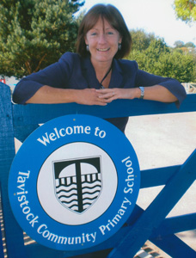
The Head teacher, Mrs Selbie is supported in her work by the Senior Leadership Team which consists of a Deputy Head and Special Educational Needs Co-ordinator, a School Business Manager and 3 Key Stage Leaders and 2 Team Leaders.

All classes including the Nursery are taught full-time by fully qualified teachers. They are supported by a team of experienced and qualified teaching assistants. We provide on-site NVQ level 2, 3 & 4 training to support their work and also to up skill our team of Mealtime Assistants. We invest in continuous professional development for all staff to ensure that we are providing the best educational opportunities for the children. All of our staff and volunteer helpers are DBS checked.

- Child Voice

Through the School Council, children are consulted on a wide range of activities and developments. They devise their own action plan for school improvements and have made successful changes to the playground as well as contributing to the running of the school. Two children, elected from each class on a termly basis, represent their peers at regular meetings.

The School Council also works hard with its peer groups to organise fund raising events for charity. Annually we support national charities such as Children in Need, Comic Relief and the British Legion Poppy Appeal.
The children feel empowered by their important role as a School Councillor and value the impact they have on our school.

- Brief Introduction to the school
We are the only Tavistock school to have a Maintained Nursery on site in a purpose built unit and we admit children from 2-11yrs. We usually have between 380 and 420 children in total. We also have a Nursery Plus (the first in Devon) which underlines and enhance our excellent reputation for providing for children with Additional Needs. You will be able to read more about these additional resources within this prospectus.
The school occupies a mature and attractive site bounded by the historic Tavistock canal to the northwest and to the River Tavy to the southeast, within walking distance of the town centre via the underpass and through the Meadows. Tavistock College are neighbours which enables close co-operation for transition. We are on the edge of central Tavistock which is a bustling market town with easy access to Dartmoor yet only 14 miles from the City of Plymouth.
- Admissions to our School

We strongly advise parents/carers to visit the school with their child/children so that you have the opportunity to take in the atmosphere and ethos of the school. A visit will also give you a chance to ask questions about school life.

Beginning school is a major event in a child’s life. We recognise that a positive start to a child’s school life is very important. We have a well established programme of induction for both children and parents.

Devon County Council organises admissions to this school and you will be asked to fill in an admission form by the middle of January of the year your child is due into school. Devon has a single admission scheme, this means that all children due to start school during the academic year may start school in September, although parents have the right to defer their child’s place until they feel the child is ready. For more information on admissions please look on the Council website, www.devon.gov.uk or contact us for more details. We are allowed to admit up to 60 children in any year.

When your child joins our school we will provide you with a ‘New Parents’ Pack’ which will contain lots of relevant information as well as some important forms for you to complete. These forms include questions relating to your child’s health and needs. Our staff will also plan a ‘Home Visit’ to give you the opportunity to talk privately and one to one about your child starting school.

- Attendance and Punctuality

Good attendance is clearly to your child’s advantage and we work with parents to ensure that your child arrives on time for school every day. Our whole school average is 96.7% which is above the Devon and national figures.

Permission cannot be given for holidays during term time. Should you need to take your child out of school for an unavoidable absence, you are requested to complete an absence request form. For medical appointments we request a copy or sight of the appointment confirmation.

- Behaviour

Our aim is to foster self control and self discipline in the children in our school. We believe that all children have the right to work, learn and play in a friendly, safe and supportive school.
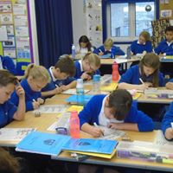

We teach children to respect each other by:
- Being honest,
- Listening to each other
- Helping each other
- Caring for each other
- Co-operating with each other

We use the ‘It’s Good to be Green!’ scheme across the whole school. Children start ‘Green’ every morning, and disrespect or bad behaviour will first receive an ‘Amber’ warning, with any subsequent incident during the school day turning their card ‘Red’, this will result in lost ‘Green Time’ and their name being reported to their parents and the Headteacher.

During playtimes all staff encourage children to use the ‘Conflict Resolution’ script to resolve differences and explain how another child’s actions made them feel.

If there are any problems with a child’s behaviour we will discuss them with parents and work together to overcome them.

- Safeguarding Children in School

The safety and well being of children is our top priority and everyone in our school community has a duty to safeguard and promote the welfare of children. This means that we have a Child Protection Policy and other procedures in place. Parents and carers are welcome to read these on request.

It is our duty to share information and work in partnership with other agencies when where there are concerns about a child’s welfare. We will always try to share our concerns about any children with their parents/carers first unless we have reason to believe that this is not in the child’s best interest.

Our Senior Designated Officer for Safeguarding is:
Mrs Lynnette Selbie (Headteacher)
Deputies are:
Mrs Laura Handel (Deputy Headteacher)
Mrs Sue Gawman (School Business Manager)
Mrs Alice White (Safeguarding Administrator)

- School Facilities

Although the school was originally part of the secondary school we have developed the space available over the years. Most recently our purpose built Foundation Unit houses 2 Nursery classes and 2 Reception year classes with canopied and garden space.
In Years 1 – 6 children are taught in partnered year groups acros 15 classrooms. We also have additional group teaching spaces, a library, a mentoring learning space, 2 environmental areas and a fully working kiln for pottery work.
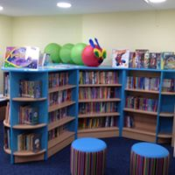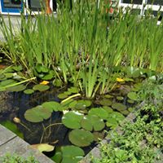

- Outdoor Spaces

At Tavistock Primary and Nursery School we are fortunate to have a variety of different areas that the children can access. The Foundation Stage playground has play equipment installed which helps support the Early Years Foundation Stage curriculum. The large Key Stage 1 and 2 playgrounds allow the children space to have outdoor PE and play times. Our large field is regularly used for outdoor PE, play times and some after school clubs as well as events such as Sports’ Days and Summer Fair.

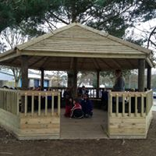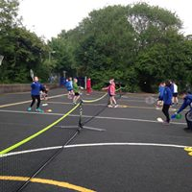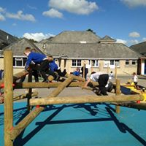

Our Foundation Stage building is specifically designed to meet the needs of our younger children and incorporates quiet areas and space for learning and exploration. Our garden area is used by all children for ‘Garden days’ and outdoor learning.

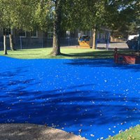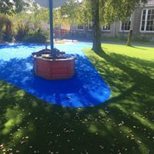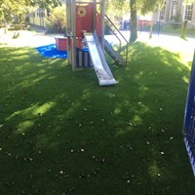

- Nursery School Provision

We operate a maintained nursery school on site for 2-4 year olds. The nursery is led by qualified teachers who are supported by NVQ3 and NVQ2 level teaching assistants. Lunchtimes are also staffed by qualified team members. Our dedicated, professionally qualified and supportive staff encourage your child to enjoy and achieve.

The Nursery teachers work closely with our Reception teachers to ensure that we provide fun, active, exciting and stimulating learning based sessions for your child.

We offer an engaging, secure indoor and outdoor learning environment in which your child can access a wide range of resources. We provide a caring and nurturing environment in which staff strive to respond to each and every child’s needs and interests.

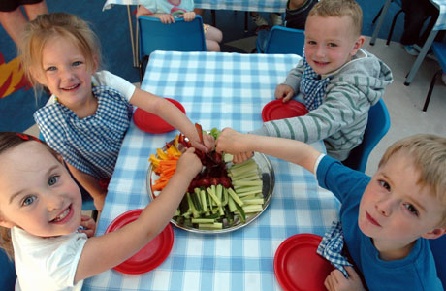
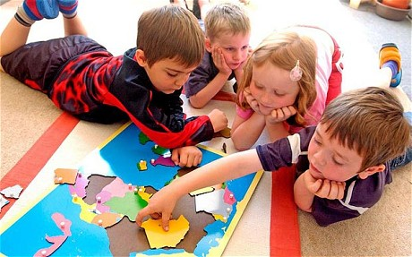
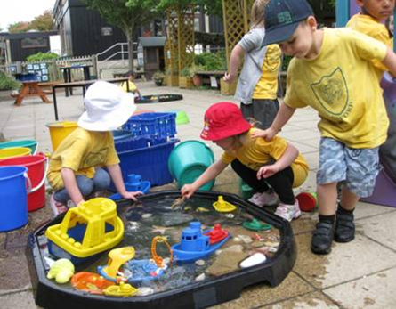

Nursery Plus
Nursery Plus is a Devon County initiative to promote inclusion through early identification and assessment of children with a range of needs including speech and language, social, behavioural and emotional needs. A Nursery Plus teacher and two Nursery Plus Teaching Assistants are based at Tavistock Primary & Nursery School, offering support to staff and children within the nursery and wider learning community, through inreach and outreach targeted work.

- Curriculum Overview

We believe it is vital to make the curriculum relevant to the children. Our curriculum is tailored to meet the learning needs of our children at each stage of their school journey.

- Nursery and Foundation Stage: The school follows the Foundation Stage curriculum for children aged between 2 and 5 years. This curriculum is planned around the children’s interests. Teachers observe children’s play and plan their learning to reflect the children’s enthusiasms and passions. We recognise that play underpins all learning and development for young children. By providing well planned experiences based on children’s spontaneous play and continuous assessment and observations by staff, our children develop intellectually, creatively, physically, socially and emotionally. All parents are encouraged to contribute to their child’s record through an online journal, Tapestry.

Subject Overviews

We follow the National Curriculum guidelines for all subjects taught to children in years 1 to 6.

English
In English children are immersed in a rich world of language. Our children are encouraged to talk, read and write drawing inspiration from quality texts and their own experiences. Reading at home is an integral part of their development as readers for life and we welcome and appreciate your support in this throughout your child’s time with us.

Mathematics
It is our ambition to ensure all children enjoy working with numbers and other mathematical concepts, understanding the basic mathematical operations and working confidently with them across the curriculum and in their life outside of school. Number, shape and mathematical information is everywhere in the world around them and parents play an essential role in making sure children make those connections.
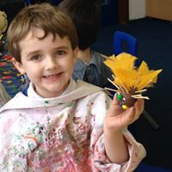
Other National Curriculum subjects include:
- Art
- Design Technology (DT)
- Computing
- Foreign Language at KS2 (French)
- Geography
- History
- Music
- Personal, Social, Health Education (PSHE)
which includes Relationship Sex Education (RSE)
- Physical Education (PE)
- Science

In addition to these subjects all schools must teach Religious Education (RE), however, parents and carers may ask for their child to be withdrawn from these lessons.

You can find further details of our curriculum plans on our website.

- Children at Work

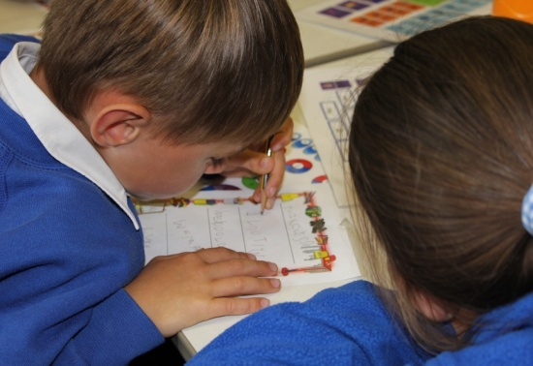
Children spend most of their school day working in their own classroom under the supervision of their own class teacher and teaching assistant. Most days involve each child in some individual work, some group work and some class work. Children are taught according to their needs and at a pace appropriate to each individual.

Teachers plan carefully to ensure that children are challenged in their learning. The Senior Leadership Team regularly review the progress of every child to make sure individual needs are met and progress is sustained by every child. Your child’s progress will be monitored throughout their school life and this information will be shared with you. Assessment takes many different forms including children’ assessment of their own achievements, teacher assessments by everyday questioning, regular tests and the more formal national testing as detailed within the section on SATs.

- Enhancing the Curriculum

Stimulating visits from theatre groups, working authors, illustrators, poets, artists, athletes and people from our local community are planned regularly to enhance the curriculum. As well as visitors coming to the school, children are regularly taken out on trips which complement their classroom learning.

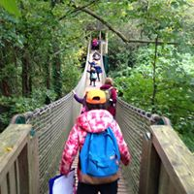
Day trips include visits to Wembury beach, Looe beach,Theatre Royal, Pennywell Farm, Buckfastleigh, Bellever,Paignton Zoo, Escot, Plymouth Aquarium and the Eden Project.

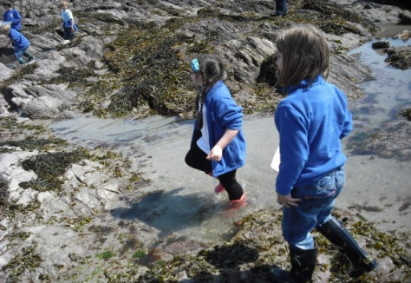

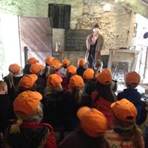

There are also exciting residential trips:

- Year 4 spend two nights away from home on an environmental visit on Dartmoor
- Year 5 enjoy three nights in Bristol exploring the sights and museums
- Year 6 finish their year with a five day outdoor adventure at Porthpean, Cornwall focused on challenge and independence

Within the school we provide additional activities including ‘garden days’ every half term for everyone, attachment based mentoring, and play therapy sessions for individual children.

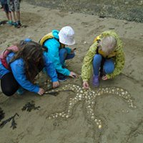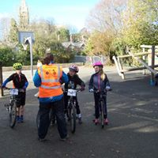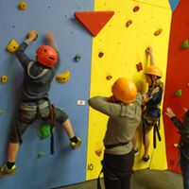

- The School Day

Foundation Stage (Nursery and Reception Classes)
08.55 Parents are welcome to accompany children into class to help settle and prepare them for their learning
09.00 – 12.00 Morning Session
12.00 – 13.00 Lunch (part of paid Nursery afternoon session)
13.00 – 15.00 Afternoon Session
15.00 Hometime

Key Stage 1
  - Parents and children are welcome in the school playground
  - Children line up in the playground
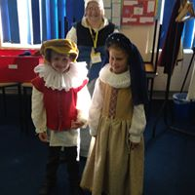
09.00 Registration
09.05 – 10.30 Session 1
10.30 – 10.50 Morning Break
10.50 – 12.00 Session 2
12.00 – 13.00 Lunch
13.00 Registration
13.05 – 14.10 Session 3
14.10 – 14.30 Afternoon Break
14.30 – 15.15 Session 4
15.15 Hometime

Key Stage 2
  - Parents and children are welcome in the school playground
  - Children line up in the playground
09.00 Registration
09.05 – 10.30 Session 1
10.30 – 10.50 Morning Break
10.50 – 12.15 Session 2
12.00 – 13.00 Lunch for Years 3 and 4
12.15 – 13.15 Lunch for Years 5 and 6
13.00/13.15 Registration
13.00 – 14.00 Session 3
14.00 – 14.15 Afternoon Break for Years 3 and 4
14.15 – 15.15 Session 4
15.15 Hometime

- Homework

Tavistock Primary & Nursery School believes in the benefit of a homework programme which supports the work children do in school and enables parents to be involved in their child’s learning. Details of homework for your child will be provided from the class teacher. We feel that a regular period of time spent with parents or carers in reading and sharing books is very important as well as taking part in activities which will develop a child’s confidence and self discipline. Children who do not complete and return set homework will be deemed to have chosen to attend the weekly homework club during Wednesday morning breaks!

- Statutory Assessments Tests (SATs)

Schools are required to formally assess children and report the results to parents and the local authority at the end of the Foundation year, Year 2 and Year 6. There is a Phonics test during Year 1. For 2021 there will also be a national Timestable Test in Year 4.

The aim of these assessments is to monitor how effective the school is with its teaching and learning standards.

- Special Educational Needs Disability (SEND)

We are proud of the fact that we are an inclusive school, providing an effective and enjoyable curriculum for children with a range of additional needs. Children have SEND if they have a learning, emotional or physical difficulty which calls for special provision to be made for them. We expect these children to make the best progress possible from their starting point.
- Children with additional needs are identified early and action taken to meet their needs
- Parents of children with additional needs are involved in reviewing and planning in partnership with the school.

Inclusion statement
We aim to be a fully inclusive community school and to provide the best possible learning experiences for all our children. We ensure that all children have full access to the taught curriculum and to our wide range of extra school enrichment activities, including school clubs and trips.

We support the Local Authority policy on Inclusion and our curriculum policies are fully inclusive. We currently follow Local Authority guidance on the education of ‘Children in Care’ and have developed our own policy. Our Special Education Needs Policy is reviewed annually by our Governors.

Disability Equality
We strive to ensure that everyone is equally valued and treats one another with respect within the whole school community. We do not discriminate against disability, race, age, gender or religion.

All publications are available in Braille or on audio on request. If you or any of your family has any specific disability needs please do let us know.

- Able, Gifted & Talented Children

Teachers further challenge the learning for these children and they are given extension opportunities within the school. They are also invited to attend enrichment and special events at both primary and secondary schools within local area, as well as regional and university hosted events. Children also take part in the various sports tournaments organised by the local and nearby schools and clubs as well as coaching opportunities as they arise.

We aim to provide:
- Breadth – a wide range of experiences
- Depth – time to reflect on learning
- Motivation – a positive approach to challenges and belief in success

- Clubs

We offer a wide variety of clubs after school and during the lunch hour. Teachers, Teaching Assistants, Parents and Governors give their time voluntarily and are all involved in taking our clubs. Clubs run for 8 weeks each term and are likely to include Science, Art, Drama, Choir, Book Club, Knitting, Cross Stitch, French, Zumba, Gardening and various sports appropriate to the time of year.

- Physical Activities

Tavistock Primary and Nursery School has a strong sporting tradition but, more than anything, we aim to bring fitness, fun and health education to our children in an enjoyable way. Our after school clubs provide the children with the opportunity to try new sports, improve on existing skills and develop links with local sports clubs.

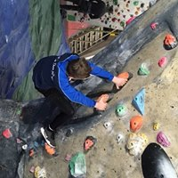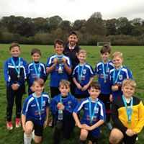

We participate in many sports festivals and tournaments and are represented at every level by a range of age groups. The school has a history of sporting success and we value the efforts and achievements of all our children. Weekly celebratory assemblies ensure we can recognise these achievements and promote the physical and social well-being of all our children.

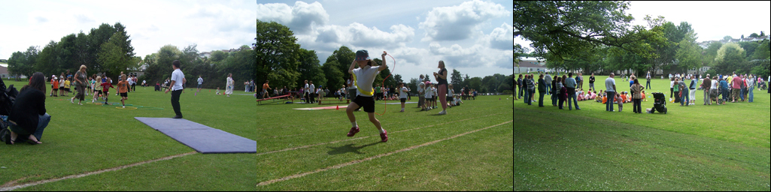
The Annual Sports’ Day

- Instrumental Lessons

Parents can choose to pay for individual lessons for their child to learn to play an instrument. We currently offer weekly piano lessons.

- Wrap Around Care

Since September 2016 we have offered wrap around care on site, these provisions are currently located within a designated space in school. Both facilities are run by fully qualified and experience staff.

Our Breakfast club facility is open from 8.00am every morning. The charge per child is £2 per morning.

Our After School Club facility is open from 3.00pm, staff will collect the youngest children from class and provide care until 6.00pm every day. Charges are £3.50 per hour per child or £10 for the whole session per child.

- Community Events

As a school we strive to support as many local events as possible. We regularly support the Tavistock Carnival, The Christmas Tree Festival, Peace Posters, Tavy 13, singing at festivals and the local church.
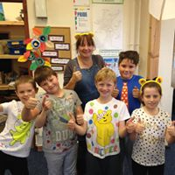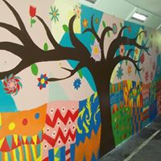

- Transition

In order to give our children the best possible preparation for their transition to secondary school we have a detailed process in place. The vast majority of our Year 6 children transfer to Tavistock College for Year 7. Our Year 5 children visit this local school where they spend the day experiencing a range of activities. Our links with the college are further strengthened by our close proximity which allows a variety of visits to take place including participation in subject based days and watching theatre productions. Tavistock College have Taster Days for Year 6 children, which allows them to experience what a day at secondary school would be like including the all important lunch!

Our Year 6 teachers liaise closely with the transition teams from all of the secondary schools in order to facilitate the best start possible to the next stage of their school career at whichever school that may be

- Uniform

The school has adopted a uniform which we encourage all children from Year R to Year 6 to wear. Uniform can be bought from Wovina or www.myclothing.com
PE Kit
White polo/sports shirt
Black sports shorts/leotard
Trainers

Key Stage 2 (Winter only) Outdoor PE
Tracksuit
Trainers

Winter Uniform
Blue sweatshirt/cardigan/fleece with:
White shirt/blouse
Grey/black trousers/skirt/dress
Black shoes

Summer Uniform
Blue sweatshirt/cardigan/fleece with:
White shirt/blouse
Grey/black trousers/shorts/skirt
Blue and white small-check dresses
Black shoes/sandals

There is an optional uniform in Nursery which comprises of a yellow t-shirt and blue fleece.

- School Dinners

We have good facilities for preparing food and we manage our catering in house. This means that we have complete flexibility over our menus and pricing. We employ our own kitchen staff and they work with the school to provide a tasteful and nutritious lunch every day. Children are free to choose to bring a packed lunch or have a cooked meal (KS2 £2.20) on a daily basis. All children in Reception, Years 1 and 2 are entitled to have a free school meal every day and we expect the majority to take this option.

- Home School Association (PTA)

Our Home School Association (HSA) successfully runs many events throughout the school year. Every parent is automatically a member of the HSA and can play a large or small part in fund raising and organising events. Some of the ways the HSA supports parents and raises funds are:

- An annual Summer Fair
- Duck Race in The Meadows
- Distribution of Harvest Gifts
- Easter Bunny visit and Eggs for all children
- Organising activities such as ‘Bag2School’
- Valentine’s Day and Christmas discos.

Here are just a few ways the HSA have made a big difference to all our children:

- The purchase of a class set of ‘Learnpads’
- The purchase of a sound and lighting system for school assemblies and productions
- Funding visits from theatre groups
- Additional books for the library
- Playground equipment
- Props for productions

- Parental Engagement

Parent and family members are their child’s first and most significant teachers and we recognise their crucial role in their child’s education.

We welcome and value involvement from all parents and carers. We aim to work in partnership with you to ensure that your child develops a positive attitude to school and their learning. We will keep in touch with you in variety of ways. The school produces a weekly newsletter so that you know what is happening at the school. We maintain an informative website and use Parentmail, text messaging and social media services to keep parents up to date.

Members of staff are available at the beginning and end of every day for a quick message, or contact the school office to agree a convenient time for a longer discussion. You are invited to regular parents’ evenings and you receive an annual report of your child’s progress and attainment.

We also welcome your support in the classrooms; we require you to complete a Disclosure (DBS) check, undertake induction training and adhere to our school policies and code of conduct.
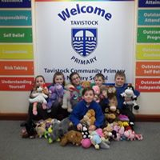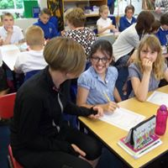

- What people say...

Parents...
A wonderful school, which is reflected in the children’s behaviour and attitude to learning – Year 3 Parent

We are extremely happy with the school, staff and leadership and would absolutely recommend it to others – Year 3 Parents

Thank you for welcoming our child into your school – she has settled really quickly and is very happy – Year 4 Parents

Highly recommended school. Best school we have had involvement with by miles! – Year 6 Parents

Children...
I love school I love all the teachers in the world – Year 1

This school is where children go to and they learn – Year 2

The teachers help us when we need help which is good – Year 3

I feel really safe at school because there are so many first aiders and teachers care about all of us – Year 4

I enjoy school because the teachers make it really fun and there are lots of clubs – Year 5

I enjoy going to school and believe I improve and learn something new everyday – Year 6

Governors...
When I went to Looe with Year 1 on Tuesday, we were all sat down eating our ice creams when a passing lady stopped me and wanted to say how well behaved the children were and that they were a credit to the teachers. She said she'd seen them all hold hands as we dipped our feet in the water and it was great to see them having such an enjoyable time at this age.

Staff...
I love working for a team who all value each other and are
always ready to give each other a hand.

I feel proud to be part of a team that is totally dedicated to the emotional and academic development of all our children.

