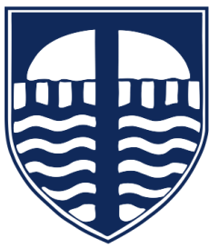

Tavistock Primary and Nursery School
Supporting Children with Reading at Home - Guidance for Parents

Why does my child need to read at home?
Reading is one of the most important skills your child will learn. Reading is the foundation for success across the whole curriculum. When children read regularly, they can:
- ✅ Understand what they are learning in all subjects
- ✅ Develop their vocabulary and language skills
- ✅ Build confidence and independence
- ✅ Enjoy stories and finding out new information - develop a love of reading

Why do we encourage reading at home?
In school, children learn reading skills such as phonics, fluency and comprehension. Reading at home helps to:
- Build vocabulary and understanding
Regular reading exposes children to new words and ideas, improving comprehension.
- Improve reading fluency
Practising little and often helps children read more smoothly and confidently.
- Develop a love of reading
Reading together helps children see reading as enjoyable.
- Support communication skills
Talking about books helps children develop speaking, listening and thinking skills.

What will my child be learning?
Reading books are carefully matched to your child’s stage. Your child will be developing a range of reading skills, including:
- Phonics (sounds, segmenting and blending sounds to read words)
- Fluency (reading smoothly and accurately)
- Comprehension (understanding what they read)
- Reading for pleasure and enjoyment

How can I help at home?
You don’t need to be an expert—just a few minutes each day can make a big difference! Try these simple ideas:
- ✅ Read daily
- ✅ Listen to your child read and offer support
- ✅ Read to your child as well as listening to them
- ✅ Talk about the story (What happened? Why?)
- ✅ Encourage a range of reading (story books, information books, comics, instructions, signs)

Top tips for success
- Keep it relaxed and enjoyable 😊
- Praise effort, not just accuracy
- Re-read favourite books—it builds confidence
- If your child gets stuck, help them sound it out or read the word
- Make reading part of your daily routine (e.g. bedtime)

Working together
Reading improves most when school and home work together. Reading regularly at home has a strong positive impact on children’s progress and confidence.

