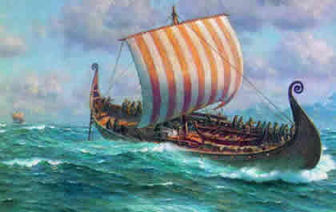

**Diary Dates:**

**16th Jan – Swim gala trials**

**4th / 6th Feb – Parents’ evenings**

**5th – Internet Safety Day**

**12th – Cross Country**

**Maths**

**Number sense** – Make appropriate decisions about when to use their understanding of counting (including counting below zero), place value and rounding for solving problems including adding and subtracting.

**Additive reasoning –** Add and subtract numbers up to three digits; estimate the answer to a calculation and use inverse operations to check answers and solve problems, including missing number problems, using number facts, place value, and more complex addition and subtraction.

**English**

Our English work will be based on the fiction book: The Tear Thief; we will use this to further extend and consolidate our skills in narrative writing. After this, we will be developing the appropriate structure and word choice for report writing using the formal voice. This will be achieved through using the book ‘Extreme Animals’,to inspire our writing.

**Our theme this term:**

**What happened when the Vikings invaded Britain?**

**Science**: Forces

**Art/DT:** Exploring landscapes

**History/Geography**: Vikings

**RE:** Expressing beliefs

**MFL:** Telling the time

**Music:** Learn an instrument

[](http://www.google.co.uk/url?sa=i&rct=j&q=CARTOON+IMAGE+OF+CHILD+READING&source=images&cd=&cad=rja&docid=GDIKGDhxjnSlLM&tbnid=28mnPTmCZ2AjFM:&ved=0CAUQjRw&url=http://www.dreamstime.com/stock-image-family-reading-cartoon-image14049521&ei=CmZeUvbNLY6whAfrw4G4Cg&psig=AFQjCNF24QcVcYTwEw65CeNPxQ38MYm6Pw&ust=1382004602345694)

**Reading and Spelling**

* Children should **read for a**
* **minimum of 15 mins** at home

every day.

* Reading books and home school diaries should come in every day.
* Children should know common words and target spellings.

**Discuss your child’s homework with them.**

**Ask your child to show you their method for adding numbers.**

**PE**

Net and racquet skills

Dance –

West Side Story

**Computing**

‘We are artists’ Using Inkscape to create tessellations



Please ensure that your child has their PE kit.

Kit should stay in school all week: Black shorts, white t-shirt & trainers.

Our Skill for Success

this half term is:

**Responsibility**

Homework:

Set on Fridays

In on Wednesday