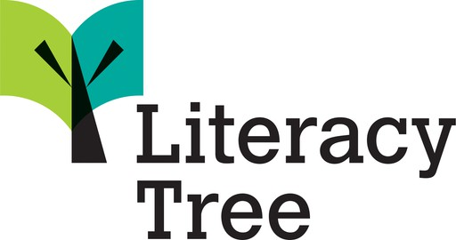

Literacy Tree Pedagogy
Principles that underpin our approach

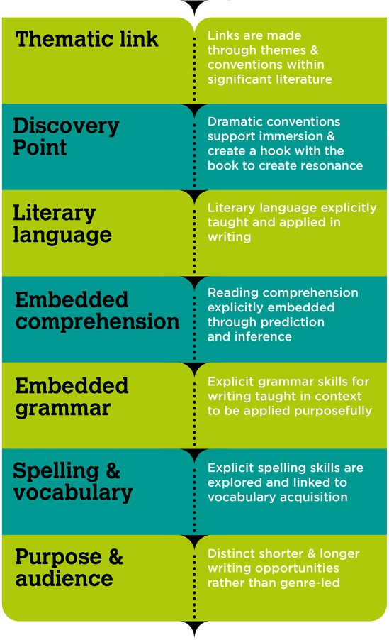
Literacy Tree is a complete book-based approach with resources for Primary English including Writing, Reading and Spelling.

Literacy Tree’s writing resource and programme, Writing Roots, based around our Teach Through a Text pedagogy, embeds all National Curriculum requirements and places audience and purpose at the core.

Literacy Tree’s primary focus through its book-based pedagogy is to motivate children to write for a range of audiences and purposes using high-quality, diverse children’s literature by significant authors. We do this by helping schools immerse children in a range of literary worlds and themes, heightening engagement and creating curiosity through process drama, discussion and debate. This allows them to see themselves represented, and also explore the lives and experiences of others.

The carefully-planned sequences of lessons provide opportunities to explore writing conventions, which are embedded, and apply them into authentic writing for a range of real-life audiences. The writing outcomes are chosen for their pertinence and relevance to the particular point in the text (not chosen for their ‘genre’), marrying the writing opportunity with the relevant conventions so that children see the purpose in the skills learnt. Skills and outcomes are revisited to practise and consolidate learning.

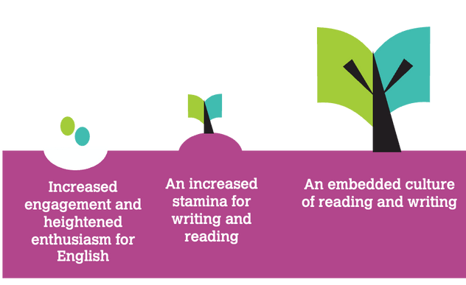
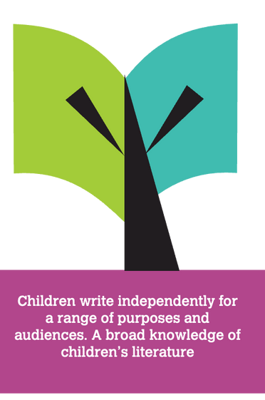
Our programme is underpinned by a range of factors supported by research that provides evidence of a likely impact on attainment. Motivation has been identified as a factor that is ‘correlated strongly both with pupil attitudes to writing and their skill as writers’ (Ofsted, 2022). We use a range of mechanisms to foster motivation for writing:
for. This provides meaningful motivation for children to attend to and use these conventions in their writing. Opportunities to write
frequently have been identified as a factor that is positively linked to teaching pupils to write effectively (Ofsted, 2022). Put simply, pupils ‘who write more. write better’ (Slavin et. al, 2019).
- We engage children in high-quality children’s literature to provide contexts for writing
- We provide children with meaningful opportunities to engage in process drama, debate and discussion which informs writing
- We provide children with authentic and engaging opportunities to write for a range of audiences and purposes. This is a key factor associated with motivation in writing (Ofsted, 2022).

Cremin (2015) recommends teachers build a skillset of drama techniques. Our resources support teachers to develop these, building confidence in using drama to cultivate purpose and audience in writing. The explicit teaching of writing conventions in the context of creative writing has been identified as a key characteristic of programmes that produce good writing outcomes (Slavin et. al, 2019). The explicit teaching of grammar is embedded across our resources in a way that links both to the engaging context of the text and to the purpose and audience that children are writing


Frequent opportunities to practise writing with a range of audiences and purposes in mind are embedded within our pedagogy. The limits of working memory are carefully attended to within these opportunities through a focus on practising using specific conventions and vocabulary that build on prior knowledge (Department for Education [DfE], 2019) and that are informed by purpose and audience. Planned repetition and regular practice of knowledge and skills can increase the likelihood that pupils are able to retain these (DfE, 2019). Our curriculum is design so that children repeatedly meet objectives over the course of an academic year and beyond. Each time they revisit these objectives, they develop increasingly complex mental models by integrating new knowledge and prior knowledge (DfE, 2019) and by applying this knowledge for a range of purposes and audiences in their writing.



“We have very quickly brought into our school the continuity, progression, and purpose that we desperately needed”
Literacy Lead, Amherst Primary, Guernsey

