 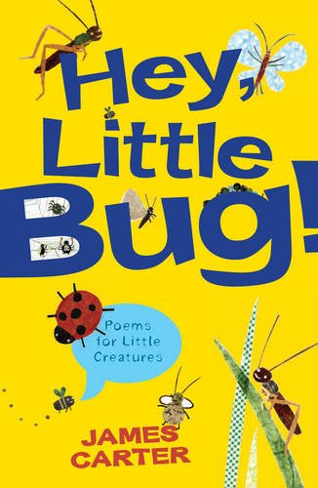 [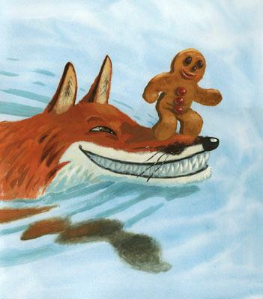](https://www.google.co.uk/url?sa=i&rct=j&q=&esrc=s&source=images&cd=&cad=rja&uact=8&ved=2ahUKEwiM-qCwzZXeAhULfxoKHcuOCp8QjRx6BAgBEAU&url=https://www.teachingchildrenphilosophy.org/BookModule/TheGingerbreadMan&psig=AOvVaw0t9R4q3q-mlIZk7qZ0vPPG&ust=1540144968894256)

**DATES FOR YOUR DIARY**

**11/12 – Drum theatre: The Gingerbread Man**

**20/12 – St Eustachius Christmas service**

1. **ENGLISH :**

**Our work will include:**

* Reading fluently.
* Reading comprehension.
* Developing vocabulary.
* Developing sentence structure

and spelling accurately.

* Using a traditional tale to write for different purposes, poetry and performing poetry.

**MATHS**: This term, we will be learning to:

* Identify the properties of 2D and 3D shapes.
* Addition and subtraction including using money.
* Identify and know the properties of odd and even numbers.
* Count in 2s, 3s, 5s from 0 and in 1s and 10s from any number. Know multiples of 2, 3, 5 and 10.
* Use coins in different combinations to make a given amount.

**This term we are going to be exploring:**

**Science**: Uses of everyday materials.

**Art/DT:** Making Christmas cards and calendars. Christmas cooking.

**History/Geography**: How did Christopher Columbus find America? Tudor Life.

**Music:** Christmas Music – singing linked to the Christmas story.

**PHSCE:** Health and Well-being.

**Computing:** Filming performance poetry and e safety.

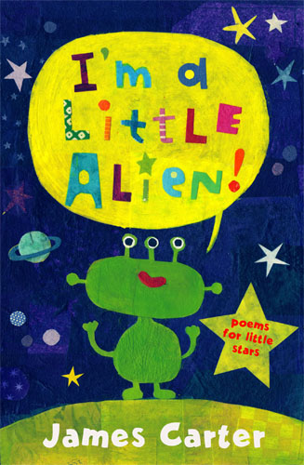

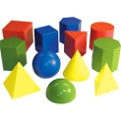

**Science: Uses of Everyday Materials**

* **Explore materials and their purposes.**
* **Investigate how different materials change shape.**
* **Learn how to carry out a fair test.**

**RE**



* Parables
* Jewish beliefs
* The Christmas Story

If you would like to come into class and help – with reading, other activities or general classroom support we would love to welcome you. Please see Mrs Alexander , Mrs Holden or Mrs Barnes.

**REMEMBER**

Please ensure your child brings their reading book and home school diary to school EVERY day.

[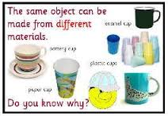](http://www.google.co.uk/url?sa=i&rct=j&q=&esrc=s&source=images&cd=&cad=rja&uact=8&ved=0CAcQjRw&url=http://www.ks1resources.co.uk/page36.html&ei=I6laVOyJCOWp7AaU7oDYAg&bvm=bv.78677474,d.ZGU&psig=AFQjCNGy3aZ1Gq3lZp_6UZf1VOBH9ukZOA&ust=1415314055432946)

**Developing children’s fundamental movement skills as the building blocks for all sport plus balance, coordination and ball skills,**

**PE KIT SHOULD STAY IN SCHOOL ALL WEEK: BLACK SHORTS, WHITE T- SHIRT & TRAINERS.**

Our **Skill for Success** this half term is

**Self Belief – I know I can do it!**

**SPELLINGS: SET ON FRIDAY; TESTED THE FOLLOWING FRIDAY**