**WATER FILTERS**

**YEAR 6 SUMMER TERM PROJECT**

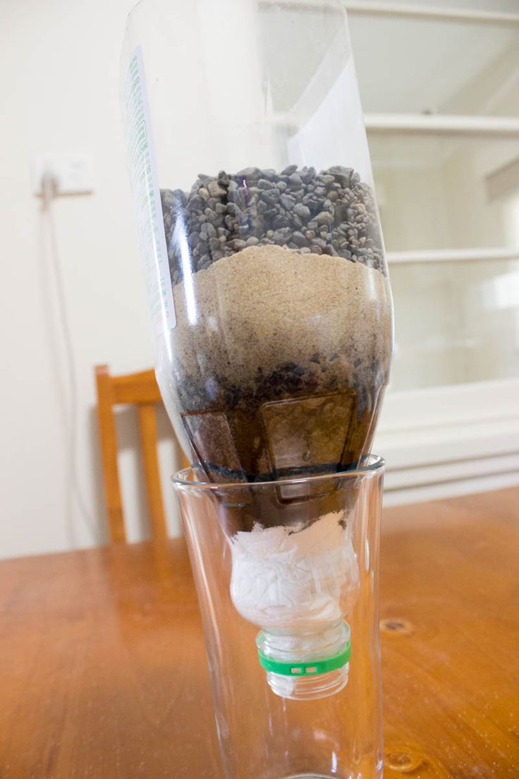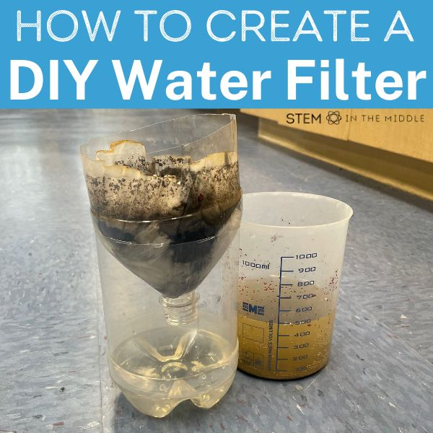

**These pictures show one way to create a basic water filter, using a 2 litre bottle. Cutting the bottom off and turning the top of the bottle upside down to sit in the bottom of the bottle, enabling you to collect the filtered water, can work well.**

**Think carefully about the layers of materials that you will use and the order you use them.**

**When all the home-made water filters have been brought into school (by Friday 11th July) Muddy water will be made available and results compared to see who has created the most efficient filter.**