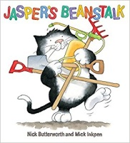

**Dates for your Diary:**

**Details to follow for a Nursery Outing!**

**Outside play**

***We play outside every day, whatever the weather! This term we will be:***

* **Growing beans and planting seeds**
* **Playing the ‘Bean game’**
* **Exploring in the sand, the water and the mud**
* **Playing parachute games**
* **Climbing up, over and under and riding around**
* **Dancing around the Maypole**

**Let’s Talk More!**

Give a choice of 2:

* At snack time, ‘apple or banana?’
* At bath time, ’wash tummy or toes?’
* At play, ‘Shall we play with cars or jigsaws?’

Why do this?

* Giving choices helps children realise their words can influence their environment
* Children learn new words and have more opportunities to talk

**Summer term topics!**

**‘Jasper’s Beanstalk’, ‘planting’ and**

**‘rainbow colours’**

* Exploring colours and colour mixing
* Sharing stories by Eric Carle
* Planting our own beanstalks
* Observing caterpillars change into butterflies
* Retelling ‘the Very Hungry Caterpillar’ story
* In Phonics we will be learning about our voice

sounds and initial letter sounds.

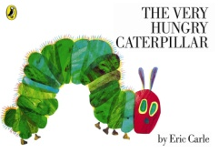

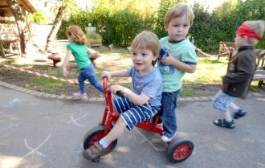

[](https://www.google.co.uk/url?sa=i&rct=j&q=&esrc=s&source=images&cd=&cad=rja&uact=8&ved=2ahUKEwiTocfyiLHhAhXzoXEKHYgiCMwQjRx6BAgBEAU&url=https%3A%2F%2Fwww.crywolfclothing.com%2Fproducts%2Frainbow-sticker&psig=AOvVaw04TbQTlWFuXNMynY2yUKcj&ust=1554282819367905)

[](https://www.google.co.uk/url?sa=i&rct=j&q=&esrc=s&source=images&cd=&cad=rja&uact=8&ved=2ahUKEwjmls35i7HhAhWfSRUIHUpIA7YQjRx6BAgBEAU&url=https%3A%2F%2Fwww.amazon.com%2FMixed-Up-Chameleon-Rise-Shine%2Fdp%2F0064431622&psig=AOvVaw2OsF7FwlBWYKCB8l2ZbsmC&ust=1554283650626660)

**Mathematics skills**

* Counting, counting, counting!
* Recognising and drawing numbers and matching numbers to groups of objects.
* Playing number games and solving number problems.
* Singing number songs and action rhymes.
* Recognising and naming the shapes.

***How can I help my child***

***with early reading and writing?***

* Share books with them every day and talk about stories.
* Encourage them to make marks and have a go at their own writing.
* Role model reading books and writing e.g. shopping lists and cards.

**Nursery information**

* *All Nursery children have a* ***key person****, we all know your child, but this person will know him or her best.*
* *We take part in daily physical activity as well as messy play. Practical clothing and spare clothes on a child’s peg are a great help!*
* *As the weather improves please send your child to Nursery with a named sun hat and apply sun cream at home*
* *Please remember to send your child to nursery with a named water bottle..*





Our **Skill for Success** this term is

**Co-operation**

