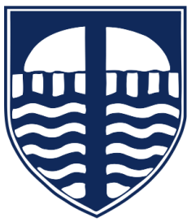

Tavistock Primary and Nursery School
Supporting Children with Spelling at Home - Guidance for Parents
Why does my child have spellings to learn?
Spelling is a key part of learning to read and write. When children know how to spell words confidently, they can:
- ✅ Read more fluently
- ✅ Write more easily
- ✅ Use more interesting vocabulary
- ✅ Feel confident in their learning
Spelling, reading and writing all work together – practising spelling helps strengthen them all.

Why do we send spellings home?
In school, children are taught spelling patterns, rules and key words. Practising at home helps to:
- 🧠 Build memory
Repeating words little and often helps children remember them for the long term.
- 📖 Support reading
Knowing spellings helps children recognise words more quickly when reading.
- ✍️ Improve writing
When children don’t have to stop and think about spelling, they can focus on their ideas.
- 🌱 Build confidence
Children who feel successful in spelling are more willing to write and try new words.

What will my child be learning?
Children learn spellings that match the National Curriculum, including:
- Common exception words (e.g. said, was, because)
- Spelling patterns (e.g. -tion, -ing, -ed)
- Rules (e.g. adding suffixes, prefixes)
Spellings are taught in school first – homework helps to practise and consolidate learning.

How can I help at home?
You don’t need to be an expert—simple, short activities work best!
👍 Try these easy ideas:
- ✅ Look, say, cover, write, check
- ✅ Practise little and often (5–10 minutes is enough)
- ✅ Ask your child to use the words in a sentence
- ✅ Spot the words in books or around the house
- ✅ Use fun games (e.g. rainbow writing, spelling in the air, chalk, or shaving foam!)

Top tips for success
- Keep it positive and encouraging 😊
- Praise effort as well as accuracy
- Break words into smaller parts (e.g. play-ing)
- Don’t worry if it takes time—spelling develops gradually

Working together
Spelling improves most when school and home work together in partnership.
Your support—just a few minutes each week—makes a big difference.

