Year 5 Project Homework
This term’s project homework allows you to choose from a range of subjects and create almost anything you like! Below is a list of what we will be studying next term in specific subjects, with some suggestions of activities that you could do. Choose something from the list (or come up with your own idea) that is linked to the curriculum next term and bring your project homework in by Monday 10th November.
Have fun, we look forward to seeing what you create!

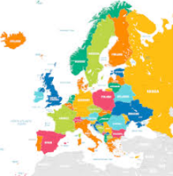  In Geography we will be studying countries in Europe | For your homework you could…  - Print or draw a blank map of Europe. Label at least 10 countries and their capital cities.  - Design a poster for one European country. Include the flag, capital city, population, and any key landmarks.  - Create a stamp or coin that represents a European country. Label it with the country’s name and capital city.
In Science we will be studying life cycles of mammals, amphibians, insects and birds  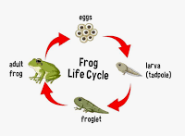 | For your homework you could…  - Choose one animal from each group and research its life cycle. Present as a short paragraph or mini-poster.  - Turn the life cycle of an insect or frog into a short illustrated story or comic — include captions for each stage.  - Build a 3D model (using recycled materials or a shoebox) showing one life cycle.
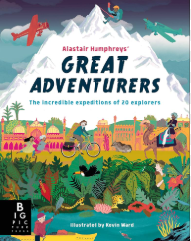  In English we will be writing about an expedition and the person that undertook it, presenting information in more than one way. | For your homework you could…  - Research one adventurer and write a short summary of who they are, where they travelled, and why their journey was incredible.  - Imagine you are an adventurer Write a diary entry describing one day of your expedition — what you saw, how you felt, and any challenges faced. You may have already been on one!  - Draw and label a map showing the route one explorer took — include key landmarks, climates, or hazards.
In Art we will be creating prints based on the work by Delitia Martin.  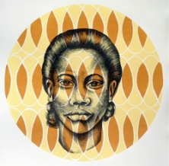 | For your homework you could…  - Use safe materials at home (e.g. cardboard, sponges, leaves) to print textures. Try layering colours to see what mood or feeling they create.  - Ask a family member what colours represent them and why — then draw or paint a quick portrait using those colours.
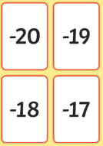  In Maths we will be working on negative numbers. | For your homework you could…  - Find out the temperature of your fridge and freezer (with an adult).Which one is below zero? How many degrees warmer is the fridge than the freezer?  - Fill two cups with water — one left at room temperature and one put in the freezer. After a few hours, record what happens and what the temperature must be in the freezer (below 0°C). Explain why water freezes at 0°C using what you know about negative numbers.

