

**MATHS**: In maths we are covering:

**Geometric Reasoning and Multiplicative Reasoning** – Shapes, angles and fractions and using these in word problems.

**OUR THEME THIS TERM:**

**The Industrial Revolution**

**Science**: Electricity (Light)

**History:** The Industrial Revolution:

**Music:** Jazz, Latin and Blues

**PE:** Social skills in sport

**MFL:** School language – school transport, routines and questions

**RE**: Why do religious books and teachings matter? Discuss Christianity, Judaism, Islam, Hinduism, Buddhism and Sikhism

**English**

**Fiction**

**The Hobbit – JRR Tolkien  
  
The Princess’ Blankets – Carol Ann Duffy**

**Daily spelling and grammar activities**

.

**Dates for your Diary:**

24th – Youth Speaks

1st Feb – Family Assembly

4th and 6th Feb – Parents’ Evenings

5th – Internet Safety Day

12th – Cross Country

15th Feb – Last day of half term

Spring Term

Year 6

MC900233964[1]

***HOW CAN YOU HELP YOUR CHILD?***

***Listen to your children read on a regular basis and discuss what has been read.***

***Encourage a wide variety of texts.***

***Practise times tables.***

**READING & SPELLING**

* Children should **read for a**

**minimum of 15 mins** at home

every day.

* Reading books and home school diaries should come in every day.
* Children should know common words and target spellings.

**Art/DT:**

**Terracotta Warriors**

**Painting -**

**Inspired by Gustav Klimt**

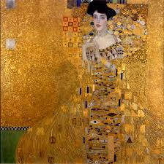

**Computing**

**Online/E-Safety – How to stay safe when using the internet.**

[](http://www.google.co.uk/url?sa=i&rct=j&q=CARTOON+IMAGE+OF+CHILD+READING&source=images&cd=&cad=rja&docid=GDIKGDhxjnSlLM&tbnid=28mnPTmCZ2AjFM:&ved=0CAUQjRw&url=http://www.dreamstime.com/stock-image-family-reading-cartoon-image14049521&ei=CmZeUvbNLY6whAfrw4G4Cg&psig=AFQjCNF24QcVcYTwEw65CeNPxQ38MYm6Pw&ust=1382004602345694)

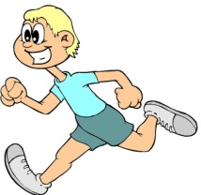

**KIT SHOULD STAY IN SCHOOL ALL WEEK: BLACK SHORTS, WHITE T-SHIRT & TRAINERS/PLIMSOLLS.**

Our **Skill for Success** this term is

**Responsibility**

**HOMEWORK:**

**SET ON FRIDAYS**

**IN ON WEDNESDAYS**

P.E.