Tavistock Primary and Nursery School - Science Curriculum Map 2025/2026

Inclusion
To make science lessons inclusive, teachers should think ahead about how certain activities or topics might pose challenges for students with special educational needs or disabilities. By planning ahead, teachers can come up with ways to make sure everyone can participate and learn effectively.
Strategies could include:

Concept Maps for Scientific Processes or Experiments:
Create concept maps or flowcharts to visually represent scientific processes or experiments.
Use symbols or icons to represent key components such as materials, procedures, observations, and conclusions.
Encourage students to orally explain the scientific process using the concept map, referring to symbols as prompts.

Visuals and Vocabulary Displays:
Display scientific questions, vocabulary, and diagrams related to the current science topic prominently in the classroom.
Refer to these displays during discussions and writing tasks to reinforce scientific language and concepts.
Incorporate visuals and diagrams to aid understanding of scientific terms and phenomena.

Teaching New Vocabulary in Context:
Introduce new scientific vocabulary in context, providing model sentences and opportunities for practice within scientific contexts.
Allow students to share their understanding of new terms and use them in discussions and written work.

Picture and Word Banks:
Provide picture and word banks of key scientific terms and concepts to support understanding and retention.
Include visuals alongside scientific terms to enhance comprehension.

Multi-sensory Learning:
Engage students in hands-on experiments, demonstrations, or simulations to reinforce scientific concepts.
Encourage multi-sensory exploration by incorporating activities such as drawing diagrams, writing observations, and discussing findings.

Thinking Time:
Allow students sufficient time to process and reflect on scientific questions or prompts before engaging in discussions or activities.
Implement strategies like "think, pair, share" to promote collaborative problem-solving and idea exchange.

Designing Accessible Resources:
Ensure resources are designed with accessibility in mind, such as clear diagrams, readable fonts, and adequate space for annotation.
Consider the needs of students with SEND when designing materials, such as providing visual supports or alternative formats for information presentation.

EYFS Reception
In the Early Years Foundation Stage, the foundations for scientific understanding are developed through the area of Understanding the World, with a focus on The Natural World. Children explore, observe and discuss the world around them, using their senses to notice patterns and changes. Through play and first-hand experiences, they learn to question, investigate and talk about what they see, hear and feel.
The EYFS outcomes link directly to later Science learning by nurturing curiosity, encouraging exploration, and building key skills such as observing closely, making predictions, noticing similarities and differences, and talking about cause and effect. These experiences prepare children for the disciplinary and substantive knowledge developed further through the National Curriculum for Science in Year 1 and beyond.
Nursery – 3 - 4

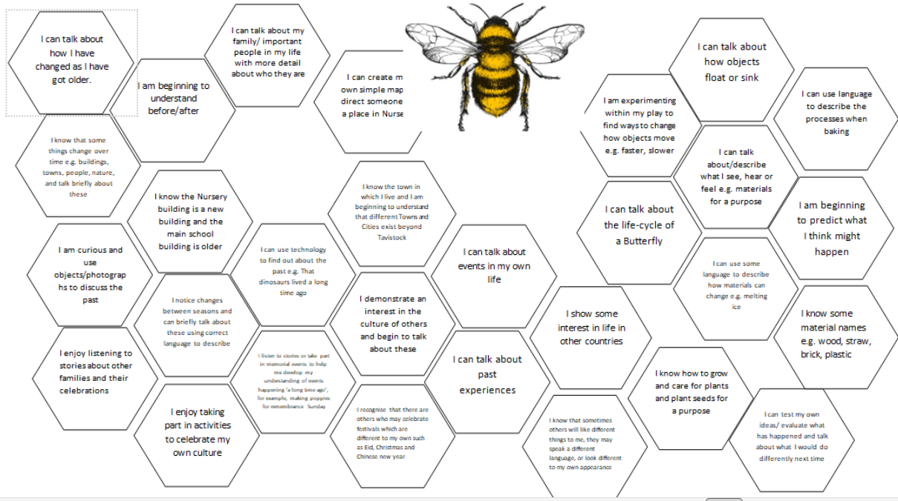

Reception – 4 - 5

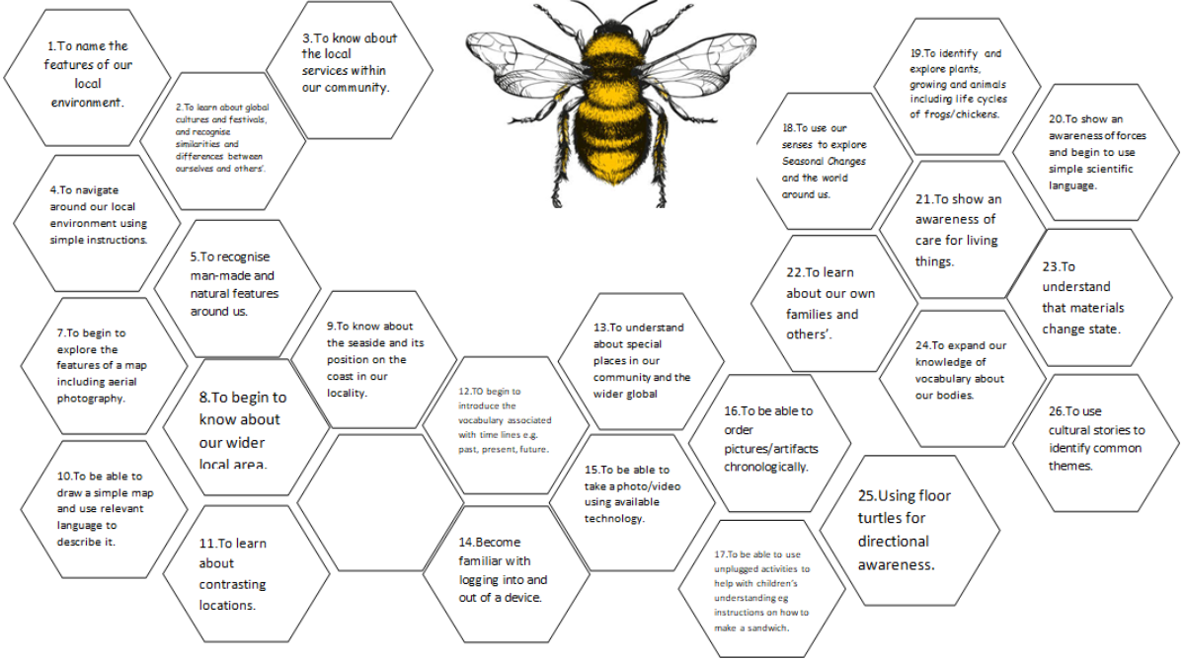
 | Plan | Do |  | Record |  | Review
 | -Explore during their play and repeat an action/test making it obvious they are trying to find something out and see if the result is always the same.  -Recognise when a simple comparison is unfair. | -Observe closely using all of their senses as appropriate.  -During their play repeat and action/test making it obvious they are trying to find something out and see if the result is always the same.  -Compare 2 (3) things by direct observation. |  | -Draw pictures |  | - Make comparisons.  -Say what happened.  -Order results (first, second. Third)  -Spot similarities and differences.
 | Autumn Term |  | Spring Term |  | Summer Term
Scientific Knowledge | Parts of our body.  Ourselves and our bodies and how we change.  How we stay healthy.  The Season of Autumn and changes around us. |  | Materials and their properties and uses- sorting, pushes and pulls.  The Season of Winter and changes around us.  Mini-beasts hunt.  Life-cycles - frogs  The seasons of Spring and changes around us. |  | Growth  Plants-Parts of a plant  Life-cycles .  Facts about animals  Floating and sinking.  The Season of Summer and changes around us.
Three Thrilling Things | - We have five senses  - Humans grow and change from babies to adults  - Trees change — leaves turn brown, red, or yellow and fall to the ground. |  | - Materials can feel and look different  - Some trees lose all their leaves, and many plants stop growing until spring.  - Mini-beasts are small creatures like worms, spiders, snails, and beetles that live in different habitats. |  | - Humans, animals, and plants need food, water, and air to grow.  - Plants have roots, stems, leaves, and flowers.  - Animals can be grouped by what they eat

Years 1 and 2
Yr 1 NC endpoints
This year, our mixed Year 1 and 2 class will focus on the Year 1 Science objectives. Last year, the class covered the Year 2 outcomes, so this year’s teaching will revisit and build on prior learning while ensuring full coverage of the Year 1 National Curriculum content.

Year 1 Topic - Seasonal changes will also be covered using Garden Days which occur once per half term:
- observe changes across the four seasons
- observe and describe weather associated with the seasons and how day length varies.

 |  | Plan |  | Do |  |  | Record |  | Review
Working Scientifically |  | -Explore during their play and repeat an action/test making it obvious they are trying to find something out and see if the result is always the same.  -Recognise when a simple comparison is unfair. |  | -Observe closely using all of their senses as appropriate.  -During their play repeat and action/test making it obvious they are trying to find something out and see if the result is always the same.  -Compare 2 (3) things by direct observation. |  |  | -Draw pictures |  | - Make comparisons.  -Say what happened.  -Order results (first, second. Third)  -Spot similarities and differences.
 | Autumn 1 |  | Autumn 2 |  | Spring 1 | Spring 2 |  | Summer 1 |  | Summer 2
Topic | Animals, including humans |  | Animals, including humans |  | Everyday materials | Living things and their habitats Year 2 outcome |  | Plants |  | Seasonal Changes
Scientific enquiry | Which sense helps us best identify a mystery object? |  | How can animals be sorted into groups? |  | Which material is best for a teddy raincoat? | Which area of the school has the most minibeasts? |  | What does cress need to grow best? |  | Is it warmer in the sun or in the shade at midday?
Scientific Knowledge | identify, name, draw and label the basic parts of the human body and say which part  of the body is associated with each sense. |  | identify and name a variety of common animals including fish, amphibians, reptiles,  birds and mammals  identify and name a variety of common animals that are carnivores, herbivores and  omnivores  describe and compare the structure of a variety of common animals (fish,  amphibians, reptiles, birds and mammals, including pets) |  | distinguish between an object and the material from which it is made  identify and name a variety of everyday materials, including wood, plastic, glass, metal, water, and rock  describe the simple physical properties of a variety of everyday materials  compare and group together a variety of everyday materials on the basis of their simple physical properties. | explore and compare the differences between things that are living, dead, and things that have never been alive  identify that most living things live in habitats to which they are suited and describe how different habitats provide for the basic needs of different kinds of animals and plants, and how they depend on each other  identify and name a variety of plants and animals in their habitats, including microhabitats  describe how animals obtain their food from plants and other animals, using the idea of a simple food chain, and identify and name different sources of food. |  | identify and name a variety of common wild and garden plants, including deciduous  and evergreen trees  identify and describe the basic structure of a variety of common flowering plants,  including trees. |  | observe changes across the four seasons  observe and describe weather associated with the seasons and how day length varies.
Three Thrilling Things | 1- We have five senses  2- We can link each sense to a body part  3-We can name and label basic body parts |  | 1- Many animals fit into groups such as fish, amphibians, reptiles, birds and mammals.  2-Animals can be herbivores, carnivores or omnivores.  3-Animals have body features that help us group them. |  | 1-An object is made from a material.  2-We can name common materials: wood, plastic, glass, metal, water and rock.  3-Materials have properties (hard/soft, waterproof/absorbent, transparent/opaque) | 1-Living things need air, water, food and shelter to survive.  2-A habitat is a place where plants and animals live.  3-Different habitats suit different living things. |  | 1-deciduous (lose leaves) and evergreen (keep leaves) trees.  2-We can name plant parts: root, stem/trunk, leaves and flower.  3-Plants need water, light and warmth to grow well. |  | 1-There are four seasons: spring, summer, autumn, winter.  2-Day length changes through the year  3-Weather changes with the seasons

Years 3 and 4
Year 4 NC endpoints
 |  | Plan |  | Do |  | Record |  |  | Review
Working Scientifically |  | Ask relevant questions.  Set up simple practical enquiries, comparative and fair tests.  -Begin to choose ways to try and answer a question  -Put forward own ideas and make some planning decisions  -Suggest ways of making the test fair or if it cannot be fair, how they will answer it by looking for a pattern  -From a selection, say what equipment is needed  -Suggest the type of data needed to be collected  -Make simple predictions based on everyday experience and knowledge |  | Making systematic and careful observations and where appropriate taking accurate measurements using standard units, using a range of equipment, including thermometers and data loggers.  -Carry out a fair test of pattern seeking enquiry with help  -Compare 3 or more things  -Use simple standard measures; m, cm, mm, kg, g, cm3, minutes, seconds, Newtons  -Measure to the nearest whole or half unit or mixed units  -Read scales to the nearest division labelled and unlabelled |  | Gather, record, classify and present data in a variety of ways to help in answering questions.  Record findings using simple scientific language, drawings, labelled diagrams, bar charts and tables.  -Construct a simple 2 column table  -Draw bar charts 1:1, 1:2, 1:5 and 1:10 scale and begin to plot line graphs. |  |  | Report on findings from enquiries, including oral and written explanations, displays or presentations of results and conclusions, making predictions for new values.  Use results to draw simple conclusions and suggest improvements and raise further questions/ new questions.  Identify differences, similarities or changes related to simple scientific ideas and processes.  -Say what they have found out and give an explanation for observations and simple patterns based on everyday experiences
 | Autumn 1 |  | Autumn 2 |  | Spring 1 |  | Spring 2 | Summer 1 |  | Summer 2
Topic | Electricity |  | States of matter |  | Sound |  | Living things and their habitats | Animals including humans |  | Living things and their habitats
Scientific enquiry – | Which materials conduct electricity? |  | How does temperature affect the state of water? |  | How does the length of a string affect the pitch of sound? |  | How do environmental changes affect habitats? | What happens to food when we eat it? |  | What dangers does an animal face due to a changing habitat?
Scientific Knowledge | Can Identify common appliances that run on electricity.  Can construct a simple series electrical circuit, identifying and naming its basic parts, including cells, wires, bulbs, switches and buzzers.  Knows and can identify whether or not a lamp will light in a simple series circuit, based o whether or not the lamp lights in a simple series circuit.  Can recognise some common conductors and insulators, and associate metals with being good conductors |  | Knows and can compare and group materials together, according to whether they are solids, liquids or gases.  Has observed that some materials change state when they are heated or cooled, and measure or research the temperature at which this happens in degrees Celsius (˚C)  Knows and can identify the part played by evaporation and condensation in the water cycle and associate the rate of evaporation with temperature. |  | Knows and can identify how sounds are made, associating some of them with something vibrating.  Can recognise that vibrations from sounds travel through a medium to the ear.  Can find patterns between the pitch of a sound and features of the object that produced it.  Can find patterns between the volume of a sound and the strength of the vibrations that produced it.  Can recognise that sounds get fainter as the distance from the sound source increases. |  | Can recognise that some living things can be grouped in a variety of ways.  Can and have used classification keys to help group, identify and name a variety of living things in their local and wider environment. | Know and can describe the simple functions of the basic parts of the digestive system in humans.  Knows and can identify the different types of teeth in humans and their simple functions.  Can construct and interpret a variety of food chains, identifying producers, predators and prey. |  | Recognise that environments can change and that this can sometimes pose dangers to living things.
Five Fantastic Facts | 1 - Electricity flows in a circuit (to power things like lights and motors).  2 - Circuits need a power source, wires, and components.  3 - Conductors let electricity pass through, but insulators don’t.  4 - Switches can open or close a circuit (to control the flow of electricity).  5 - Batteries store energy to power electrical devices. |  | 1 - Solids, liquids, and gases have different properties.  2 - Heating or cooling can change a material's state (e.g., ice to water).  3 - Water can exist as solid (ice), liquid, or gas (steam).  4 - Evaporation and condensation are part of the water cycle.  5 -Temperature affects how quickly materials change state. |  | 1 - Sound is made when objects vibrate.  2 - Vibrations travel through solids, liquids, and gases to our ears.  3 - Loud sounds have big vibrations, and quiet sounds have small vibrations.  4 - The pitch of a sound depends on how fast an object vibrates.  5 - Sounds get quieter as they travel further away. |  | 1 - Living things can be grouped into categories (like mammals, birds, insects, and plants based on their characteristics.)  2 - Habitats provide food, water, and shelter (that living things need to survive.)  3 - Changes to an environment can harm habitats and the animals living there (like pollution or deforestation)  4 - A food chain shows how energy moves through a habitat, starting with plants (producers).  5 - Living things adapt to their habitats (like polar bears having thick fur for cold climates.) | 1 - Animals have different teeth for eating different types of food.  2 - Digestion breaks food into nutrients the body can use.  3 - The stomach and intestines are key parts of the digestive system.  4 - Food chains show how energy flows through living things.  5 - Every food chain starts with a producer, like plants. |  | 1 - Living things can be grouped into categories (like mammals, birds, insects, and plants based on their characteristics.)  2 - Habitats provide food, water, and shelter (that living things need to survive.)  3 - Changes to an environment can harm habitats and the animals living there (like pollution or deforestation)  4 - A food chain shows how energy moves through a habitat, starting with plants (producers).  5 - Living things adapt to their habitats (like polar bears having thick fur for cold climates.)

Year 5
 |  | Plan |  |  | Do |  | Record |  |  | Review
Working Scientifically |  | Ask relevant questions.  Set up simple practical enquiries, comparative and fair tests. (A2, Sp2,Su1)  -Begin to choose ways to try and answer a question (A2, Sp1, Sp2, Su1)  -Put forward own ideas and make some planning decisions( Sp1, Sp2, Su1)  -Suggest ways of making the test fair or if it cannot be fair, how they will answer it by looking for a pattern ( A2, Sp2, Su1)  -From a selection, say what equipment is needed ( Sp1, Sp2, Su1)  -Suggest the type of data needed to be collected ( Su, Su2)  -Make simple predictions based on everyday experience and knowledge ( A2, Sp2, Su 1, Su2) |  |  | Making systematic and careful observations and where appropriate taking accurate measurements using standard units, using a range of equipment, including thermometers and data loggers. (Sp2,Su1,Su2)  -Carry out a fair test of pattern seeking enquiry with help (A2,Sp1,Sp2,Su1)  -Compare 3 or more things (A1, Sp1,Su1)  -Use simple standard measures; m, cm, mm, kg, g, cm3, minutes, seconds, Newtons ( Sp2,Su1, Su2)  -Measure to the nearest whole or half unit or mixed units (Sp2, Su1, Su2)  -Read scales to the nearest division labelled and unlabelled (Su2) |  | Gather, record, classify and present data in a variety of ways to help in answering questions. (A1, Sp1, Sp2, Su1) |  |  | Report on findings from enquiries, including oral and written explanations, displays or presentations of results and conclusions, making predictions for new values. (A2, Sp1, Sp2, Su1, Su2)  Use results to draw simple conclusions and suggest improvements and raise further questions/ new questions. ( A2, Sp1, Sp2, Su1)  Identify differences, similarities or changes related to simple scientific ideas and processes. (A1, A2, Sp1, Su1)  -Say what they have found out and give an explanation for observations and simple patterns based on everyday experiences ( A1, A2, Sp1, Sp2, Su1, Su2)
 | Autumn 1 |  | Autumn 2 |  |  | Spring 1 |  | Spring 2 | Summer 1 |  | Summer 2
Topic | Physics – Earth and Space |  | Biology – Living things and their habitats. |  |  | Physics - Forces |  | Chemistry – Properties and changes in materials | Chemistry – Properties and changes in materials |  | Biology – Animals including humans
Scientific enquiry – | How does the Earth’s rotation cause day and night? |  |  | How do different habitats affect the types of living things that live there? |  | How does the type of surface affect the amount of friction acting on a moving object? |  | How can we separate a mixture of sand, salt and water? | Can all changes to materials be reversed? |  | What changes happen to the human body as we grow from a baby to an elderly adult?
Scientific Knowledge | Describe the movement of the Earth and other planets relative to the sun in the solar system.  Describe the movement of the moon relative to the Earth.  Describe the sun, Earth and moon as approximately spherical bodies.  Use the idea of the Earth’s rotation to explain day and night and the apparent movement of the sun across the sky |  |  | Describe the differences in the life cycles of a mammal, an amphibian, an insect and a bird.  Describe the life process of reproduction in some plants and animals. |  | Explain that unsupported objects fall towards the Earth because of the force of gravity acting between the Earth and the falling object.  Identify the effects of air resistance, water resistance and friction, that act between moving surfaces.  Recognise that some mechanisms including levers, pulleys and gears allow a smaller force to have a greater effect. |  | compare and group together everyday materials on the basis of their properties, including their hardness, solubility, transparency, conductivity (electrical and thermal), and response to magnets  know that some materials will dissolve in liquid to form a solution, and describe how to recover a substance from a solution | use knowledge of solids, liquids and gases to decide how mixtures might be separated, including through filtering, sieving and evaporating.  give reasons, based on evidence from comparative and fair tests, for the particular uses of everyday materials, including metals, wood and plastic.  demonstrate that dissolving, mixing and changes of state are reversible changes.  explain that some changes result in the formation of new materials, and that this kind of change is not usually reversible, including changes associated with burning and the action of acid on bicarbonate of soda. |  | Describe the changes as humans develop to old age.
Five Fantastic Facts | 1 - The Sun is at the centre of our solar system.  All the planets, including Earth, orbit the Sun.  2 - The Earth takes approximately 365¼ days to orbit the Sun.  3 - The Moon orbits the Earth every 28 days.  4 - The Earth spins (rotates) once every 24 hours on its axis.  5 - The Sun, Earth, and Moon are spherical in shape. |  |  | 1 - Mammals give birth to live young and usually feed them with milk.  2 - Amphibians lay eggs in water, and their young (like tadpoles) live in water before developing into adults.  3 - Insects go through stages in their life cycle, called metamorphosis.  4 - Birds lay eggs with hard shells, and their chicks hatch fully formed.  5 - Reproduction in plants often happens through seeds produced after pollination, and in animals through mating and fertilisation. |  | 1 - Gravity is a force that pulls objects towards the Earth.  2 - Air resistance is a force that slows down objects moving through air.  3 - Water resistance works like air resistance but acts on objects moving through water.  4 - Friction is a force between two surfaces that resists motion and can cause things to slow down or stop.  5 - Simple machines like levers, pulleys, and gears help us use less force to move or lift things. |  | 1 - Materials can be grouped by their properties like hardness, solubility, transparency, conductivity, and magnetism.  2 - Hardness describes how easily a material can be scratched or dented.  3 - Solubility is how well a material dissolves in a liquid to form a solution.  4 - Some materials conduct electricity or heat well (conductors), while others do not (insulators).  5 - When a material dissolves in a liquid, it forms a solution. | 1 - Mixtures can be separated using methods like filtering.  2 - Materials such as metals, wood, and plastic are used for different purposes.  3 - Dissolving, mixing, and changes of state (like melting and freezing) are reversible changes.  4 - Some changes create new materials and are usually not reversible.  5 - Fair tests and evidence help us understand which materials are best for certain uses by comparing their properties. |  | 1 - Humans go through different life stages: baby, child, teenager, adult, and old age.  2 - As humans grow, their bodies change in size, shape, and abilities.  3 - During puberty, the body undergoes many physical changes, including development of reproductive organs.  4 - In adulthood, the body is fully grown and can reproduce.  5 - In old age, the body’s strength, memory, and senses may decline.

Year 6
 |  | Plan |  | Do |  |  | Record |  | Review
Working Scientifically |  | Plan different types of scientific enquiries, including recognising and controlling variables where necessary to answer questions.  -Ask a variety of types of scientific questions (A2)(Sp1)(Su1)  -Choose the most appropriate scientific enquiry method to answer a question and outline the method (A1)(Su1)  -List all the equipment needed (A1)(A2)(Sp1)(Sp2)  -Decide what data to collect and how much of it is needed (A1)(Sp1)(Sp2)(Su1)  -Make predictions based on scientific knowledge (A1)(A2)(Sp1)(Sp2)(Su1) |  | Take measurements using a range of scientific equipment with increasing accuracy and precision, taking repeat readings when appropriate.  -Make a series of measurements adequate for the task (Sp1)  -Select appropriate measuring equipment (A1)(Sp1)  -Use standard measure as in including fractions and mixed units and decimals to one place (A1)(Sp1)  -Read scales with increased accuracy  -Compare 5 or more things (A1)(Sp1)  -Select apparatus and use with care(A1)(A2)(Sp1)  -Read scales with precision and accuracy appropriate to the task(Sp1)  -Repeat readings and find averages (A1)(Sp1)(Sp2) |  |  | Record data and results of increasing complexity using scientific diagrams, labels, classification keys, tables, scatter graphs, bar and line graphs and models.  -Present information clearly in tables including for repeat readings (A1)(A2)(Sp2)  -Record observations and measurements systematically (A1)(A2) (Sp1)(Sp2)  -Draw bar graphs using more complex scales, possibly involving fractions or decimals)(Su1)  -Draw line graphs, possibly involving fractions and decimals (A1)(Sp1) |  | Report and present findings from enquiries, including conclusions, casual relationships and explanations of results, explanations of the degree of trust in results, in oral and written forms such as displays and other presentations.  Use test results to make predictions to set up further comparative and fair tests.  Identify scientific evidence that has been used to support or refute ideas or arguments.  -Use graphs to spot and interpret patterns/ trends in results (A1)(Sp1)(Su1)  -Draw conclusions using these patterns and begin to relate conclusions to scientific knowledge and understanding consistent with the evidence (A1)(A2)(Sp1)(Su1)  -Offer simple explanation for differences in repeated measurements/ observations (A1)(A2)(Sp1)(Sp2)(Su1)
 | Autumn 1 |  | Autumn 2 |  | Spring 1 | Spring 2 |  | Summer 1 |  | Summer 2
Topic | Biology – Animals including humans |  | Biology - Evolution and inheritance |  | Physics - Light | Physics – Electricity |  | Biology – Living things and their habitats |  | Relationship and Sex Education
Scientific enquiry – Which working scientifically strands do you intend to cover? | How do different forms exercise affect my resting heart rate? |  | Is there a pattern between the size and shape of a bird’s beak and the food it will eat? |  | How does the distance between the light and the object change the size of a shadow? | Does the type of circuit affect how the components work/long the battery lasts? |  | What happens to a piece of bread if you leave it on the windowsill for two weeks? |  | Linked to the PSHE curriculum
Scientific Knowledge | Identify and name the main parts of the human circulatory system, and describe the functions of the heart, blood vessels and blood.  Describe the impact of diet, exercise, drugs and lifestyle on the way their bodies function .  Describe the ways in which nutrients and water are transported within animals, including humans. |  | Recognise that living things have changed over time and that fossils provide information about living things that inhabited the Earth millions of years ago.  Recognise that living things produce offspring of the same kind, but normally offspring vary and are not identical to their parents.  Identify how animals and plants are adapted to suit their environment in different ways and that adaptation may lead to evolution. |  | Recognise that light appears to travel in straight lines.  Know that light travels in straight lines to explain that objects are seen because they give out or reflect light into the eye.  Explain that we see things because light travels from light sources to our eyes or form light sources to objects and then to our eyes.  Use the idea that light travels in straight lines to explain why shadow have the same shape as the objects that cast them. | Explain that the brightness of a lamp or the volume of a buzzer with the number and voltage of cells used in the circuit.  Compare and give reasons for variations in how components function, including the brightness of bulbs, the loudness of buzzers and the on/off position of switches.  Use recognised symbols when representing a simple circuit in a diagram. |  | Describe how living things are classified into broad groups according to common observable characteristics and based on similarities and differences, including micro-organisms, plants and animals.  Give reasons for classifying plants and animals based on specific characteristics |  | (Non-statutory guidance)  Describe the changes experienced in puberty.
Five Fantastic Facts | 1 - The heart pumps blood around the body through blood vessels.  2 - Nutrients from food are absorbed in the small intestine.  3 - Exercise helps keep the heart and muscles healthy.  4 - The lungs take in oxygen and remove carbon dioxide.  5 - Circulatory and digestive systems work together to keep us alive. |  | 1 - Living things change over time to adapt to their environment.  2 - Fossils show us how living things from the past were different.  3 - Offspring inherit characteristics from their parents.  4 - Variation within a species helps some survive better than others.  5 - Over time, natural selection can lead to new species. |  | 1 - Light travels in straight lines.  2 - Shadows are created when light is blocked.  3 - Mirrors reflect light to change its direction.  4 - We see objects when light reflects off them into our eyes.  5 - White light is made up of many colours. | 1 - Voltage affects how bright a bulb is in a circuit.  2 - Electrical symbols represent components like bulbs and switches.  3 - Circuits need a complete loop to work.  4 - Some materials, like metals, conduct electricity.  5 - Too much electricity can damage circuits or devices. |  | 1 - Living things are classified into broad groups (microorganisms, plants, and animals).  2 - Animals can be grouped as vertebrates (fish, amphibians, reptiles, birds, mammals) or invertebrates (insects, spiders, snails, worms).  3 - Classification is based on observable characteristics (like fur, scales, or wings).  4 - Carl Linnaeus developed the modern classification system used by scientists.  5 - Classification keys help identify and sort living things in different habitats.

