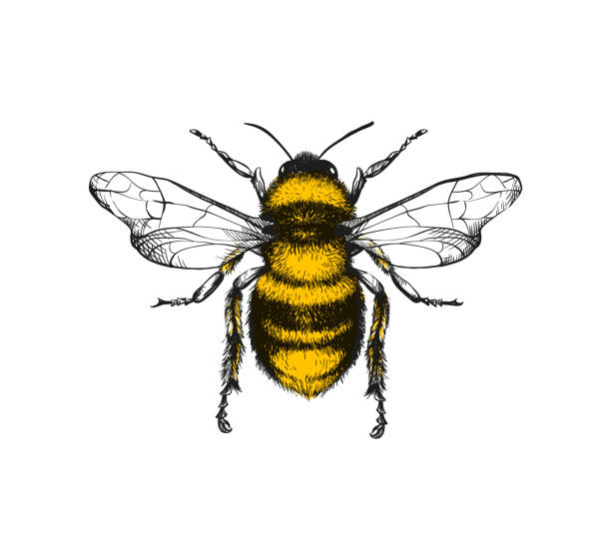

I can create my own simple map to direct someone to a place in Nursery

I am experimenting within my play to find ways to change how objects move e.g. faster, slower

I know the town in which I live and I am beginning to understand that different Towns and Cities exist beyond Tavistock

I enjoy listening to stories about other families and their celebrations

I am curious and use objects/photographs to discuss the past

I know that some things change over time e.g. buildings, towns, people, nature, and talk briefly about these

I know how to stay safe near the roads and traffic

I can talk about my family/ important people in my life with more detail about who they are

I am beginning to understand before/after

I can talk about how I have changed as I have got older.

I can test my own ideas/ evaluate what has happened and talk about what I would do differently next time

I listen to stories or take part in memorial events to help me develop my understanding of events happening ‘a long time ago’, for example, making poppies for remembrance Sunday

I recognise that there are others who may celebrate festivals which are different to my own such as Eid, Christmas and Chinese new year

I show some interest in life in other countries

I can talk about the life-cycle of a Butterfly

I know some material names e.g. wood, straw, brick, plastic

I know how to grow and care for plants and plant seeds for a purpose

I know that sometimes others will like different things to me, they may speak a different language, or look different to my own appearance

I can talk about past experiences

I can talk about events in my own life

**Understanding of the World**

Every child will learn about the people and places in their own community and be encouraged to explore, investigate the natural world.

I demonstrate an interest in the culture of others and begin to talk about these

I can use technology to find out about the past e.g. That dinosaurs lived a long time ago

I can talk about/describe what I see, hear or feel e.g. materials for a purpose

I can talk about how objects float or sink

I can use language to describe the processes when baking

I enjoy taking part in activities to celebrate my own culture

I know the Nursery building is a new building and the main school building is older

I notice changes between seasons and can briefly talk about these using correct language to describe

I am beginning to predict what I think might happen

I can use some language to describe how materials can change e.g. melting ice