This term in geography, we are comparing the human and physical geography of countries in Europe to those of South America.
Human geography explores any human interaction or association with a place, such as population, migration, flags, man-made features, notable buildings, culture etc.
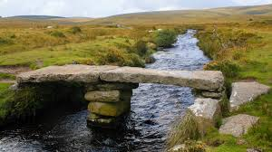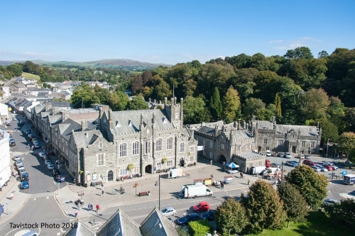
Physical geography explores natural features like rivers, hills and mountains and land features.
Your project this term is to do a local study of a place in Devon. Choose any place in Devon that interests you and present information about the physical and/or human geography.
You may make a model, create a PowerPoint presentation, create a book or poster. Adding photographs of your own would be particularly valuable.
Please return your project, named, to class by Friday 28th March.

