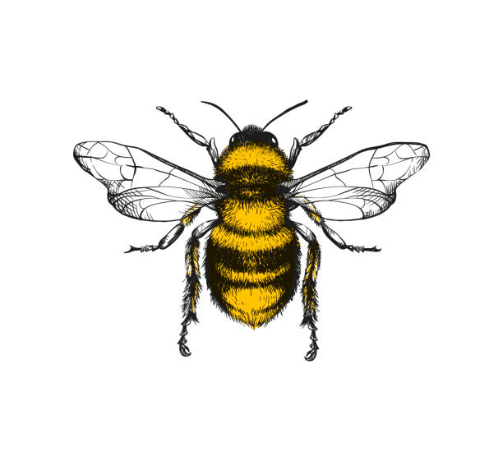

I have an understanding of rhythm and can tap/clap along to a beat with an adults guidance

I can talk about music and use some words to describe it e.g. whether it is loud, quiet, calm

I can move in a variety of ways e.g. hopping, leaping, running, climbing, balancing

I have some favourite poems and can share these with others

I engage in narrative imaginative play where there are some roles/rules

I engage in pretend play that reflects a favourite story and uses such language

I can create some 2d and 3d shapes using malleable materials

I can design my own props to support imaginative play/story telling

I enjoy different musical styles e.g. cultural music that reflects the heritage of our cohort

I can use proportion in my drawings/paintings e.g. knowing that the nose is larger than an eye

I know how to make clay more malleable

**Expressive Arts and Design**  
Every child will be able to develop their own ideas and decide which materials to use to create them. They will create songs and use musical instruments with increasing control.

.

I know how to join construction materials together to make simple models

I am proud to share my designs/models with others and ask to put them on display

I can create a natural rubbing and talk about it

I can dance to music (Sometimes spontaneously)

I can create different textures when making e.g. textured paint, collage

I can sing some of our core Nursery Rhymes *See long term overview

I can create/paint/draw something from experience/observation and with increasing detail

I can use colours for a particular purpose when creating

I can join in with some ring/group games

*See long term overview

I can make my own powder paint colours and use these to mix colours

I can use watercolour paints/ block paints

I can talk about how and why I am doing something/ the process I am undertaking

I engage with pretend play that reflects familiar home scenarios

I can use the work of an artist to inspire my own

I can create a pattern using a range of media

I can choose tools (other than scissors )that might help me with my work e.g. clay knives, smaller paint brushes

I am beginning to plan my work before I make it and can say how I can change my work to make it better next time

I make up my own songs and can sing with some melody, moving in time to the music

I can perform with musical instruments to myself/an adult/group