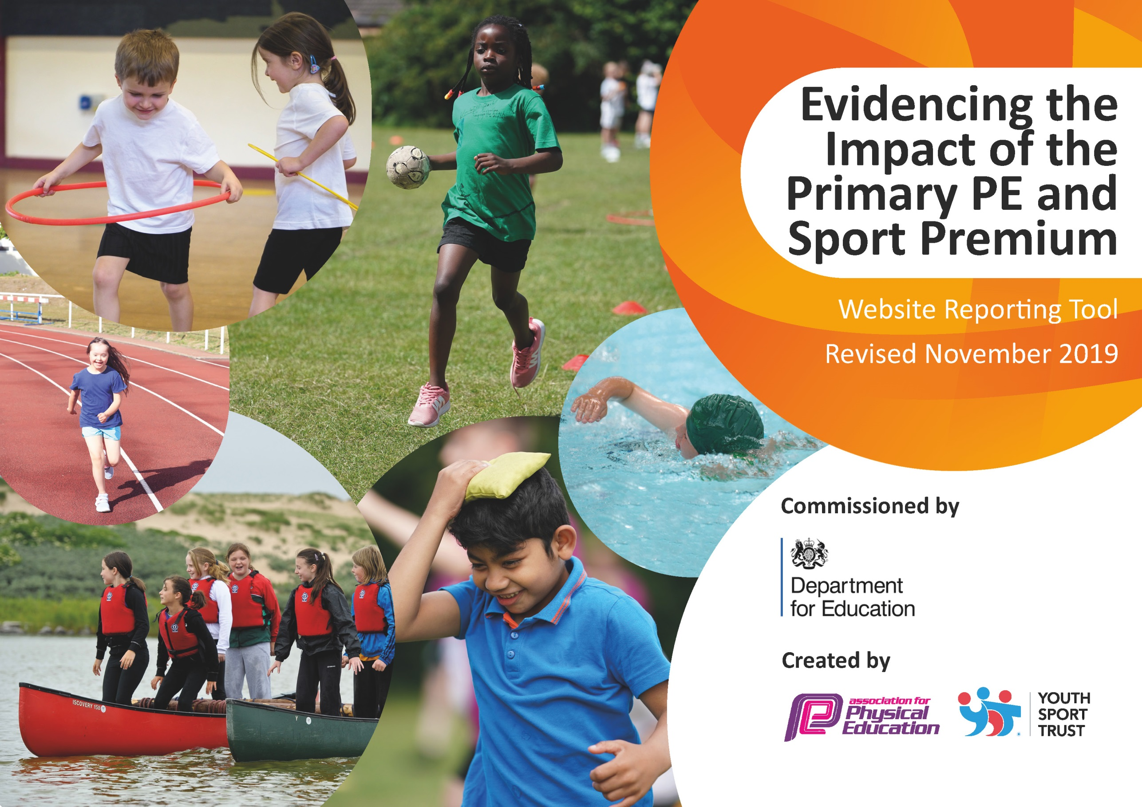
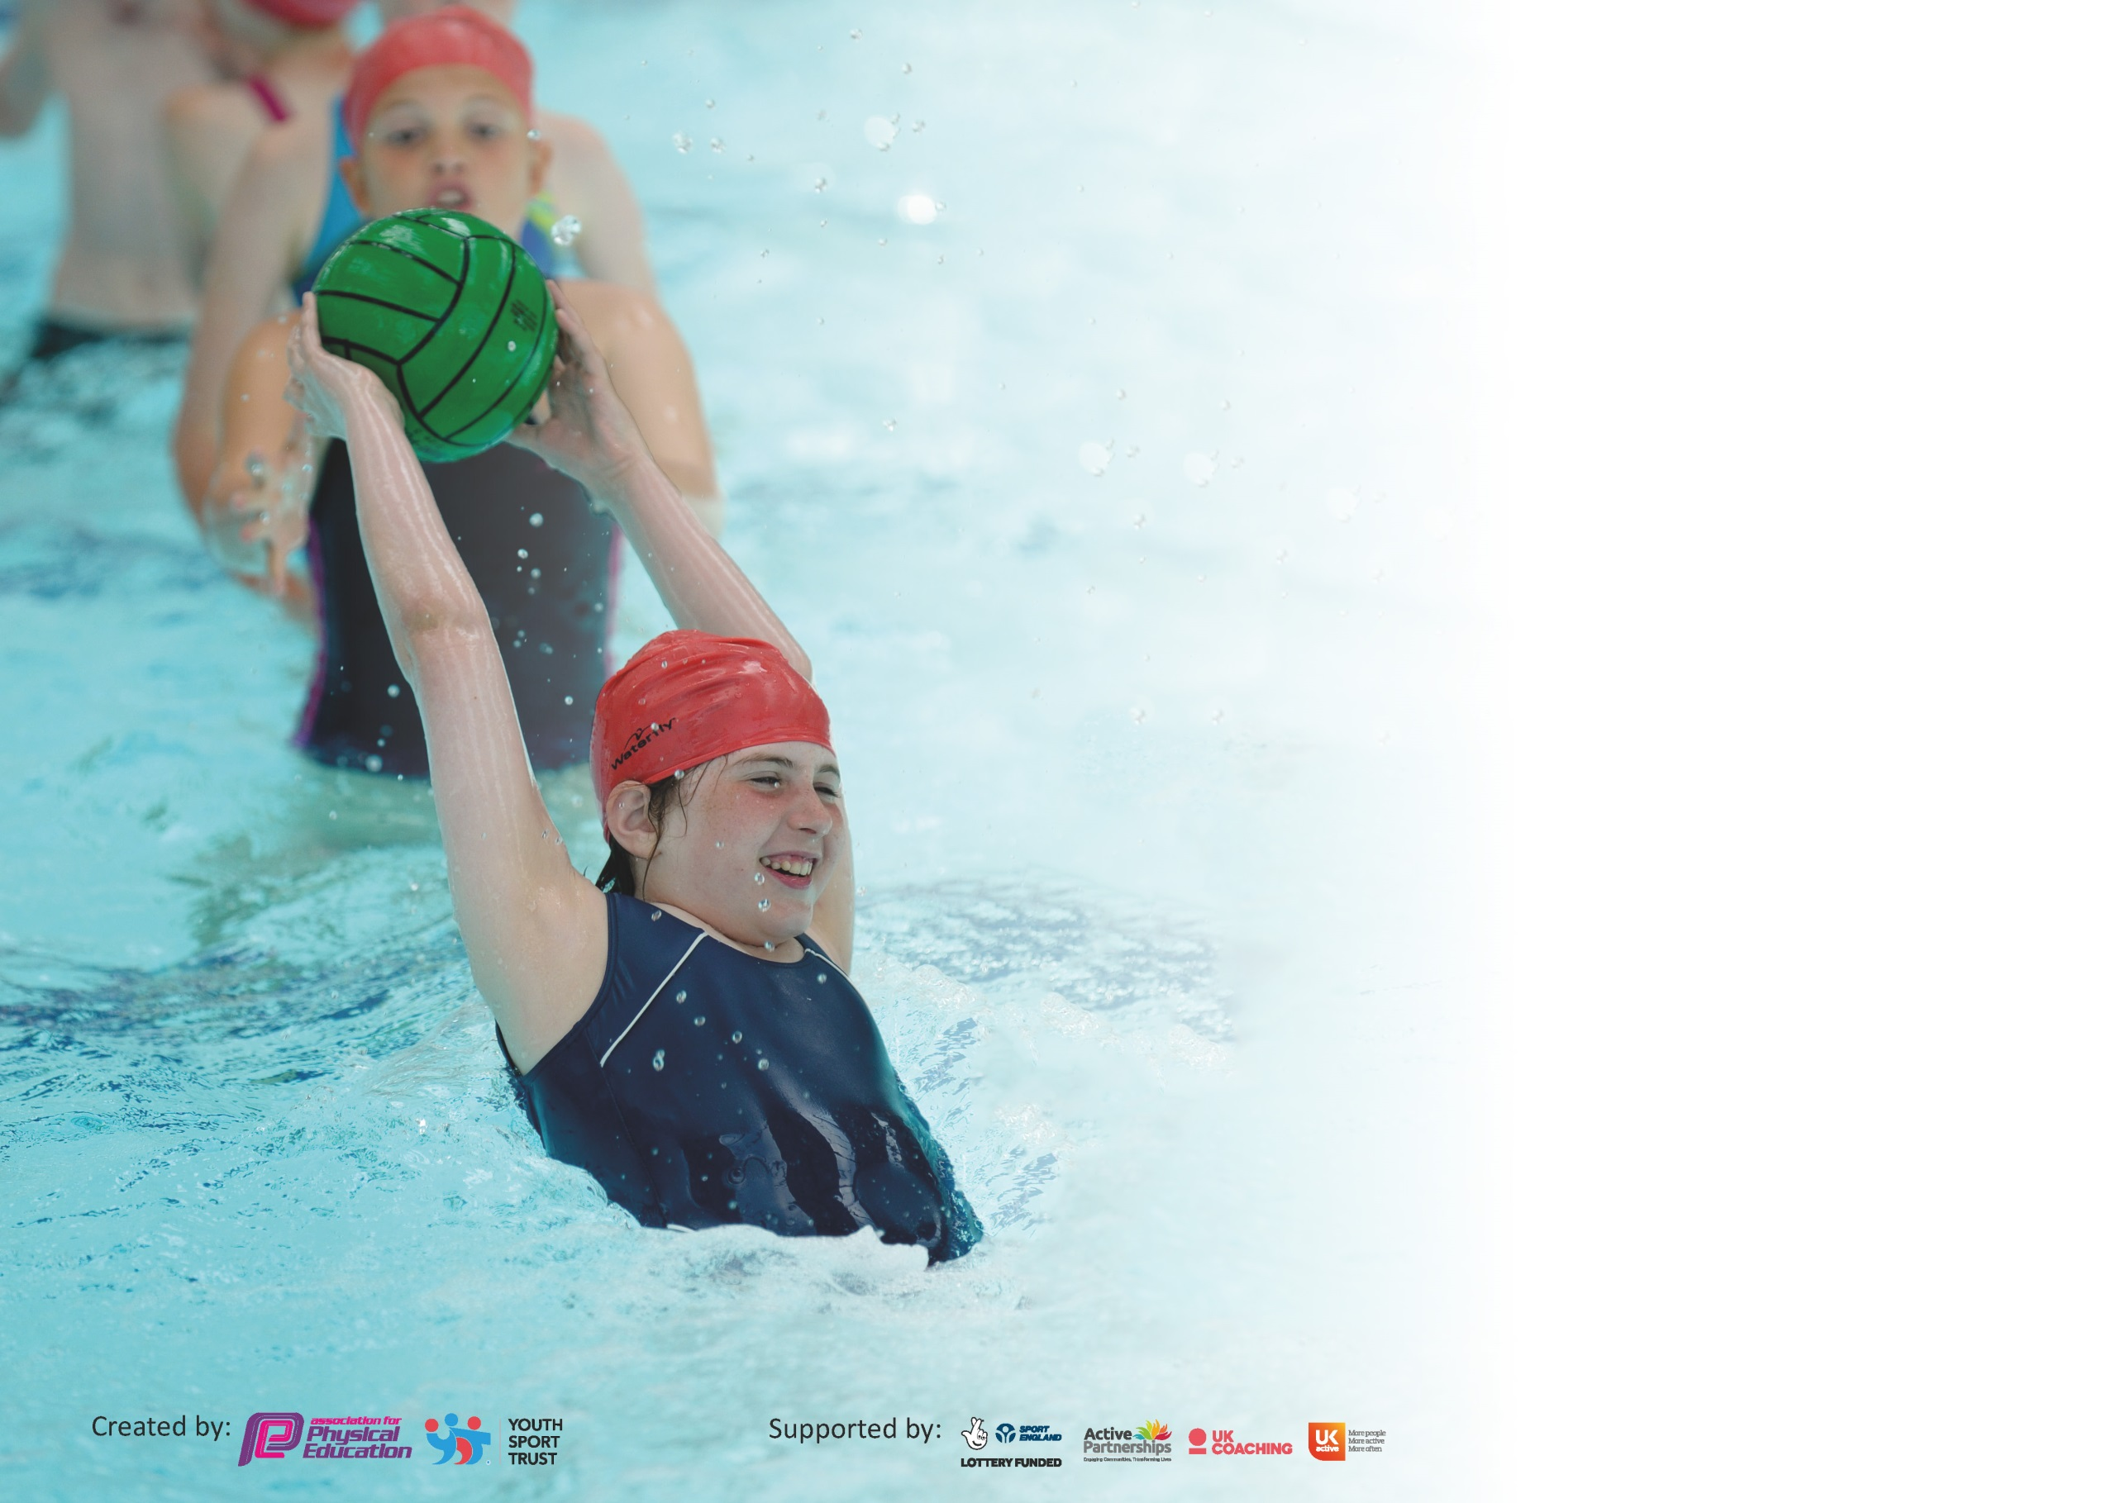

It is important that your grant is used effectively and based on school need. The Education Inspection Framework (Ofsted 2019 p64) makes clear there will be a focus on ‘whether leaders and those responsible for governors all understand their respective roles and perform these in a way that enhances the effectiveness of the school’.

Under the Quality of Education criteria (p41) inspectors consider the extent to which schools can articulate their curriculum (INTENT), construct their curriculum (IMPLEMENTATION) and demonstrate the outcomes which result (IMPACT).

To assist schools with common transferable language this template has been developed to utilise the same three headings which should make your plans easily transferable between working documents.

Schools must use the funding to make additional and sustainable improvements to the quality of Physical Education, School Sport and Physical Activity (PESSPA) they offer. This means that you should
use the Primary PE and Sport Premium to:

- Develop or add to the PESSPA activities that your school already offer
- Build capacity and capability within the school to ensure that improvements made now will benefit pupils joining the school in future years

Please visit gov.uk for the revised DfE guidance including the 5 key indicators across which schools should demonstrate an improvement. This document will help you to review your provision and to report your spend. DfE encourages schools to use this template as an effective way of meeting the reporting requirements of the Primary PE and Sport Premium.

We recommend you start by reflecting on the impact of current provision and reviewing the previous spend.

Schools are required to publish details of how they spend this funding as well as on the impact it has on pupils’ PE and sport participation and attainment by the end of the summer term or by 31st July 2020 at the latest.

We recommend regularly updating the table and publishing it on your website throughout the year. This evidences your ongoing self-evaluation of how you are using the funding to secure maximum, sustainable impact. Final copy must be posted on your website by the end of the academic year and no later than the 31st July 2020. To see an example of how to complete the table please click HERE.

Support for review and reflection - considering the 5 key indicators from DfE, what development needs are a priority for your setting and your pupils now and why? Use the space below to reflect on previous spend and key achievements and areas for development.

Key achievements to date until July 2020: | Areas for further improvement and baseline evidence of need:
- Increasing pupils’ engagement in regular physical activity by:  - Providing a broad range of active outside school hours clubs  - Engaging in as many competitive sporting opportunities and sporting festivals as possible, using funding for transport.  - Encourage and facilitate active break times through provision of engaging equipment and facilities  - Promote importance of a healthy diet and lifestyle.  - The PE and PSHE curriculums have been rewritten and work alongside each other to ensure that children are informed progressively about the need to balance exercise with a healthy diet.  - Raise the profile of PE and sport across the school by:  - Developing additional squad focus, to ensure we compete to the best of our ability.  - Cups, badges and certificates presented in assemblies  - Increase confidence, knowledge and skills of all staff in teaching PE and sport.  - High quality sports provider to work weekly alongside staff, delivering fundamental movement skill sessions  - REAL PE material and training completed, for staff to deliver high quality sessions, developing fundamental movement skills  - Additional PE training made available to all staff to develop provision of high quality PE and Games, including gymnastics, dance, tennis and basketball. | Raise the profile of PE and sport across the school by:  - Inviting high-achieving participants, from a range of sports, to speak in assemblies and promote an active lifestyle.  Offer a broader experience of a range of sports and activities to pupils:  - Audit children about their sporting interests and activities  - Local clubs invited to demonstrate  - Providers of a range of sports, not already provided in school, to  deliver sessions, exposing children to new activities.

Meeting national curriculum requirements for swimming and water safety.
What percentage of your current Year 6 cohort swim competently, confidently and proficiently over a distance of at least 25 metres?  N.B. Even though your pupils may swim in another year please report on their attainment on leaving  primary school at the end of the summer term 2020. | 48/ 55 = 87%
What percentage of your current Year 6 cohort use a range of strokes effectively [for example, front crawl, backstroke and breaststroke]? | 40/55 = 73%
What percentage of your current Year 6 cohort perform safe self-rescue in different water-based situations? | 40/55= 73%
Schools can choose to use the Primary PE and Sport Premium to provide additional provision for swimming but this must be for activity over and above the national curriculum requirements. Have you used it in this way? | Yes – training of able swimmers as school squad for entry into gala

Action Plan and Budget Tracking
Capture your intended annual spend against the 5 key indicators. Clarify the success criteria and evidence of impact that you intend to measure to evaluate for pupils today and for the future.

Academic Year: 2019/20 | Total fund allocated: £18,910 |  |  | Date Updated: July 2020
Key indicator 1: The engagement of all pupils in regular physical activity – Chief Medical Officer guidelines recommend that primary school pupils undertake at least 30 minutes of physical activity a day in school |  |  |  |  |  |  | Percentage of total allocation:
 |  |  |  |  |  |  | 40%
Intent | Implementation |  |  |  |  | Impact
Your school focus should be clear what you want the pupils to know and be able to do and about  what they need to learn and to  consolidate through practice: | Make sure your actions to achieve are linked to your intentions: |  |  | Funding allocated: |  | Evidence of impact: what do pupils now know and what can they now do? What has changed? | Sustainability and suggested next steps:
Increase opportunities for pupils to participate in activities across the school day. | Employment of training ‘Huff & Puff’ leader and selection and training of pupil ‘Huff & Puff’ helpers.  Purchase ‘Huff & Puff’ resources  Provide a broad range of sporting after-school extra-curricular clubs  Maintenance of playground games facilities |  |  | £2,988  £627  £160  £3,812 |  | Playtime games have been well-structured and supervised by Y5 & 6 pupils, providing a high level and quality of engagement. No MTA has been able to commit to role of H & P leader because of limited numbers and existing school commitments.  A range of appropriate and durable equipment, based on feedback from Playground Leaders, has ensured longevity and high levels of pupil engagement and high activity levels.  Football KS1 & KS2, Tag rugby, netball, fitness club, hockey, running club all well supported. No summer term clubs due to Covid 19.  Availability of basketball, climbing, table-tennis and football for pupils on rotation. All well supported. | Pupil training to be continued annually and Playground Leaders developed and sustained for the year. A regular MTA for KS1 & KS2 playground to be paid to attend H & P training with the next cohort, to support provision.  Continue to invest in a range of balancing, skipping, hand-eye- coordination and throwing & catching resources.  Not all clubs were at full capacity due to same day provision. Possibility of Zumba club to be pursued for next academic year to increase breadth of interest.  Annual maintenance checks to ensure safety of wooden climbing trails and frame
Key indicator 2: The profile of PESSPA being raised across the school as a tool for whole school improvement |  |  |  |  |  |  | Percentage of total allocation:
 |  |  |  |  |  |  | 6%
Intent | Implementation |  |  |  |  | Impact
Your school focus should be clear what you want the pupils to know and be able to do and about  what they need to learn and to  consolidate through practice: | Make sure your actions to achieve are linked to your intentions: |  |  | Funding allocated: |  | Evidence of impact: what do pupils now know and what can they now do? What has changed? | Sustainability and suggested next steps:
To promote sport and a healthy lifestyle by recognition of engagement and achievements of pupils and staff in physical activities. | Celebration of pupils’ and staff sporting achievements within and outside of school environment. Individual and team achievements to be recognised within weekly assemblies.  Provide staff with paid leave to represent GB and attend national and international competitions.  Purchase and erect dedicated noticeboard for sporting events and achievements  Purchase a set of team and staff waterproof jackets to be worn at sporting events  Subject leader time to collate evidence for School Games Mark Application |  |  | £0.00  £320  £240  £480  £160 |  | All sporting events undertaken have been acknowledged and celebrated, pupils are aware of the range of sporting opportunities available and the benefits of participating in them.  Leave granted for staff member to attend Aquathlon World Champs in Sept 2020. Students recognise that a level of sporting excellence and achievement is attainable and offers personal rewards  School sports clubs, events and teams are displayed to raise sporting profile and motivation and to show links with local sports clubs  Students feel pride and unity representing school, are easily identifiable for safety and will raise the profile of the school  Award deferred for a year due to Covid 19 | Monday and Thursday assemblies continue to recognise success weekly. Sportsmanship and Sporting achievement promoted by award of Cups termly/annually  Sustainable staff members compete at national level.  We can continue to publish achievements and events and contact details for sports clubs  Reusable at future events  School games mark gold to be aimed for next year.
Key indicator 3: Increased confidence, knowledge and skills of all staff in teaching PE and sport |  |  |  |  |  |  |  | Percentage of total allocation:
 |  |  |  |  |  |  |  | 18%
Intent |  | Implementation |  |  | Impact
Your school focus should be clear |  | Make sure your actions to | Funding |  | Evidence of impact: what do |  |  | Sustainability and suggested
what you want the pupils to know |  | achieve are linked to your | allocated: |  | pupils now know and what |  |  | next steps:
and be able to do and about |  | intentions: |  |  | can they now do? What has
what they need to learn and to |  |  |  |  | changed?:
consolidate through practice:
Improve teaching of PE across all year groups. |  | Specialist coach, Mark Wickett employed across the academic year supporting a different year group each ½ term.  PE leader to attend annual PE conference  Termly PE leader time to plan schedule of events and transport  Supply cover and costs of CPD in PE training | £1,682  £510  £480  £750 |  | Pupils demonstrate application of improved fundamental movement skills in PE lessons and sports clubs. Teachers learn games and exercises to develop pupils skills and mobility  National guidance and latest strategies in PE observed in school  Termly plan of sporting events to be attended based on OCRA timetable of sports events. Transport implications and pupils commitments to be accounted for  Staff benefitted from up to date training to ensure that pupils receive high quality provision |  |  | Continue to target years R to 5  Additional provision to be negotiated to develop targeted low achievers and to challenge higher achievers  Annual event as availability allows  Some success. Covid 19 interruption prevented further development. A formal timetable needs to be created with details of pupil numbers, staff numbers and transport requirements  OCRA continue to provide coaching as required.
Key indicator 4: Broader experience of a range of sports and activities offered to all pupils |  |  |  |  |  |  |  | Percentage of total allocation:
 |  |  |  |  |  |  |  | 15%
Intent |  | Implementation |  |  | Impact
Your school focus should be clear |  | Make sure your actions to | Funding |  | Evidence of impact: what do |  |  | Sustainability and suggested
what you want the pupils to know |  | achieve are linked to your | allocated: |  | pupils now know and what |  |  | next steps:
and be able to do and about |  | intentions: |  |  | can they now do? What has
what they need to learn and to |  |  |  |  | changed?:
consolidate through practice:
Introduce a broad range of sports to all pupils across the year |  | Buy in specialist services to introduce pupils to new sporting opportunities such as archery, fencing, golf, zumba, dance etc  Booster swimming sessions at Meadowlands Leisure centre for pupils in Y 5 & 6 unable to swim 25m confidently  Squad swimming sessions at Meadowlands Leisure Centre to compete effectively at Schools Swimming Gala | £0.00  £2,304  £700 |  | Plans interrupted by Covid 19  24 Y 5 & 6 pupils unable to swim the 25m competently, benefitted from additional sessions to close the gap to attainment  Year 4, 5 & 6 volunteers had swimming trials and the resulting squad benefitted from training sessions to improve ability and raise self esteem, achieving bronze at the gala |  |  | Continue to plan for separate KS1 and KS2 days providing fencing &/0r archery  Year 5/6 cohort to be assessed annually from Y4 provision and intervention group  Annual selection based on trials

Key indicator 5: Increased participation in competitive sport |  |  |  | Percentage of total allocation:
 |  |  |  | 19%
Intent | Implementation |  | Impact
Your school focus should be clear | Make sure your actions to | Funding | Evidence of impact: what do | Sustainability and suggested
what you want the pupils to know | achieve are linked to your | allocated: | pupils now know and what | next steps:
and be able to do and about | intentions: |  | can they now do? What has
what they need to learn and to |  |  | changed?:
consolidate through practice:
An increased number of pupils develop skills in competitive sport and games | Buy into OCRA sports provision to support school with provision of intra-school competitive opportunities.  Buy into Create Development software to help teach higher level skills  Transport and supply costs to release staff from classroom commitments to lead and supervise pupils at competitions | £1,872  £245  £1,580 | A wide range of competitive and sporting opportunities have been available to the pupils, limited only by availability and restrictions due to covid 19  Pupils have been able to participate in wide range of sporting events and in additional regional events with additional transport costs | The school was represented regularly in local sporting events and future extensive participation will contribute to a good outcome in School Games Mark  Continue to attend as many events in line with advanced plan as possible

