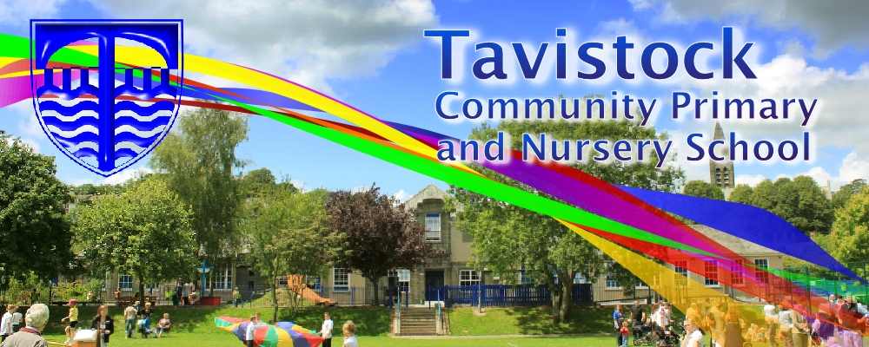

**Clubs – 25th September**

**Harvest – 2nd October**

**Parents’ Eves – 8th and 9th October**

**Goose Fair – 10th October**

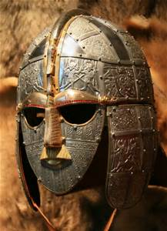

**MATHS**: In maths we are covering:

**Number sense** – understanding place value.

**Additive reasoning and multiplicative reasoning** –counting and calculating.

**English**

**Our English work will be based on the Anglo Saxon tale of Beowulf and we will use this to develop our skills in narrative writing. After this, we will be developing the appropriate structure and word choice for persuasive texts. This will be achieved through using car adverts to inspire our writing.**

**OUR THEME THIS TERM:**

**How did the Anglo Saxons change Britain?**

**Science**: The Earth and Space

**Art/DT:** Illuminated letters

**History/Geography**: Anglo Saxons

**Music:** Stop Bullying

**RE:** Beliefs and Questions

**MFL:** Everyday French

[](http://www.google.co.uk/url?sa=i&rct=j&q=CARTOON+IMAGE+OF+CHILD+READING&source=images&cd=&cad=rja&docid=GDIKGDhxjnSlLM&tbnid=28mnPTmCZ2AjFM:&ved=0CAUQjRw&url=http://www.dreamstime.com/stock-image-family-reading-cartoon-image14049521&ei=CmZeUvbNLY6whAfrw4G4Cg&psig=AFQjCNF24QcVcYTwEw65CeNPxQ38MYm6Pw&ust=1382004602345694)

**READING & SPELLING**

* Children should **read for a**
* **minimum of 15 mins** at home

every day.

* Reading books and home school diaries should come in every day.
* Children should know common words and target spellings.

Talk regularly to your child about their reading and complete their Home/School Diary.

Practise the Year 5 and 6 spellings

**Computing**

**Using ‘Scratch’ to simulate real life computer controlled systems eg. traffic lights**

**PE**

Gymnastics

Invasion Games &

Cognitive Skills



**PLEASE ENSURE THAT YOUR CHILD HAS THEIR PE KIT.**

**KIT SHOULD STAY IN SCHOOL ALL WEEK: BLACK SHORTS, WHITE T-SHIRT & TRAINERS/PLIMSOLLS.**

Our **Skill for Success** this term is **Resilience**

**HOMEWORK:**

**SET ON FRIDAYS**

**IN ON WEDNESDAYS**