|  |
| --- |
| Some new words we will be learning are; **emotion, delighted, furious, ravenous and miserable!** |

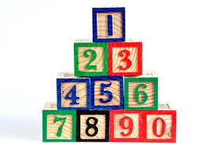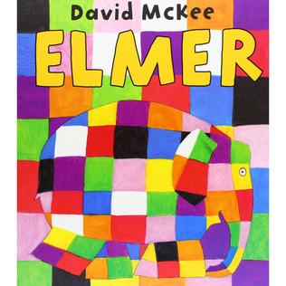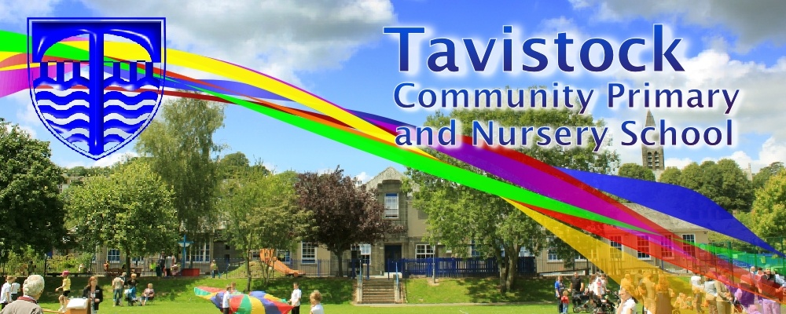

**Dates for your Diary;**

**Workshop dates to be confirmed – see newsletter**

**MATHS**: We are learning to recognise our numbers to 10 and beyond. We are learning to use 1:1 correspondence to count groups of objects and actions. We are learning about 2D shapes and their properties and using them to create patterns and build models.

**OUR THEME THIS TERM:**

**Ourselves and people who help us.**

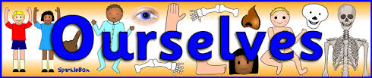

**LITERACY/COMMUNICATION AND LANGUAGE**

We will be developing our listening skills, following instructions and developing our vocabulary. Some of the stories that we will be reading are;  **Elmer, Some Dogs Do, Vegetable Glue and Hedgehugs.**

We will be learning to name letters and the sounds they make and extending our mark making skills to introduce initial sounds and whole words.

***HOW CAN YOU HELP YOUR CHILD? Count everything! Steps, shoes, buttons on coats, toys etc. Read to your child regularly and talk about the pictures and what has happened in the story. Play number games, concentrating on numbers to 10.***

***Look out for words and numbers in the environment.***

**Personal, Social and Emotional Development**

We are learning to work together, share and settling into school routines.

We will be building relationships with our friends and the adults in the school.

**Physical Development**

Experimenting with different ways of moving and using tools with more control. Learning about how to stay healthy.

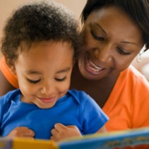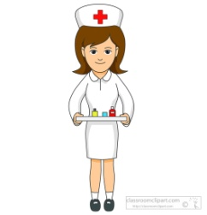

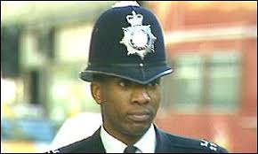

**Understanding the World**

We will be looking at people who help us and different occupations.

**Expressive Arts and Design**

Drawing, painting and model making based on our topic and using Paul Klee pictures for inspiration.

Learning songs and singing familiar rhymes and creating simple representations of events, people and objects.

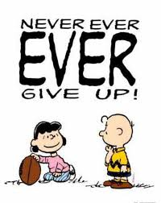

**HOMEWORK: 10-15 minutes of daily reading, including tricky words and letter sounds labelled ‘Phase 2’ in the front of our reading records.**

Our **Skill for Success** this half term is

Resilience