

**Funky Fingers**

See the funky fingers activities that are uploaded onto Tapestry under ‘**Phonics Workshop’.**

You might want to do one of these activities to a piece of music like ‘Move it, move it‘ from Madagascar.



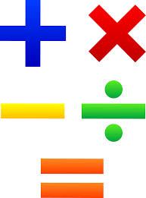

**This week in Phonics**

Use the graphemes that you were given after the phonics workshop and practise recognising the letters and their sounds.

Put the graphemes together to make simple words with. Reinforce pen grip and cursive handwriting.  
Let your child try writing words independently. (Do not ask your child to copy words you have written.)

***SELF-ISOLATION IDEAS 2021***Remember that you can upload all of your activities onto Tapestry so that we can share them with your classmates***.***

**This week in MATHS**:

Please see Helping your child learn at home in Maths that was given out after the maths workshop( we have included another copy for you)

Use BBC Iplayer to watch an episode on Numberblocks daily. Concentrate on numbers 1-10.

* <https://www.ictgames.com/mobilePage/index.html> -Maths games
* <https://whiterosemaths.com/homelearning/early-years/-> Click on early years and start at week one.

**READING**

**Read a variety of books at home. Favourites can be repeated.**

**We encourage children to read with their parents daily. Visit Oxford Owl for free E-Books linked to your child’s book band.**

***This week in STEM:***

***Use a recipe to make tea together and talk about the changes that happen to your food when it cooks –melting, frozen, solid.***

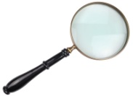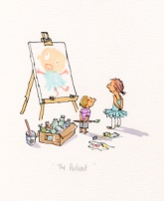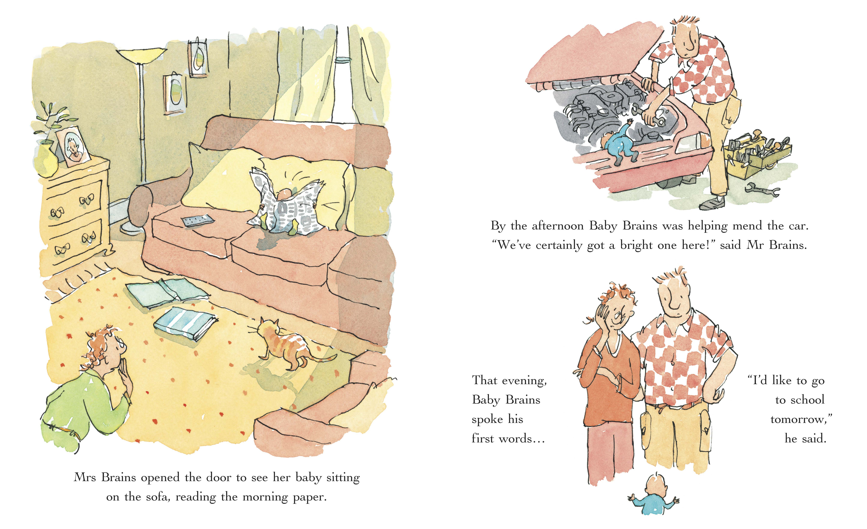



**Physical activity:**

* [www.Youtube.co.uk](http://www.Youtube.co.uk) - Jumpstart Jonny, Cosmic Kids, Just dance kids

**Art/Design Technology:**

**What can you make from a toilet roll or your recycling box?**<https://fabulesslyfrugal.com/diy/toilet-paper-roll-crafts/>

**Useful websites:**

<https://www.phonicsplay.co.uk/>

<https://www.oxfordowl.co.uk/>

<https://www.bbc.co.uk/iplayer/episodes/b08bzfnh/numberblock>

s

**Understanding the World**

Draw a simple map of your house/garden and label it. You could even hide some pretend treasure and use your map to find it.