

**ALL ABOUT NURSERY...**

Your child will change and develop a lot in their time at Nursery. These are just some of the things they may learn to do...

* Talk and listen in lots of different situations

* Pour my own drinks

* Use the toilet independently

* Remember to wash my hands

* Dress myself e.g. put on my own coat and shoes

* Make choices e.g. what I want to play with, what I would like to choose from the snack cafe

* Tell you what I have been learning

* Have a go at new things

* Not to worry if I cannot do something the first time

* Play with others and learn to take turns

* And lots more!

***Please come and talk to a member of staff if you would like to know more about our Nursery Curriculum***

**LITERACY/COMMUNICATION AND LANGUAGE**

* Listening for sounds in the environment.
* Hearing rhythm and rhyme
* Free mark making with a range of materials and media.
* Recognising and writing my name.
* Sharing fiction and non-fiction books linked to our topics.

**Autumn term topics!**

Our new topics this term will include ‘**Bonfire Night’**, ‘**Super Heroes**’, **‘Winter’** and ‘**Christmas**’.

[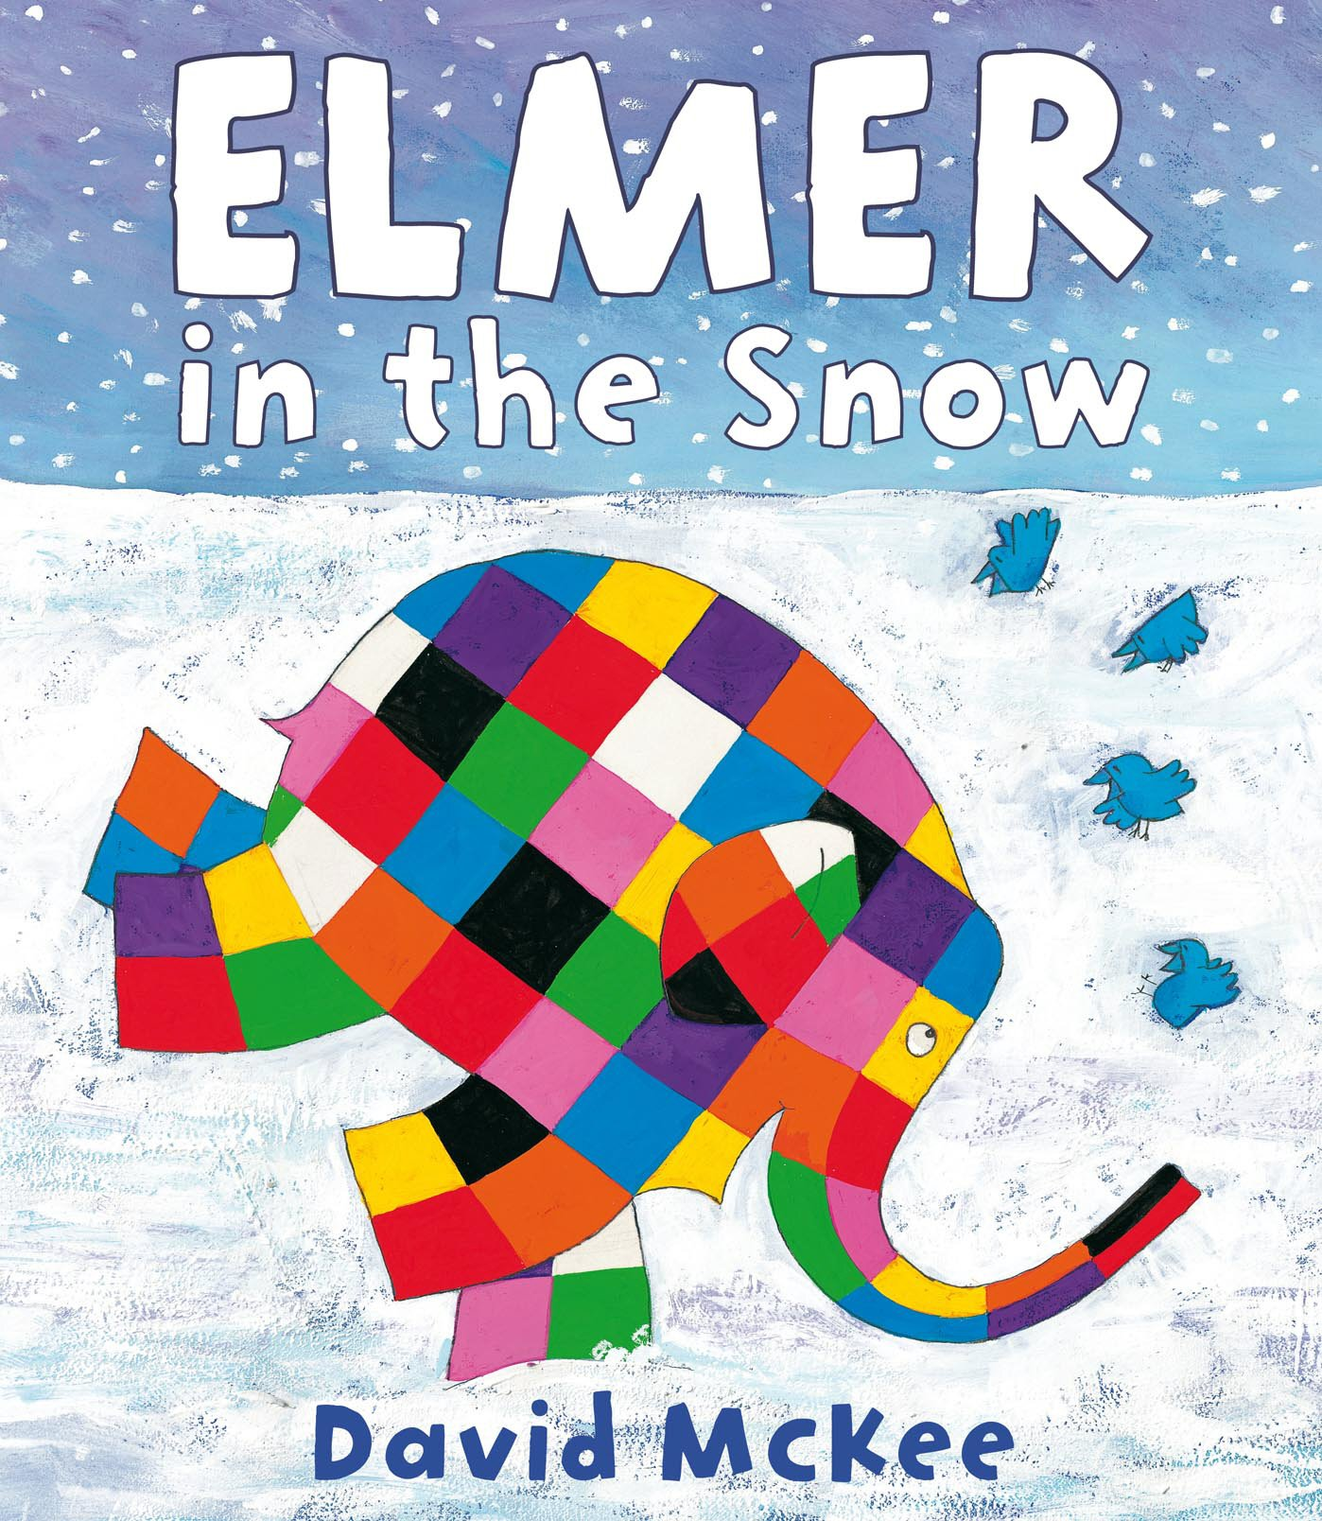](https://www.google.co.uk/url?sa=i&rct=j&q=&esrc=s&source=images&cd=&ved=2ahUKEwjpk9Sas6zeAhUDTcAKHVayCVcQjRx6BAgBEAU&url=https%3A%2F%2Fwww.amazon.co.uk%2FElmer-Snow-Picture-Books%2Fdp%2F1842707833&psig=AOvVaw21DKgr4lfL8AGHHNh1oXmE&ust=1540928237538326) [](https://www.google.co.uk/url?sa=i&rct=j&q=&esrc=s&source=images&cd=&cad=rja&uact=8&ved=2ahUKEwjivK7QtKzeAhUQe8AKHewsBkcQjRx6BAgBEAU&url=https%3A%2F%2Ffridaymagazine.ae%2Flife-culture%2Fpeople-profiles%2Fsuperhero-therapy-1.1483159&psig=AOvVaw0P-nEHzYoLXAb03NKLY7Ne&ust=1540928621495768) [](https://www.google.co.uk/url?sa=i&rct=j&q=&esrc=s&source=images&cd=&cad=rja&uact=8&ved=2ahUKEwiit7butKzeAhUrL8AKHb5tAuwQjRx6BAgBEAU&url=https%3A%2F%2Ffrodsham.gov.uk%2F2016%2F11%2Ffrodsham-christmas-tree%2F&psig=AOvVaw0w5qXD-Yg6TsjajtjCOLfA&ust=1540928691372856)



**Christmas Nativity**

**We are really looking forward to our Christmas Nativity!**

**Performances will be on 10th and 11th December.**

**[](https://www.google.co.uk/url?sa=i&rct=j&q=&esrc=s&source=images&cd=&cad=rja&uact=8&ved=2ahUKEwiA7KfQtqzeAhVqAsAKHaJIDb4QjRx6BAgBEAU&url=https%3A%2F%2Fwww.pinterest.com%2Fpin%2F387168899190279958%2F&psig=AOvVaw0kp_LHgx3rrjHh8C3jTCNQ&ust=1540929138839846)**

**Mathematics skills**

* Counting to 3, then 5, then 10 and beyond!
* Recognising and drawing numbers and matching to an amount.
* Playing number games and solving number related questions with toys.
* Singing and doing number songs and action rhymes.
* Recognising and naming the shapes around me.

[](http://www.google.co.uk/url?sa=i&rct=j&q=CARTOON+IMAGE+OF+CHILD+READING&source=images&cd=&cad=rja&docid=GDIKGDhxjnSlLM&tbnid=28mnPTmCZ2AjFM:&ved=0CAUQjRw&url=http://www.dreamstime.com/stock-image-family-reading-cartoon-image14049521&ei=CmZeUvbNLY6whAfrw4G4Cg&psig=AFQjCNF24QcVcYTwEw65CeNPxQ38MYm6Pw&ust=1382004602345694)

***How can I help my child***

***with early reading and writing?***

* Share books with them every day and talk about stories.
* Encourage them to make marks and have a go at their own writing.
* Role model reading books and writing e.g. shopping lists and cards.

**Nursery information**

* *We enjoy sharing information with you about your child’s time at Nursery. You are always welcome to ask about their day!*
* *We take part in daily physical activity as well as messy play. Please ensure that your child comes to Nursery in**named practical**clothing and has spare clothes on their peg.*



Our **Skill for Success** this term is

**Self Belief**