

Handwriting and Fluency Progression – Tavistock Primary and Nursery School
At Tavistock Primary and Nursery School we use Little Wandle phonics programme to teach letter formation in EYFS and Year 1. Cursive handwriting is introduced in year 2. Our progression document is matched to the National Curriculum expectations (2014).
All children and staff are expected to write using the cursive script and use XCCW 1a font in displays and working walls as much as possible across the school to further promote high standards of handwriting, presentation and pride in work. All staff writing on boards, in books and on displays should model this font for the pupils at the level that is expected for their class. i.e. Year 3 onwards should model a joined script.
EYFS | Daily mark making and direct teaching  Daily opportunities to improve fine motor skills
EYFS | Little Wandle used to teach letter formation - link to phonics  Planned writing opportunities in continuous provision  Funky fingers activities
EYFS | 30 - 50m | - Draws lines and circles using gross motor movements  - Holds pencil between thumb and two fingers, no longer using whole-hand grasp  - Holds pencil between near point between first two fingers and thumb and uses it with good control  - Can copy some letters e.g. in name
EYFS | 40 - 60m | - Shows a preference for a dominant hand  - Begins to use anticlockwise movement and retrace vertical lines  - Begins to form recognisable letters  - Uses a pencil and holds it effectively to form recognisable letters
EYFS | ELG | Fine Motor Skills: Hold a pencil effectively in preparation for fluent writing – using the tripod grip in almost all cases  Writing: Write recognisable letters, most of which are correctly formed;
READY TO WRITE ROUTINES | Nursery | - Gross motor warm‑ups: large shoulder/arm movements; tracing shapes in air / with large chalks  - Fine motor warm‑ups: play‑dough, threading, finger games  - Posture check: sitting position, hand support, dominant hand usage  - Mark‑making: wide brushes, chunky crayons, large movements on vertical surfaces (easel)  - Drawing / pattern work (zig‑zags, curves, circles)
READY TO WRITE ROUTINES | Notes on progression:  Teachers monitor pupils’ progress in handwriting and take action to support those who are not progressing in line with their peers:  Gradually smaller implements; move towards more control; introduce holding a pencil in tripod grip; more frequent fine motor work.
READY TO WRITE ROUTINES | Reception | - Warm‑ups: hand and finger exercises; songs or rhymes involving hand movement  - Posture and pencil grip reminder at each session  - Model correct letter formation; start practising lower‑case letters with visual/exemplar models; also capitals and digits  - Use “letter families” (letters formed in similar ways) to teach efficiently  - Use line paper (guided lines) so children practise sitting letters on line, size consistency  - Frequent short handwriting sessions (e.g. 5‑10 mins)
Notes on progression:
More letters taught; increasing accuracy in start / finish points; more consistency in size and orientation; begin to form some simple joins if/maybe some ready children

Year 1 | Daily practise of letter formation  Helping children to progress from accuracy to fluency  Direct, in the moment intervention / support / explicit feedback for individual children based on AFL (linked to sitting position, grip, letter formation)  Focus more on those children already showing signs of slipping behind
Year 1 | Use Little Wandle to teach letter formation - link to phonics  Opportunities and activities for children to improve their fine motor skills and master pencil grip
Year 1 | - Sit correctly at a table, holding a pencil comfortably and correctly (using the tripod grip in almost all cases)  - Begin to form lower-case letters in the correct direction, starting and finishing in the right place  - Form capital letters in the correct direction, starting and finishing in the right place  - Form 0-9 digits in the correct direction, starting and finishing in the right place  - Understand which letters belong to which handwriting ‘families’ (i.e. letters that are formed in similar ways) and to practise these  - Leaving spaces between words
READY TO WRITE ROUTINES | - Warm‑ups continue: refine grip, finger strength  - Formal discrete handwriting lessons daily  - Teach all lower‑case letters, capitals, digits with correct formation, orientation, size  - Practice high‑frequency / common exception words with correct formation  - Introduction to the simplest joining strokes if ready (some schools start late in Year 1)  - Regular modelling by teacher; visual reminders around classroom (alphabets, correct formation)
READY TO WRITE ROUTINES | Notes on Progression:  Teachers monitor pupils’ progress in handwriting and take action to support those who are not progressing in line with their peers:  Increase speed, consistency; reduce lifting of pencil where appropriate; more automatic formation; less need for visual cues; begin uniformity in letter height, baseline alignment, consistent spacing between letters and words.
Year 2 | Teach and practise correct cursive letter formation typically 3 times a week  Write with a joined style as soon as they can form letters with horizontal/diagonal joins formed correctly  Direct, in the moment, intervention / support / explicit feedback for individual children based on AFL  Continue to monitor and address seating position and grip  Teachers focus explicitly on those falling behind or with specific areas for development such as grip.
Year 2 | Begin with a handwriting warm up and remind children of pencil grip, paper orientation and sitting position  Model the formation of each letter, give time for independent practise then apply – link to spelling  Once completed, model joins. Once children have sufficiently practised the join, class teacher model different words with the join, for children to practise.
Year 2 | - Correct pencil grip (using the tripod grip in almost all cases)  - Knows the diagonal and horizontal strokes needed to join and those unjoined  - Form lower-case letters of the correct size relative to one another  - Start joining some of the letters and understand which letters, when adjacent to one another, are best left unjoined  - Write capital letters and digits of the correct size, orientation and relationship to one another and to lower-case letters

- Use spacing between words that reflects the size of the letters
- (Revision of previous years’ handwriting where appropriate)
READY TO WRITE ROUTINES | - Warm‑up fine motor / hand exercises at start of handwriting sessions  - Discrete handwriting lessons: focus on introducing and practising joins (horizontal / diagonal), learning which letters join and which are “break letters”  - Consolidate letter formation (lower‑case, capitals, digits) with joins applied in writing words, short texts  - Practice spacing, size consistency, slope / slant (if part of style)  - Use lined or appropriate paper to help alignment and margins  - Frequent short‑dictation or copying wherein focus is on neatness, formation, joins
READY TO WRITE ROUTINES | Notes on progression:  Teachers monitor pupils’ progress in handwriting and take action to support those who are not progressing in line with their peers:  Fluency improves; less conscious effort; joined writing more automatic; ability to maintain legible joined script in independent writing; start to use cursive or semi‑cursive style more consistently.
Year 3 | Typically a weekly discrete handwriting lesson and twice weekly handwriting practice using Year 3/ 4 and personal spellings  Direct, in the moment, intervention / support / explicit feedback for individual children based on AFL
Year 3 | Begin with a handwriting warm up and remind children of pencil grip, paper orientation and sitting position (where appropriate)  Refine letter formation  Start with ladder letters and then progress through each letter family (see appendix 2) - the speed of this is at the discretion of the teacher  Once completed each letter, work through letter joins (in order) bottom joins first, top exit to ‘e’ and then top exit letter joins. Once children have sufficiently practised the join, class teacher model different words with the join, for children to practise. Children can then write their own sentences using some of the practised words.
Year 3 | - use joined handwriting throughout all independent writing, support given to increase fluency and speed which will then support composition and spelling  - Use the diagonal and horizontal strokes that are needed to join letters and understand which letters, when adjacent to one another are best left unjoined Increase the legibility, consistency and quality of their handwriting (e.g. parallel and equidistant downstrokes) and that lines of writing are sufficiently spaced so that ascenders and descenders of letters do not touch. (Revision of previous years’ handwriting where appropriate)
READY TO WRITE ROUTINES | - Warm‑ups still included in handwriting sessions (finger / wrist exercises etc.)  - Regular handwriting sessions one or more per week, plus embedding into writing across the curriculum  - Emphasis on quality of joins, ensuring smooth transitions, consistent slant / slope where applicable  - Review and correct any bad habits or mis formed letters; teachers model correcting formation live  - Begin increasing writing speed while keeping legibility; timed short writes paying attention to handwriting presentation  - Peer / self-check with set criteria: letter size, baseline, spacing, joins, slope  -Dictation is regularly used to apply skills. Teacher uses this time to focus on one-to-one intervention to address incorrect handwriting.
READY TO WRITE ROUTINES | Notes on progression:  Teachers monitor pupils’ progress in handwriting and take action to support those who are not progressing in line with their peers:  More independent responsibility; fewer prompts; faster pace; neat, joined handwriting across subjects; begin differentiating styles (e.g. neat final draft vs quick notes)
Year 4 | Typically, a weekly discrete handwriting lesson and twice weekly handwriting practise using Year 3/ 4 and personal spellings  Direct, in the moment, intervention / support / explicit feedback for individual children based on AFL
Year 4 | Recap specific letters where appropriate  Begin with a handwriting warm up and remind children of pencil grip, paper orientation and sitting position (where appropriate)  Recap specific tricky letters from AfL, then work through letter joins (in order)

 | Once children have sufficiently practised the join, class teacher model different words with the join, for children to practise. Children can then write their own sentences using some of the practised words.
- Use joined handwriting throughout all independent writing support given to increase fluency and speed which will then support composition and spelling
- Use the diagonal and horizontal strokes that are needed to join letters and understand which letters, when adjacent to one another are best left unjoined (e.g top joins to bottom joins)
- Increase the legibility, consistency and quality of their handwriting (e.g. parallel and equidistant downstrokes) and that lines of writing are sufficiently spaced so that ascenders and descenders of letters do not touch
- (Revision of previous years’ handwriting where appropriate)
READY TO WRITE ROUTINES | -Warm‑ups or quick drills at start to refresh and solidify joins, formation  - Regular taught handwriting / practise, modelling and monitoring  - Focus on advanced consistency: spacing, uniformity of slant, ascenders / descenders, proportion  - Encourage writing with flow: minimal pencil lifts, more fluid motion  - Focus also on speed with legibility maintained  - Children reflecting on their handwriting (self‑assessment) and setting improvement goals  - Dictation is regularly used to apply skills. Teacher uses this time to focus on one-to-one intervention to address incorrect handwriting.
READY TO WRITE ROUTINES | Notes on progression:  Teachers monitor pupils’ progress in handwriting and take action to support those who are not progressing in line with their peers:  Greater fluency: neat, joined handwriting becomes more “automatic”; ability to adapt style for purpose; quality in presentation even under pressure / time constraints
Year 5 | Typically, a weekly discrete handwriting lesson and twice weekly handwriting practise using Year 5/6 spelling list and personal spellings  Direct, in the moment, intervention / support / explicit feedback for individual children based on AFL
Year 5 | Recap any difficult letters and joins using AfL  Practise spellings – teacher to model  Write sentences to finish
Year 5 | - Children should be aware of draft and best handwriting styles for different purposes  - Write legibly, fluently and with increasing speed  - Vary letter shape for effect Choose the best writing implement for the task  - Print as appropriate e.g. algebra/emails  - (Revision of previous years’ handwriting where appropriate)
READY TO WRITE ROUTINES | - Warm‑ups continue, perhaps more subtle: e.g. drills for tricky joins, transitions, tricky letters  - More independent handwriting practise: writing of longer texts, cross‑curricular writing, with teacher feedback on handwriting  - Emphasis on speed + stamina: handwriting over longer periods, writing more under time constraints  - Using different styles where needed (e.g. unjoined for diagrams, print for labels etc.)  - Ensuring legibility remains even at speed; regular self / peer checking of presentation  - Reinforce posture, grip, consistency as needed for those slipping  - Dictation is used regularly to apply skills. Teacher uses this time to focus on one-to-one intervention to address incorrect handwriting.
READY TO WRITE ROUTINES | Notes on progression:  Teachers monitor pupils’ progress in handwriting and take action to support those who are not progressing in line with their peers:  High standard of consistency, style, speed; handwriting does not interfere with writing content; children have a personal, neat, legible style; can adapt for purpose / audience
Year 6 | Typically, a weekly discrete handwriting lesson and twice weekly handwriting practise using Year 5/6 spelling list and personal spellings  Direct, in the moment, intervention / support / explicit feedback for individual children based on AFL
Year 6 | Recap any difficult letters and joins  Practise spellings  Write sentences to finish
Year 6 | - Children should be aware of draft and best handwriting styles for different purposes  - Write legibly, fluently and with increasing speed Vary letter shape for effect  - Choose the best writing implement for the task
 | ● | Print as appropriate e.g. algebra/emails
 | ● | (Revision of previous years’ handwriting where appropriate)
READY TO WRITE ROUTINES |  | - Warm‑ups / refreshers for any weak joins or letters; work on fluency  - Regular handwriting in final drafts; good presentation expected in all subjects; children aware of what is expected for finished vs rough work  - Timed writing tasks where handwriting quality counts (so practice under pressure)  - Use of handwriting as part of assessment of presentation (books etc.)  - Child self‑evaluation: what are my strengths / what could be neater?  - Flexibility: deciding when print might be better (labels, forms etc.) and applying unjoined style where needed  - Maintaining speed + legibility, even in exams, cross‑curriculum tasks  - Dictation is regularly used to apply skills. Teacher uses this time to focus on one-to-one intervention to address incorrect handwriting.
READY TO WRITE ROUTINES | Notes on progression:  Teachers monitor pupils’ progress in handwriting and take action to support those who are not progressing in line with their peers:  Automatic, fluent, legible joined handwriting; presentation is a matter of pride; handwriting does not slow down composition; task‑dependent style adaptation; consistency across all writing contexts.
SEND  And pupils who struggle with handwriting and are at risk of falling behind. |  | Pupils who are not making expected progress or have been identified as having gaps in their handwriting skills must be supported through in the moment assessments during all lessons that involve writing, wherever possible. They must also have regular 1-1 or small group handing writing support, in addition to the OAIP led by their class teacher. The class teacher will liaise with the SENDCo, and the SENDCo will support the implementation of this, where needed. Additional resources may be trialled, such as pencil grips or writing slopes etc, to support pupils. SEE BELOW

Tier 1  OAIP |  | Tier 2 |  | Tier 3
Area | Action/Strategy |  | Action/Strategy | Area | Action/strategy
  Area
Seating & Posture | Ensure feet flat on floor, 90-degree angle at knees, desk at elbow height, chair supports lower back. Small adjustments (e.g. footstool) as needed. |  | Observe for poor fine motor control, visual perception issues, or fatigue. | OT/External Input | SENDCO to seek further advice from OT or handwriting specialist
  Assess Underlying Difficulty
Grip & Pencil Control | Explicitly teach tripod grip. Use short pencils, triangular grips, or adaptive pencils if grip is poor. Monitor and model regularly. | Intervention Groups | Sessions 3x a week, focusing on: letter families, joins, spacing, fluency | Long term adaptations | Adapt expectations for output in certain subjects. Consider scaffolded templates, scribe support, or reduced writing tasks.
Letter Formation | Daily modelling of correct formation. Use guided, traced, copied, then independent practice. Emphasise start/end points, correct direction. | Fine Motor Interventions | Activities: tweezers, Lego, threading, scissors, peg boards. | IEP of SEND support plan | Write SMART handwriting targets on an IEP or SEND support plan. Regular review with pupil, parent, SENCo.
Paper Positioning | For right-handers: top-right corner angled up slightly. For left-handers: top-left corner angled up. Avoid vertical positioning. | Handwriting Focus Time | 1:1 or paired conferencing with pupil — show examples of expected handwriting, agree targets (e.g. spacing, size), track progress | Access Arrangements | Consider formal assessment for access arrangements in tests (scribe, extra time, use of word processor) if appropriate.
Line Guides | Use wider lined paper, coloured lines, or highlighted margins to support spacing and alignment. | Alternative Resources | Use adapted line guides, larger pencils, pencil grips, sloped writing boards, or stabilising writing surfaces. Trial until best fit found.
Motor Warm-Ups | 2–3 minutes of fine motor exercises (finger walks, dough, threading, hand push-ups) before writing. | Short Writing Bursts | Allow writing in short intervals with frequent breaks. Focus on stamina building.
Fluency Practice | Use short speed-writing exercises focusing on consistency, not just neatness. | Feedback & Self‑Monitoring | Use handwriting targets or checklists. Pupils reflect on improvements (e.g. "Which letter was best today? Why?").
Visual Modelling | Show model handwriting in real-time. Use visualisers or anchor charts. Encourage slow, careful formation. | Technology Consideration | Trial keyboard/voice-to-text use if handwriting becomes a barrier to composition. Introduce touch typing programme if appropriate (e.g. BBC Dance Mat, Nessy Fingers).
Pen Licence
A Pen Licence may be awarded at the class teacher’s discretion once a child consistently demonstrates fluent, legible handwriting and meets all non-negotiable presentation standards in their work. If a teacher is unsure whether a child meets the criteria, they should consult the Headteacher.
Appendix
Appendix 1: National Curriculum
Appendix 2: Letter Families (order for teaching each letter) and diagonal and horizontal joins
Appendix 3: School script
Appendix 4 - Seating Position (to be referred to at the start of lessons)
Appendix 5 - Tripod Pencil Grip (to be referred to at the start of lessons)
Appendix 6: Handwriting Warm-Ups
National Curriculum:
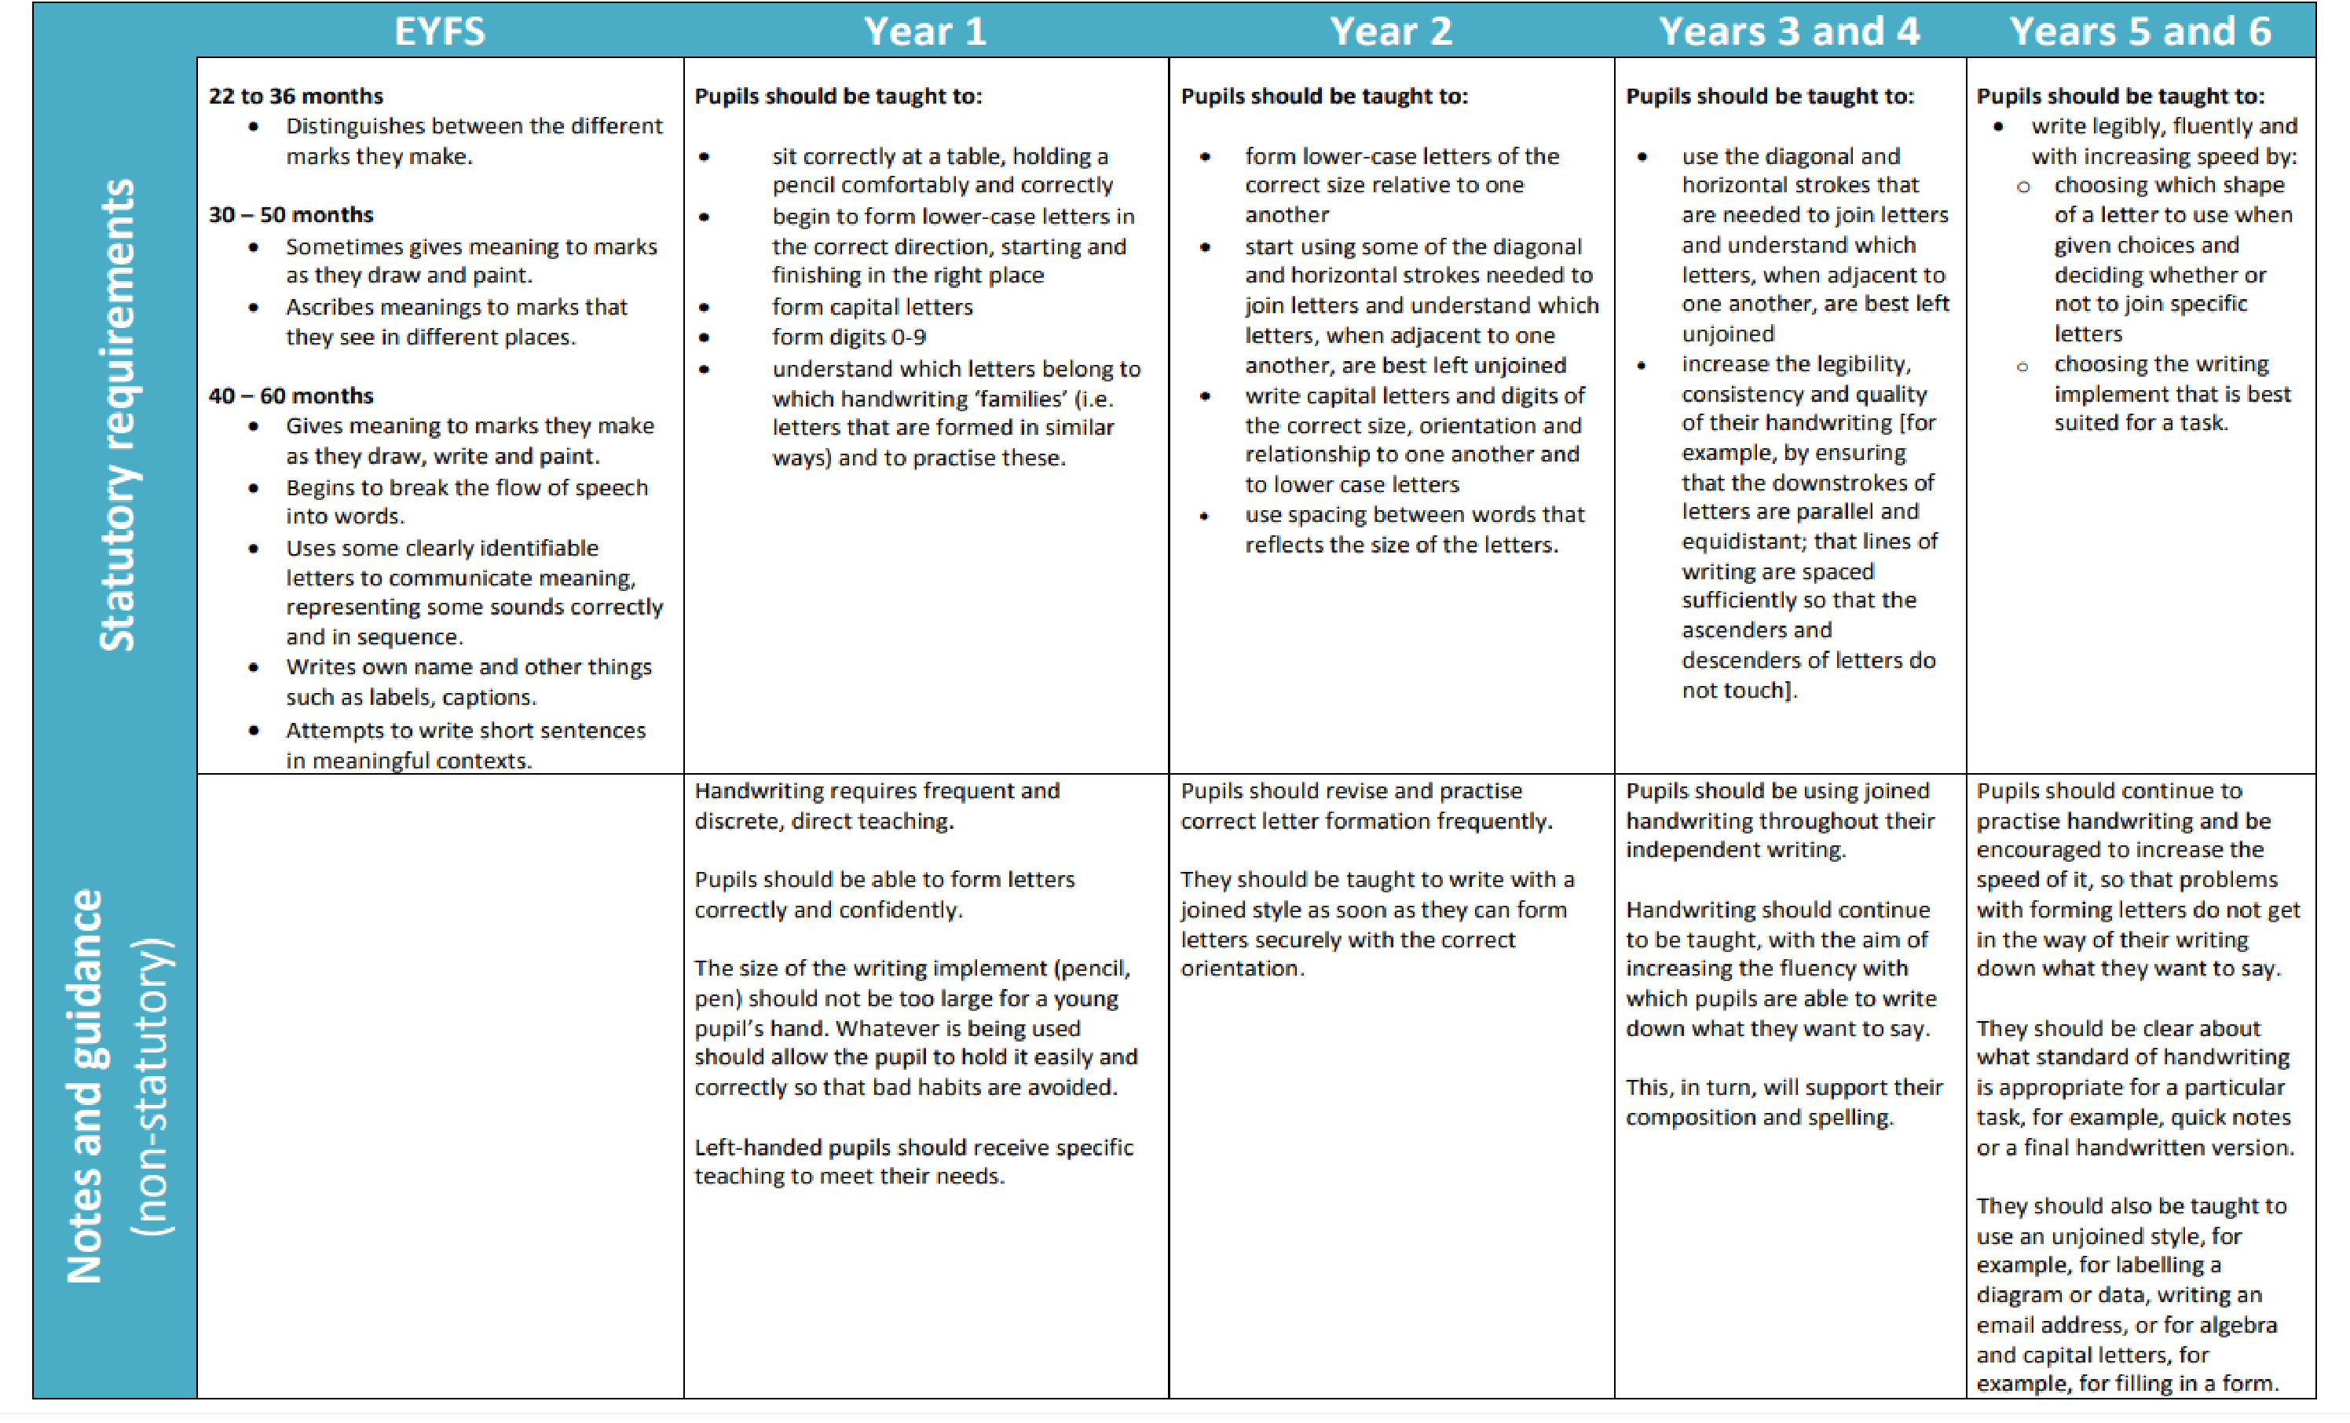
Appendix 2:
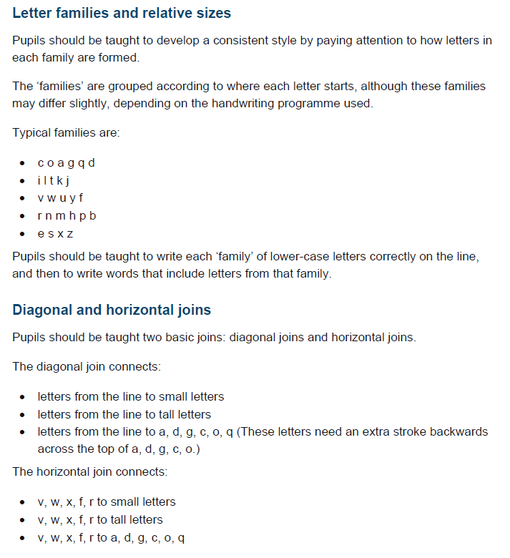
Appendix 3: school script: including types of join

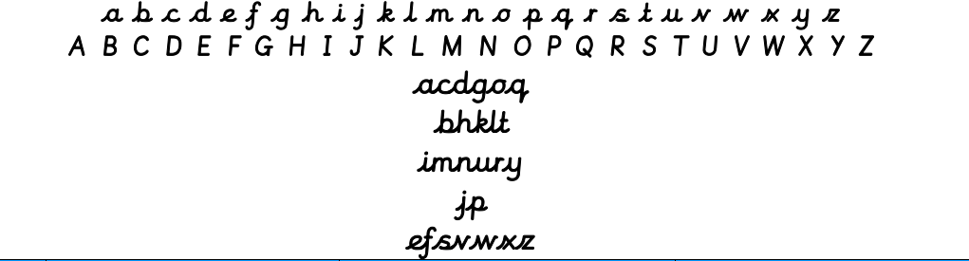

Appendix 4 and 5 – notes from Writing Framework 2025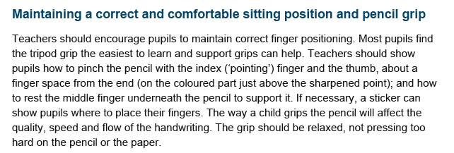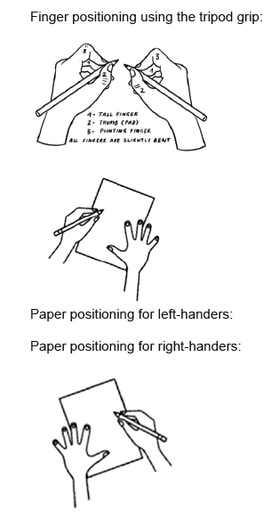

Appendix 4 - Seating Position (to be referred to at the start of lessons)
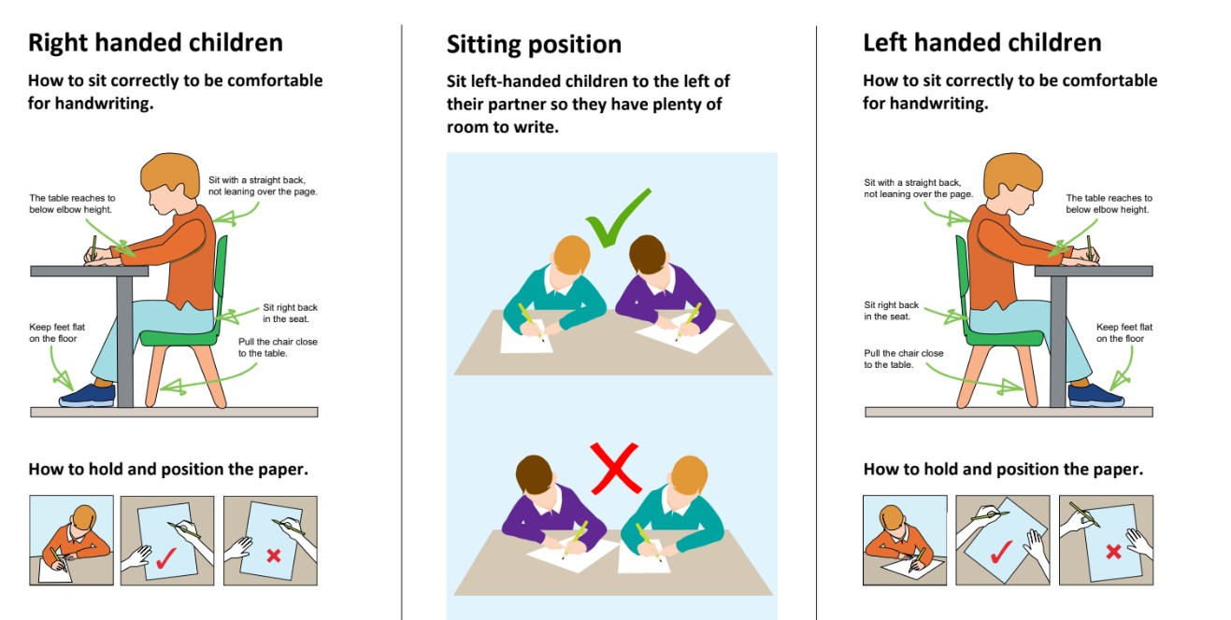

Appendix 5 - Tripod Pencil Grip (to be referred to at the start of lessons)
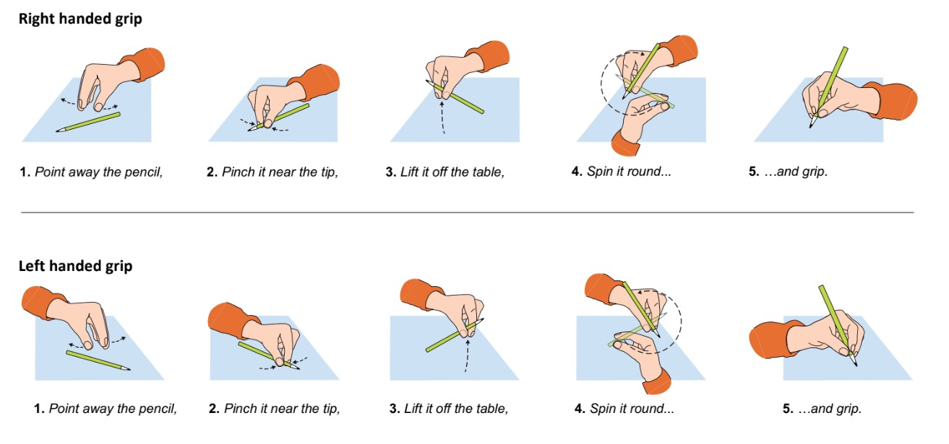

Appendix 6 - Handwriting Warm Ups

