Year 3/4 Project Homework
This term’s project homework allows you to choose from a range of subjects and create almost anything you like! Below is a list of what we will be studying next term in specific subjects, with some suggestions of activities that you could do. Choose something from the list (or come up with your own idea) that is linked to the curriculum next term and bring your project homework in by Monday 10th November.
Have fun, we look forward to seeing what you create!

In History we will be studying The Mayans  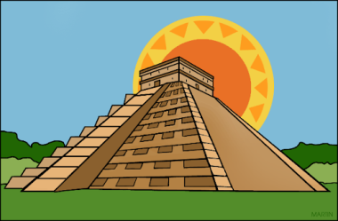 | For your homework you could…  - Create a timeline from the Mayan times to now  - Compare the Mayan times with modern day  - Research a Mayan site  - Create a Mayan artefact
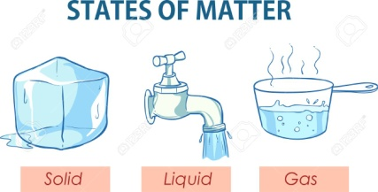  In Science we will be studying States of matter | For your homework you could…  - Research the different states of matter (solid, liquid and gas)  - Create a states of matter poster  - Organise a states of matter experiment
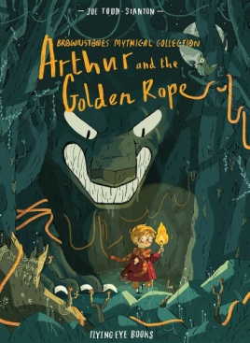  In English we will be creating a quest story inspired by inspired by the book ‘Arthur and the Golden Rope by Joe Todd Stanton’ | For your homework you could…  - Create a word bank of words that would be suitable for a quest story  - Rewrite the story with a new character on a new quest.  - Create a comic book of your own quest story.
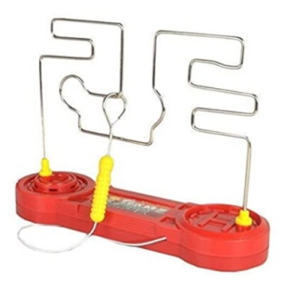  In Design Technology we will be creating a steady hand game linked to electrical systems | For your homework you could…  - Play a steady hand game like operation  - Research how a steady hand game works  - Design or make your own steady hand game
In Maths Year 3’s are working on numbers to 1000 and Year 4’s are working on the 3,6,9 times tables  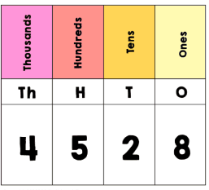 | Year 3s, for your homework you could…  - Choose a 3 digit number and represent it in different ways (cherry model, place value chart etc)  - Mind map around a 3 digit number as many ways to create it as a number sentence e.g. 365 could be 300 + 60 + 5 | Year 4s, for your homework you could…  - Make a times table poster  - Create patterns in groups of 3, 6 or 9  - Join in with the 3,6 and 9 times table tournament on TTRS.

