Year 5 Project Homework
This term’s project homework allows you to choose from a range of subjects and create almost anything you like! Below is a list of what we will be studying next term in specific subjects, with some suggestions of activities that you could do. Choose something from the list (or come up with your own idea) that is linked to the curriculum next term and bring your project homework in by Monday 2nd March
Have fun, we look forward to seeing what you create!

In Geography we will be studying human and physical features  | For your homework you could…  - Research human and physical features  - Create a fact file about a European country and its features
In Science we will be studying everyday materials   | For your homework you could…  - Group objects around your house based on hardness/material/flexibility  - Explore magnetic materials around your home  - Create a poster about different materials around your home and their purpose  - https://www.bbc.co.uk/bitesize/topics/zq4skhv
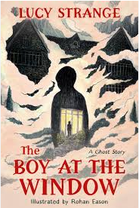  In English we will be creating a mysterious story where a character is trapped. | For your homework you could…  - Create a word bank of words that would be suitable for a mysterious story  - Write a story about a character getting trapped
In Art we will be creating a relief print based on Delitia Martin  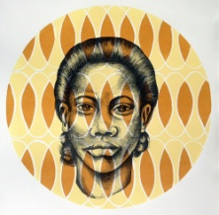 | For your homework you could…  - Research Delitia Martin and her work  - Create your own artwork inspired by Delitia Martin  - Draw a self-portrait
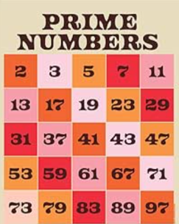  In Maths we will be learning about factors, multiples and prime numbers | For your homework you could...  - Choose 3 numbers and write down all of their factors  https://www.bbc.co.uk/bitesize/topics/zfq7hyc/articles/zp6wfcw  - Find all the prime numbers between 1 and 50 https://www.bbc.co.uk/bitesize/topics/zfq7hyc/articles/z2q26fr#zy873qt

