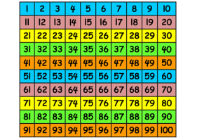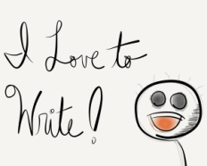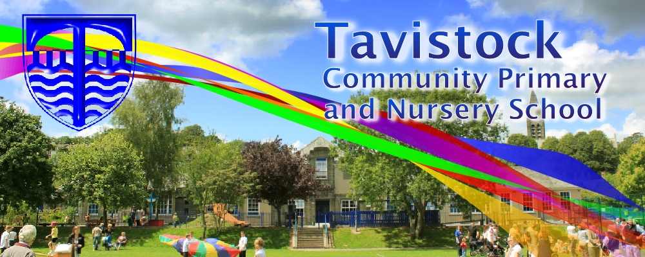 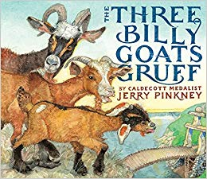

**ENGLISH**

**Our English work will include:**

* Traditional Tales – The 3 Billy Goats

Gruff

* Nonsense Rhymes
* Dogger by Shirley Hughes
* Developing reading comprehension

and inference skills

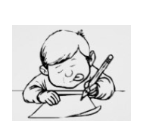

**This term we are going to be exploring:**

**Art/DT:** the artist Adam Bunce and creating Dartmoor images influenced by his work

**Music:** Singing and playing glockenspiels

**PSHCE:** Relationships, growing and changing

**Computing:**  Using classification and design programmes

**PE:** Team games and

Coordination with bats and

balls

**MATHS**: This term, we will be learning:

* Properties of 2D and 3D shapes
* Describe position, direction and movement
* Counting in multiples of 2, 5 and 10
* Measurement – time: seconds, minutes, hours and weight: choosing the appropriate unit and reading scales
* Place value to two digits
* Reading and writing numbers in numerals and words to 20 (Y1) and 100 (Y2)

**DATES FOR YOUR DIARY**

* **W/C 23.4 Walk to Meadows to trip trap over the bridge**
* **W/C 20.5 Visit to the Synagogue in Plymouth**
* **W/C 24.5 – Art show for parents**
* **Y2 SATs w/c 7.5.19 - reading and w/c 20.5.19 - maths**

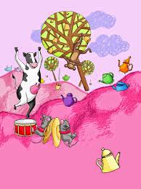 

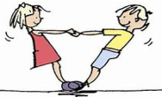

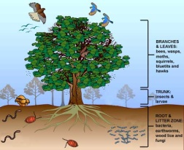

***SCIENCE***

* Living things and

their habitat

* Plants as food
* Micro habitats

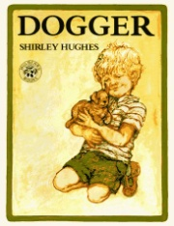

**RE**

**LOVING READING**

Ask your child:

* to tell you about the book so far – what has happened
* to give alternative meanings for words and phrases
* what the author is telling the reader
* Judaism and a visit to the Synagogue
* Religious symbols and their meanings





**KIT SHOULD STAY IN SCHOOL ALL WEEK: BLACK SHORTS, WHITE T-SHIRT & TRAINERS/PLIMSOLLS.**

**HOMEWORK:**

**SET ON FRIDAY: IN ON THURSDAY**

**SPELLING TEST ON FRIDAY**

Our **Skill for Success** this half term is

**Co-operation**