|  |
| --- |
| New words we will be learning this term: **blustery, delicate, hibernate, melting, spectacular and freezing.** |

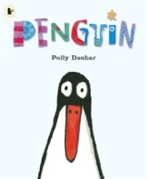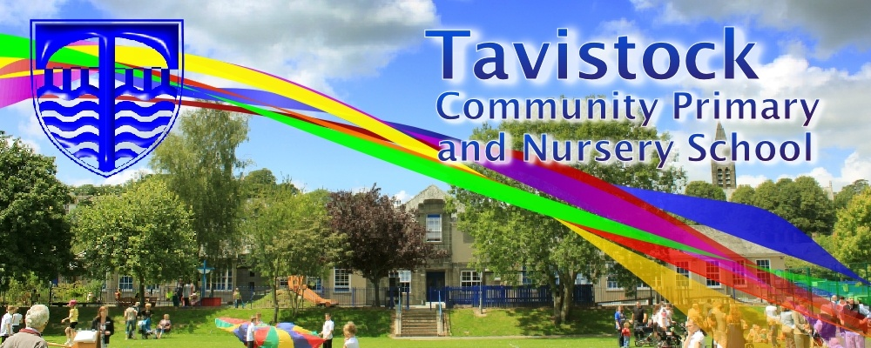[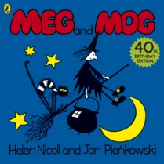](https://www.google.co.uk/url?sa=i&rct=j&q=&esrc=s&source=images&cd=&cad=rja&uact=8&ved=0ahUKEwiKjLXe55jXAhWK6xQKHcpXCOYQjRwIBw&url=https%3A%2F%2Fwww.amazon.co.uk%2FMeg-Mog-Helen-Nicoll%2Fdp%2F071819442X&psig=AOvVaw0AZDpKhhe2axot7Rkdxmh3&ust=1509468831512690)

**Dates for your Diary;**

**Developing Early Literacy -15/11/18**

**Maths in the Early Years- 23/11/18**

**Nativity Performance 10/12/18 (pm) & 11/12/18 (am)**

**MATHS**: We are learning to count and order our numbers to 10, place them in order and recognise small numbers without the need to count them. We are beginning to say one more and one less than a given number and begin to use the vocabulary involved in adding and subtracting. We will be learning about parts and wholes of objects and 2D shapes and beginning to use everyday language related to money.

**OUR THEME THIS TERM:**

**Winter Festivals and Celebrations.**

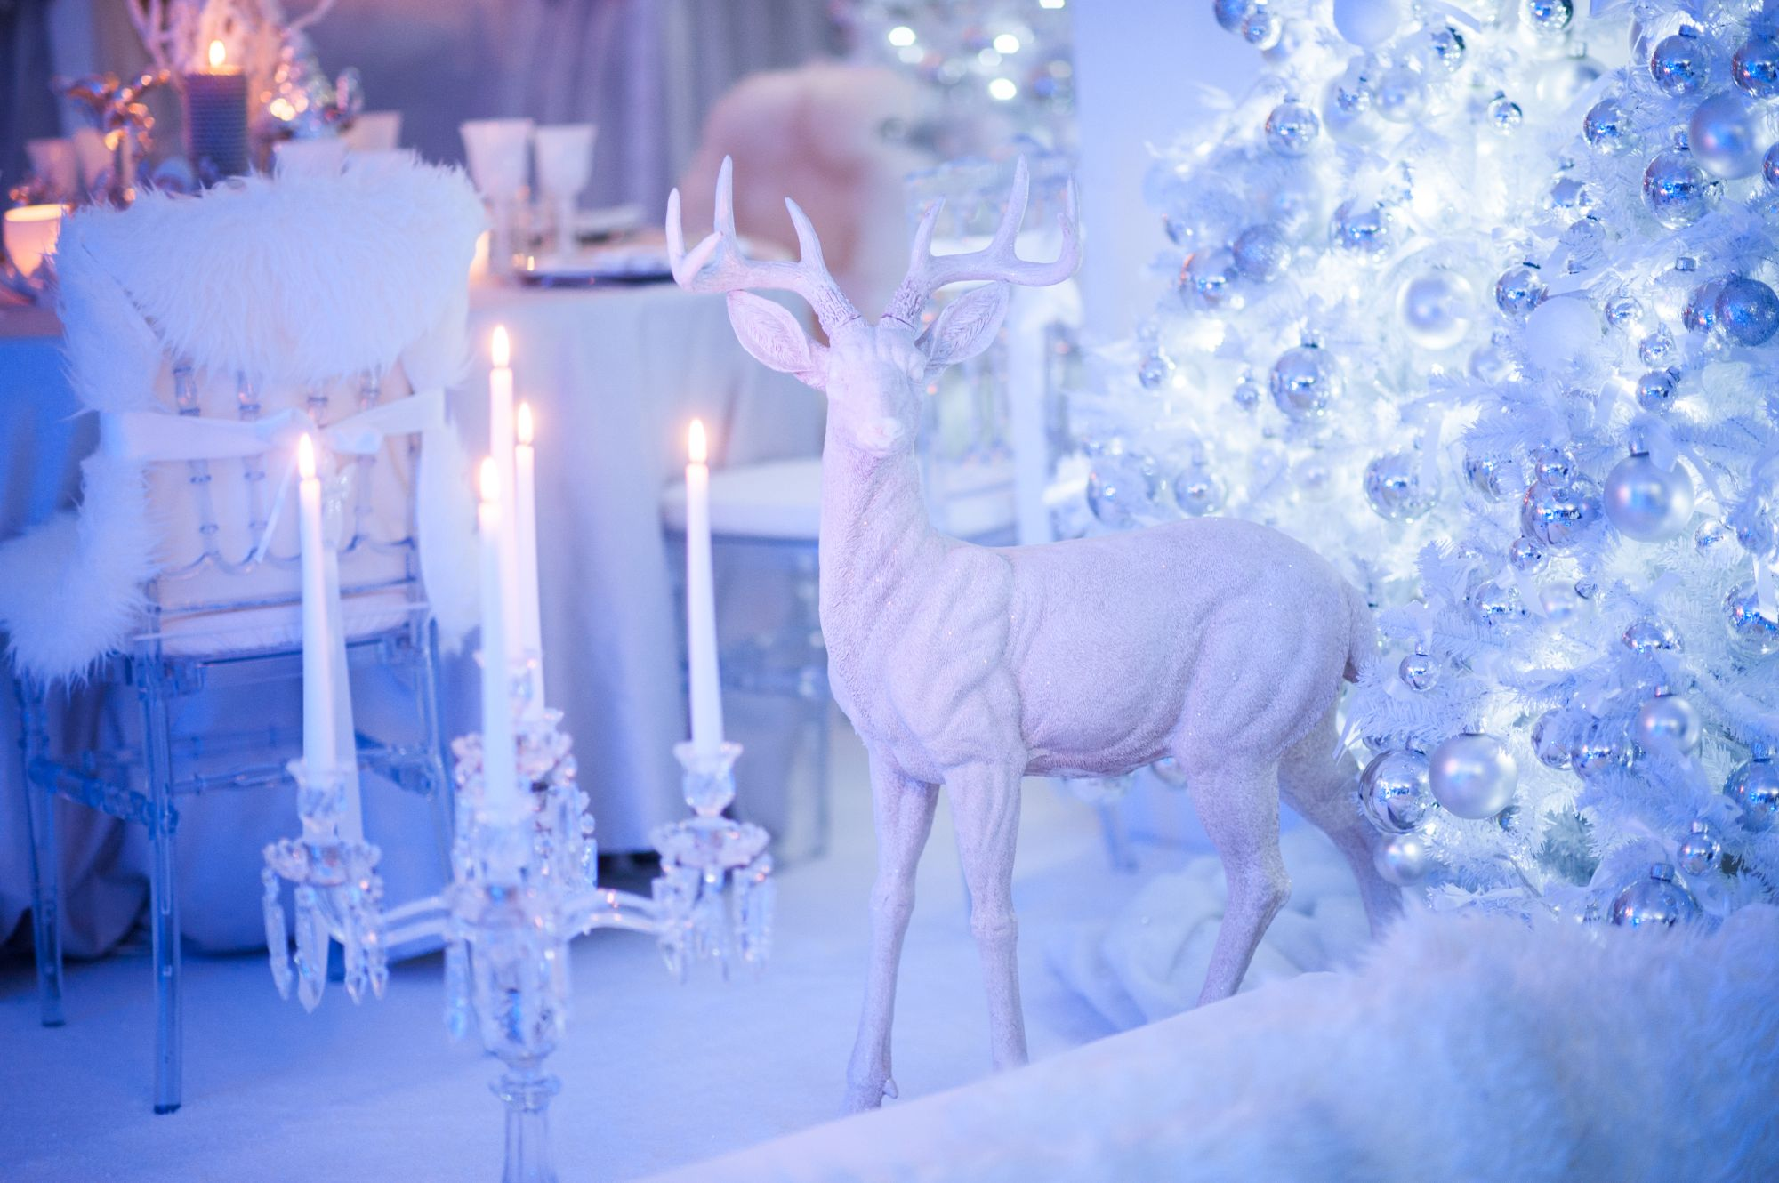

**LITERACY/COMMUNICATION AND LANGUAGE**

We will be developing our listening skills, listening to oral stories and developing our vocabulary. Some of the stories that we will be reading are;  **Meg and Mog, A Little Bit of Winter, Stick Man, Father Christmas Needs a Wee, Penguin and The Nativity Story.**

We will be moving onto Phase 3 letters and sounds, please look in the front of your reading diaries.

***HOW CAN YOU HELP YOUR CHILD?***

* ***Read to your child regularly and talk about the what has happened in the story and what they think may happen next.***
* ***Support them to blend the letter sounds they know together.***
* ***Play number games, concentrating on numbers to 10 and 20***
* ***Look out for words, numbers, shapes and patterns in the environment.***

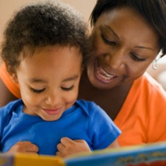

**Personal, Social and Emotional Development**

.

We will be learning to share resources and how to work co-operatively and how we can achieve things by having a ‘can do’ attitude

**Physical Development**

We will be developing confidence, control and co-ordination in large and small scale movements. We will be learning how to use tools safely.

[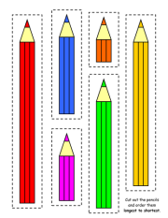](https://www.google.co.uk/url?sa=i&rct=j&q=&esrc=s&source=images&cd=&cad=rja&uact=8&ved=0ahUKEwjJqrei6pjXAhWCUhQKHXdFAcgQjRwIBw&url=https%3A%2F%2Fwww.tes.com%2Fteaching-resource%2Flength-worksheets-6229111&psig=AOvVaw3d8Su2nKZhPGHvz2wFjWqV&ust=1509469509138081)

**Understanding the World**

We will be talking about getting ready for celebrations and how they differ in our households. We will be looking at changes in the environment linked to the Seasons. We will also be finding out about penguins and polar bears and using Google Earth.

**Expressive Arts and Design**

We will be singing, dancing and acting to do with our topic, including learning our Christmas Performance.

We will be using different materials for specific purposes and looking at how they change.



**HOMEWORK: 10-15 minutes of daily reading, including tricky words and letter sounds labelled ‘Phase 2’ in the front of our reading diaries. Some books are labelled ‘shared books’. Please read together, with your child picking out as many of the words as they can and using the pictures to help.**

Our **Skill for Success** this term is

Self-Belief