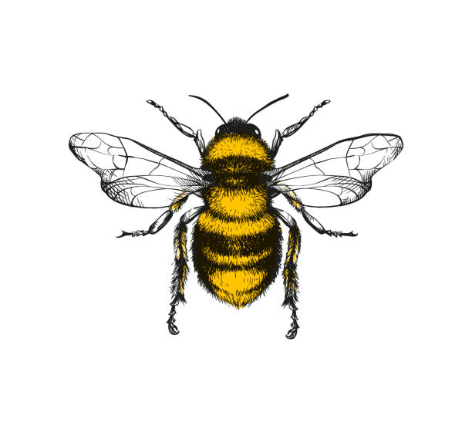

**Expressive Arts and Design**  
Children will be able to express themselves and their work creatively and imaginatively, drawing from a range of different mediums.

.

To explore colour matching, sorting and mixing.

To explore a range of textures within materials.

To know the potential of drawing tools,

To explain the processes used to make a piece of Art.

To investigate the quailities of 3D materials.

To perform in front of others.

To know and sing a range of Nursery Rhymes and songs.

To learn about music from different cultures/ countries.

To make music with different instruments.

To respond to the work of an artist.

To investigate how to apply materials to one another.

To explore the concept of mono printing.

To understand the concept of balancing within construction.

To explore ways that materials can be decorated.

To explore cutting, tearing and gluing.

To explore a range of mark making.

To move in different ways to pieces of music.

To provide opportunities and props for role play.

To move with enjoyment and in time to different types of music.

To see a live performance of the Arts.

To listen to and discuss changes in musical pieces.

To learn to hold drawing /painting tools correctly.

To use simple weaving to create a pattern.

To create 2D and 3D designs.