

Dates for your Diary:

Governors’ Board - 15th Jan

School Census Day – 17th Jan

Parents’ Evenings - 4th and 6th Feb

Internet Safety Day – 5th Feb

Governors’ Board – 5th Feb

Cross Country – 12th Feb

**ENGLISH**

**This term we are reading the book ‘Bill’s New Frock’ by Anne Fine. This is a story where Bill wakes up one morning and he is a girl. It is a really, fun and engaging text that will inspire the children to write their own story where someone has woken up as something different.**

**Next, we will look at a short film and use it to write our own engaging story where we will need to think about the vocabulary we use to paint a picture in the readers head and use dialogue to move the story forward.**

**Lastly, the children will be looking at Howard Carter’s diary entries from when he made his magnificent discovery of Tutankhamen’s tomb. The children will then use their knowledge from our History lessons to write their own account of a discovery of a tomb.**

**OUR THEME THIS TERM:**

**Ancient Egyptians**

**Science**: Light

**Computing:** Opinion Polls

**Music:** Three Little Birds

**PE:** Tennis and Personal Skills

**MFL:** Classroom instructions, greetings, questions and answers.

**RE:** Inspiration

**Art:** Ancient Egyptian Art

**MATHS**:

Fractions

Addition and Subtraction

Place Value

MC900233964[1]

***HOW CAN YOU HELP YOUR CHILD?***

***Listen to your children read on a regular basis and discuss what has been read.***

***Encourage a wide variety of texts.***

***Practise times tables.***

[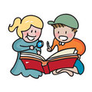](http://www.google.co.uk/url?sa=i&rct=j&q=CARTOON+IMAGE+OF+CHILD+READING&source=images&cd=&cad=rja&docid=GDIKGDhxjnSlLM&tbnid=28mnPTmCZ2AjFM:&ved=0CAUQjRw&url=http://www.dreamstime.com/stock-image-family-reading-cartoon-image14049521&ei=CmZeUvbNLY6whAfrw4G4Cg&psig=AFQjCNF24QcVcYTwEw65CeNPxQ38MYm6Pw&ust=1382004602345694)

**READING & SPELLING**

* Children should **read for a minimum of 15**

**minutes** at home every day.

* Reading books and home school diaries

should come into school every day.

* We will be concentrating on **spelling and grammar** this year including the national curriculum, compulsory list of year 3 and 4 words (provided in the home school diary) which we will test the children on each week.

**History:**

**Ancient Egyptians**

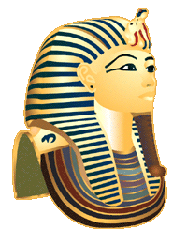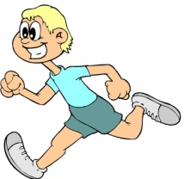

**KIT SHOULD STAY IN SCHOOL ALL WEEK: BLACK SHORTS, WHITE T-SHIRT & TRAINERS/PLIMSOLLS.**

Our **Skill for Success** this term is

**Responsibility**

**HOMEWORK:**

**SET ON FRIDAYS**

**IN ON WEDNESDAYS**