[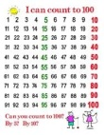](http://www.google.com/url?sa=i&rct=j&q=counting+to+100&source=images&cd=&cad=rja&uact=8&docid=-iFbK-qdjqnEPM&tbnid=40m2Q_YQqPsK4M:&ved=&url=http://www.pinterest.com/bettertolaugh/100th-day-counting-posters/&ei=7VcIVKYFk4HtBti4gcAM&psig=AFQjCNEPBm_LMc7b8ST2V1Mf9wh7ZfivNQ&ust=1409919341355597) 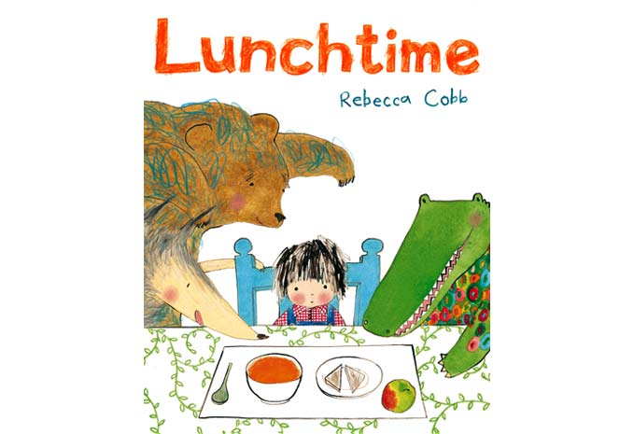

***SCIENCE: ANIMALS INCLUDING HUMANS***

* Basic needs of animals for survival.
* Know that animals have offspring that grow into adults
* Describe the importance for humans of exercise, eating the right amount of different types of food and hygiene

**MATHS**: This term, we will be learning to:

* Read and write numbers from 1 to 100 in

numerals and to 20 in words.

* Read, write and interpret mathematical statements involving addition (+), subtraction (-) and equals (=) signs
* Compare, describe and solve practical problems using measurement.

**This term we are going to be exploring:**

**Science**: Animals including humans

**Art:** Portraits and Picasso

**History**: Henry VIII and Tudor life.

**Music:** South African music – singing, playing instruments and improvising

**PSHE:** I know how to be responsible and to keep myself safe.

**COMPUTING:** Creating a program and understanding algorithms (instructions)

**DATES FOR YOUR DIARY**

25th September: Buckfast Butterfly Farm

2nd October: Harvest Festival St Eustachius

18th & 19th October: Year 1/2 assembly

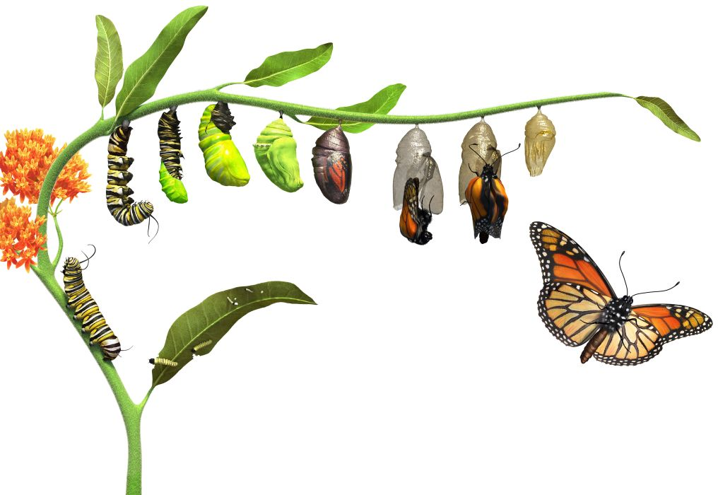



**ENGLISH**

**Our literacy work will include:**

* Exploring and then writing a story with a

familiar setting

* Writing across the curriculum – linked to our topics
* Developing sentences: spellings, construction, vocabulary and punctuation

[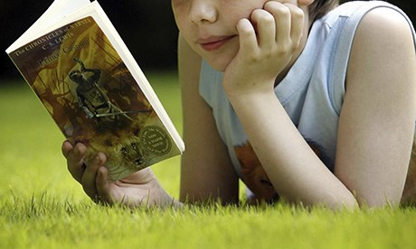](http://www.google.co.uk/url?sa=i&rct=j&q=chidlren+loving+reading&source=images&cd=&cad=rja&uact=8&docid=EDQURSyHKaQAUM&tbnid=E72TyqN2Ub9zvM:&ved=0CAUQjRw&url=http://www.theguardian.com/books/2013/oct/14/neil-gaiman-children-books-reading-lecture&ei=15OMU-GAAsaN0AXoroGABw&psig=AFQjCNHPfvQl92fqlI8I7a91ZVeIv95p6g&ust=1401808057524271) **LOVING READING**

* **LOVING READING**





**RE**

**REMEMBER**

Please ensure your child brings their reading book and home school diary with them EVERY day.

**HOMEWORK**

**Daily: 10 minutes reading. Please sign and record comments in the home school diary.**

**Weekly: Spellings will be given out on Friday and tested the following Friday.**

* **Ball skills**
* **Floor movement patterns**
* **Balancing**

**PE KIT SHOULD STAY IN SCHOOL ALL WEEK: BLACK SHORTS, WHITE T- SHIRT & TRAINERS.**

* Facts and beliefs
* Parables
* Christianity and Judaism

**WELCOME**

If you would like to come into class and help – with reading, other activities or general classroom support we would love to welcome you. Please see Mrs Alexander, Mrs Barnes or Mrs Holden.

Our **Skill for Success** this half term is

**RESILIENCE – Keep going, even when it’s hard.**