Year 1 and 2 Project Homework
This term’s project homework allows you to choose from a range of subjects and create almost anything you like! Below is a list of what we will be studying next term in specific subjects with some suggestions of activities that you could do. Choose something from the list (or come up with your own idea) that is linked to the curriculum next term. If you would like to bring anything in to school to share, please do so by Monday 2nd March.
In Geography we will be looking at our environment around us and look at natural and man made things.   | For your homework you could…  - Nature spotting walk to find natural and man-made things outdoors.  - Sorting household items into natural and man-made groups.  - Build a model environment showing natural and man-made features.  - Litter hunt and recycling challenge to discuss caring for the environment.  - Draw “before and after” pictures showing how humans change a place.  - Materials scavenger hunt to find objects and identify if they come from natural sources or are man-made.
In Science we will be studying Living things and their habitats.  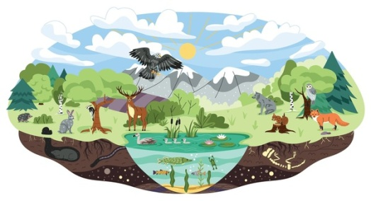 | For your homework you could…  - Mini-beast hunt in the garden or park to find insects and observe their microhabitats.  - Build a simple bug hotel using sticks, leaves, and recycled materials.  - Sort animals into different habitats (forest, desert, ocean, pond, garden).  - Bird watching from a window or garden, recording what they see.  - Go on a “living or non-living” hunt around the home or garden, collecting or listing items and deciding which are living, once living, or never living.
In English we will be writing fiction and non-fiction pieces.   | For your homework you could…  - Visit the library and choose some non-fiction books to share  - Write a set of instructions to explain how to do something; bake a cake, play a game, build something etc.  - Create a mixed-up fairy tale where you mix some fairy tales together to make your own.  - Create your own ending to a well-known story.  - Keep a diary of your week off
In Art we will be looking at painting.  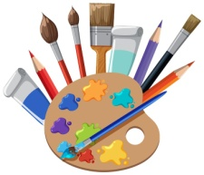 | For your homework you could…  - Nature brush painting using leaves, sticks, or flowers.  - Blow painting by blowing watery paint through a straw.  - Handprint or fingerprint art to create pictures.  - Try painting with different paints, poster paint, powder paint, acrylic paint, watercolours etc.  - Use different materials to paint with; sponges, potatoes etc.
In Maths we will be working on counting, addition and subtraction.   | For your homework you could…  - Practice writing the numbers 1-20  - Practise counting in 2s, 5s and 10s  - Look at money and the values of different coins and notes  - Begin to explore telling the time using analogue clocks  - Learn and remember the months of the year  - Learn all the number facts that make 3, 4, 5, 6, 7, 8, 9 and 10. (For example, 3 + 4 = 7)

Please make sure you continue to read to your child and also listen to them read their reading book. Please record this in their reading record.

