 [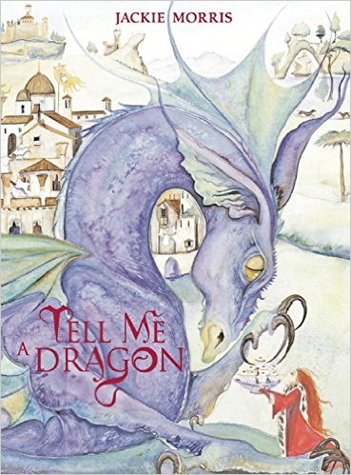](https://www.google.co.uk/url?sa=i&rct=j&q=&esrc=s&source=images&cd=&cad=rja&uact=8&ved=0ahUKEwiWtJXm6ajRAhUBOxoKHfYOBQMQjRwIBw&url=https://www.amazon.co.uk/Tell-Me-Dragon-Jackie-Morris/dp/184507534X&psig=AFQjCNG23rY2d63Xd_zaR5jrJ0SlnQVpVg&ust=1483630854622696)

**THE IMPORTANCE OF VOCABULARY**

Support your child to develop their vocabulary and language skills through talk, reading and exploring words.

When reading ask:

Show me the word that means ...

Give me another word for ...

Play word and rhyming games – have fun!



**This term we are going to be exploring:**

**Science**: Materials and plants

**Art/DT:** Designing and making African instruments

**History/Geography**: Comparing Tavistock to a village in Gambia

**Music:** Playing djembe drums, rhythm and beat

**PSHE:** health and well being, respecting other people.

**COMPUTING:** We are photographers

**ENGLISH**

**Our work in English will include:**

* Exploring and writing using descriptive language
* Writing a story
* Writing across the curriculum – linked to our topics
* Developing sentences: construction, vocabulary and punctuation
* When reading, retrieving information and making predictions based on the text so far

**! ‘ ,**

**MATHS**: This term, we will be learning to:

* Find halves, quarters and thirds of shapes and

quantities

* Making different amounts of money
* Calculating the cost of 2 or more items and finding change
* Telling the time to the nearest hour, half hour and 5 minutes
* Measuring distance (m / cm);  
  mass (kg / g); temperature (°C); capacity (litres / ml)

**? ! ,**

***SCIENCE***

* Changes in materials
* Materials: insulators and

waterproofing

* Growing plants from bulbs
* Parts of plants

**RE**



* Christianity and Judaism
* Leadership
* Stories of Abraham, Samuel and David

[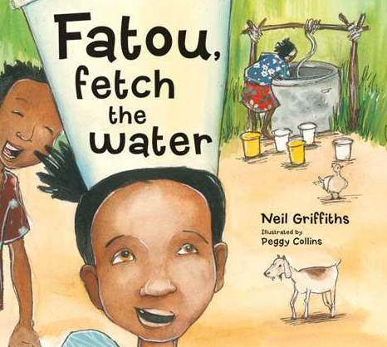](http://www.google.co.uk/url?sa=i&rct=j&q=&esrc=s&source=images&cd=&cad=rja&uact=8&ved=0ahUKEwi31qeS_o_KAhWBhA8KHS3_A2cQjRwIBw&url=http://www.little-linguist.co.uk/multicultural-stories-story-books/fatou-fetch-the-water.html&psig=AFQjCNE6JR6wupSNMsGfd9ROZfPXsSdx-w&ust=1451991000367304)

**LOVING READING**

Sharing reading with your child is invaluable – discuss your favourite parts of a story, how it made you feel and what you thought about the characters.

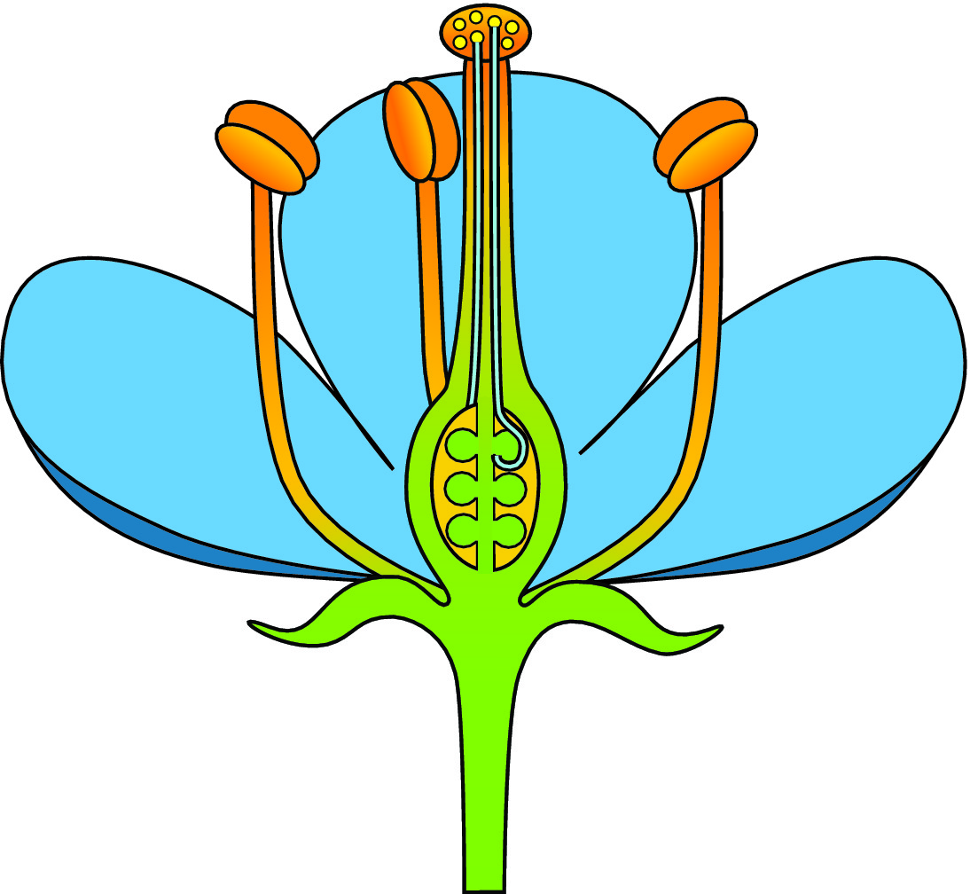

* **Dynamic and static balance incorporating agility.**
* **Combining jumps and mirror image**
* **Partner and team work**

**PE KIT SHOULD STAY IN SCHOOL ALL WEEK: BLACK SHORTS, WHITE T- SHIRT & TRAINERS**

**.**

Our **Skill for Success** this half term is

**RESPONSIBILITY – Think about how the things you do affect others.**

**HOMEWORK:**

**SET ON FRIDAY: IN ON WEDNESDAY**

**SPELLING TEST ON FRIDAY**