**Year 6 Project Homework**

As part of our learning about WW2, we want to give you an opportunity to bring this important part of history to life by researching one of the men, women or children who lived through the experience.

You can choose to create a project on a known family member, research a name on a war memorial or you could use a search engine to find an interesting individual’s story to tell.

You can choose how you present the stories you discover.You could make a poster, create a power point or make a book.

**What is their story?**

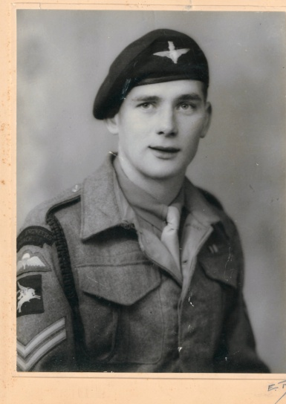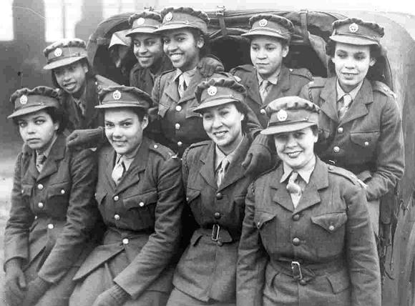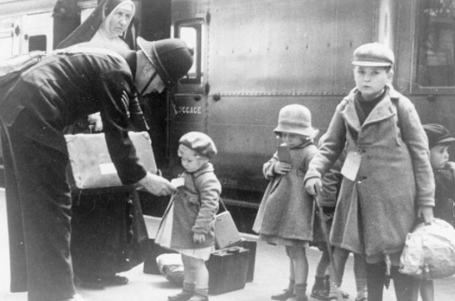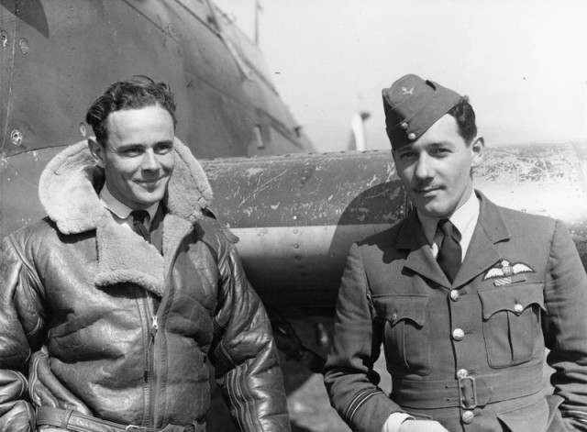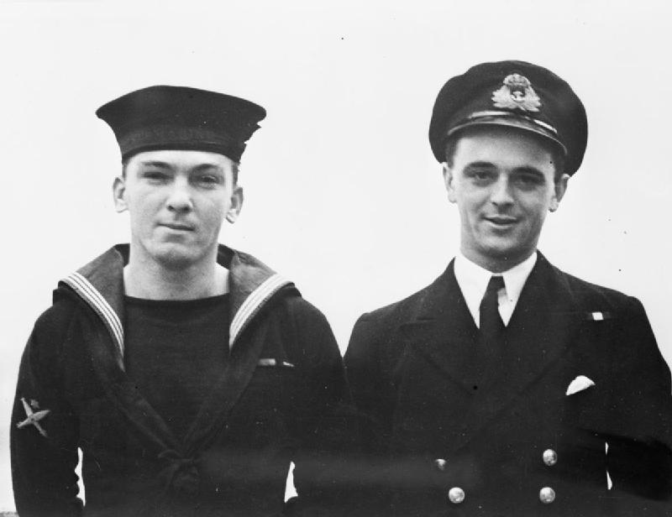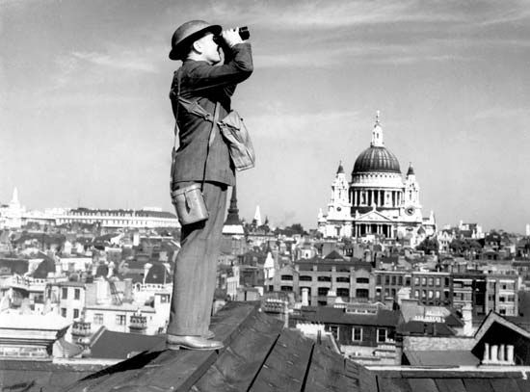

Some useful websites:

<https://www.cwgc.org/>

https://www.iwm.org.uk/