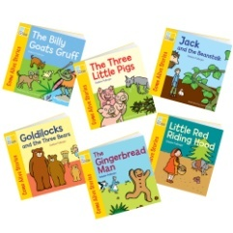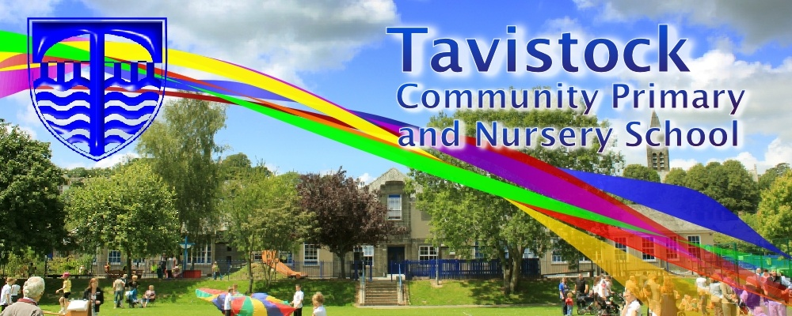

**Dates for your Diary**

**Friday 9th February 9.15am Family Assembly in the school hall**

**MATHS**: Estimating and counting objects with careful 1:1 correspondence. Adding two groups of objects together and finding a total. Understanding and using positional language. Ordering and sequencing familiar events. We are continuing to look at and solve maths related problems.

**OUR THEME THIS TERM** Traditional Tales

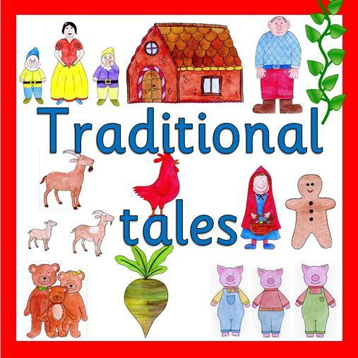

**LITERACY/COMMUNICATION AND LANGUAGE**

We will be responding to stories and using story book language and introducing storyline into our play. Some of the stories that we will be reading are: **Little Red Riding Hood, The 3 Little Pigs, Goldilocks and the 3 Bears, The 3 Billy Goats’ Gruff and The Gingerbread Man.** We will be continuing with Phase 3 letters and sounds, please look in the front of your reading diaries.

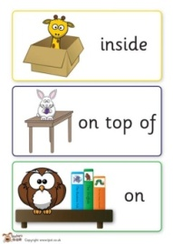

***HOW CAN YOU HELP YOUR CHILD?***

* ***Read to your child regularly and ask them to re-tell the story.***
* ***Support them to blend the letter sounds they know together.***
* ***Play number games, concentrating on numbers to 10 and 20***
* ***Estimate how many things you can see and then check by counting with careful 1:1 correspondence.***

**Personal, Social and Emotional Development**

.

We will be learning how to be sensitive to others’ needs and feelings.

We will be building our confidence to talk in familiar groups.

**Physical Development**

We will be practising our letter formation and developing our balance using large scale obstacles.

We will be looking at how to transport and use things safely.



**Understanding the World**

We will be looking at festivals throughout the half term – Valentine’s Day and Chinese New Year and the season of Winter.

We will be looking at similarities and differences in locations from Traditional stories

**Expressive Arts and Design**

We will be singing, dancing and acting to do with our topic, including learning songs for our Family Assembly. We will be looking at building and joining using tools and techniques.



**HOMEWORK: 10-15 minutes of daily reading, including tricky words and letter sounds labelled ‘Phase 2 &3’ in the front of our reading diaries. Use the Phase 2 & 3 letter cards sent home with your child to make words – alien and real.**

Our **Skill for Success** this term is

Responsibility