
Helping your child
learn at home in...
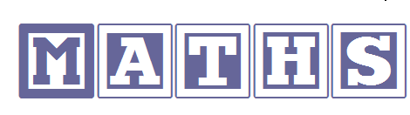

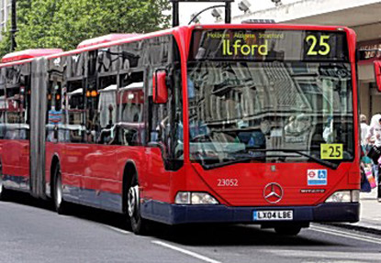
In the street
- Recognising bus numbers
- Number plate hunt. Who can find a 7? Add the numbers up.
- Comparing door numbers
- Counting – how many lampposts on the way to school?


Doing the washing
- Counting in 2s – socks etc
- Sorting by colour and size.
- Matching/pairing up socks.
- Find four shoes that are different sizes.
- Can you put them in order?

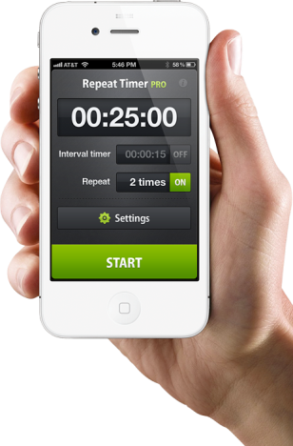
Time
- What day is it yesterday, today, tomorrow?
- Use timers, phones and clocks to measure short periods of time.
- Count down 10/ 20 seconds to get to the table/ into bed etc.
- Recognising numbers on the clock. If you cover a number, what number was missing?
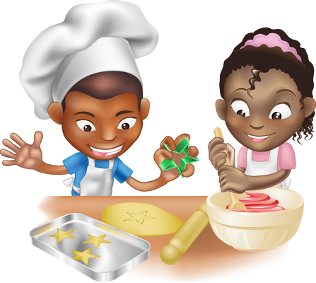
Food!
- Can you cut your toast into 4 pieces? Can you cut it into triangles?
- Setting the table. Counting the right number of plates etc. How many more do we need?
- Can you make shapes/ patterns out of the knives and forks. Can you put them in the right place in the drawers?
- Helping with the cooking by measuring and counting ingredients.
- Setting the timer.
- Positional language at dinner time: what is on the rice, where are the carrots etc?
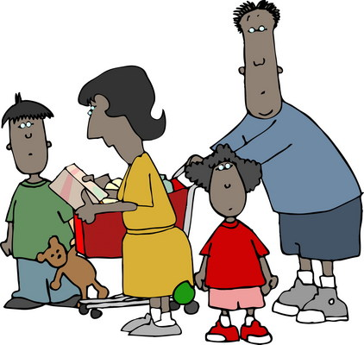
Going shopping
- Reading price tags
- Counting items into the basket
- Finding and counting coins
- Comparing weights – which is heavier

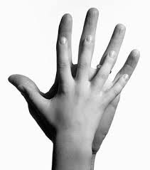
Measuring
- Are you taller than a …?
- Marking height on the wall.
- Cut hand shapes out of paper. How many hands long is the couch? How long is the table? Which is longer?
- Who has the biggest hands in our family?
- How many steps from the gate to the front door?

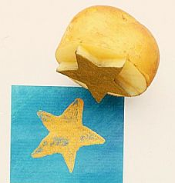
Shapes
- Cut a potato into shapes (circles, triangle etc). Use with paint to make pictures and patterns.
- Cut out shapes from coloured paper/ newspaper and arrange into pictures.
- Shape hunt: Can you find a square in your house (windows etc), a circle …

Playdough
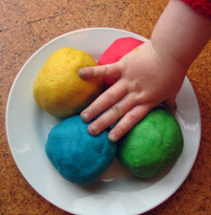
Here’s our simple recipe:
2 cups of plain flour
Up to 1and a half cups of boiling water
2 tablespoons vegetable oil
2 tablespoons cream of tartar
Half a cup of salt
food colouring and essences (optional)
Mix all of the dry ingredients together in a bowl and then begin to add the boiling water(and then colouring/ essence). Keep stirring until it begins to form a ball and then knead with your hands into a ball. Keep it wrapped in clingfilm or in a covered tub to stop it drying out.

Then ….
- Make numerals and shapes
- Sort shapes into groups, or order by size
- Make long and short wiggly snakes.
- Make 5 balls, 2 sausages etc
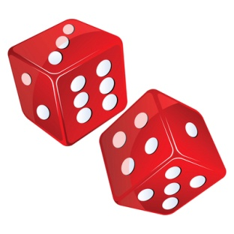
Games
- Jigsaws (you can make your own by cutting up a magazine picture)
- Snap (matching pairs) or Happy Families (collect 4 of a kind)
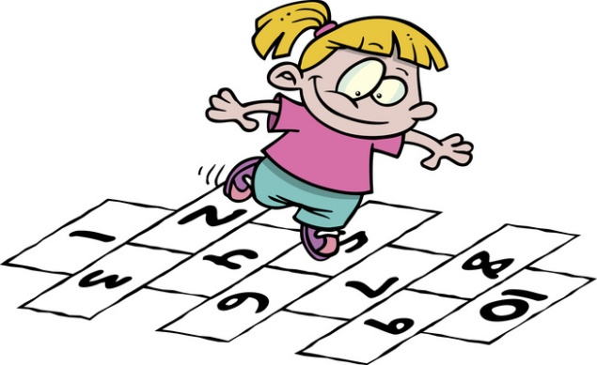
- Snakes and ladders or other simple dice games.
- Adding numbers on two dice.
- Bingo, with numbers or shapes
- Hopscotch

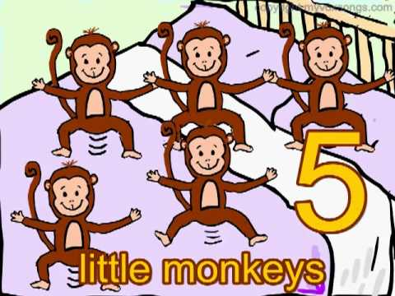
Number rhymes and songs
Eg: 5 little monkeys jumping on the bed
One fell off and bumped his head
Mummy called the doctor and the doctor said
“No more monkeys jumping on the bed!”
4 little monkeys jumping on the bed …

There are lots more such as:
5 Little Ducks went swimming one day...
5 currant buns in a bakers shop...
5 little speckled frogs...
1,2,3,4,5 once I caught a fish alive...
Lots can be found on the internet for example at http://www.nurseryrhymes.org/numbers.html (here you will find the lyrics, the skills taught as well as a link to the song on you tube if you are not a keen singer!)

Useful internet maths websites:
Follow this link to our school Maths resource web page
http://tavistockpans.eschools.co.uk/website/maths_resource/69691
as well as looking at:


www.mathszone.co.uk
http://www.bbc.co.uk/bitesize/ks1/maths/
http://www.familylearning.org.uk/online_math_games.html
www.sesamestreet.org (search “counting” or “shapes”)

