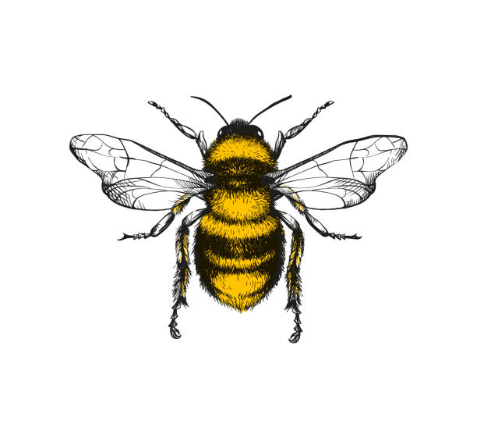

Become familiar with logging into and out of a device.

To be able to order pictures/artifacts chronologically.

To learn about our own families and others’.

To use cultural stories to identify common themes.

Using floor turtles for directional awareness.

To be able to use unplugged activities to help with children’s understanding eg instructions on how to make a sandwich.

To be able to take a photo/video using available technology.

To understand about special places in our community and the wider global community.

To navigate around our local environment using simple instructions.

To learn about the similarities and differences in and between our own homes.

**Understanding of the World**Children will know about their local, wider community and environment and begin to understand the need to respect all living things.

TO begin to introduce the vocabulary associated with time lines e.g. past, present, future.

To know about the seaside and its position on the coast in our locality.

To know about the local services within our community.

To learn about global cultures and festivals, and recognise similarities and differences between ourselves and others’.

To name the features of our local environment.

To use our senses to explore Seasonal Changes and the world around us.

To show an awareness of care for living things.

To identify and explore plants, growing and animals including life cycles of frogs/chickens.

To show an awareness of forces and begin to use simple scientific language.

To learn about contrasting locations.

To be able to draw a simple map and use relevant language to describe it.

To begin to explore the features of a map including aerial photography.

To recognise man-made and natural features around us.

To begin to know about our wider local area.

To understand that materials change state.

To expand our knowledge of vocabulary about our bodies.