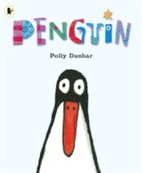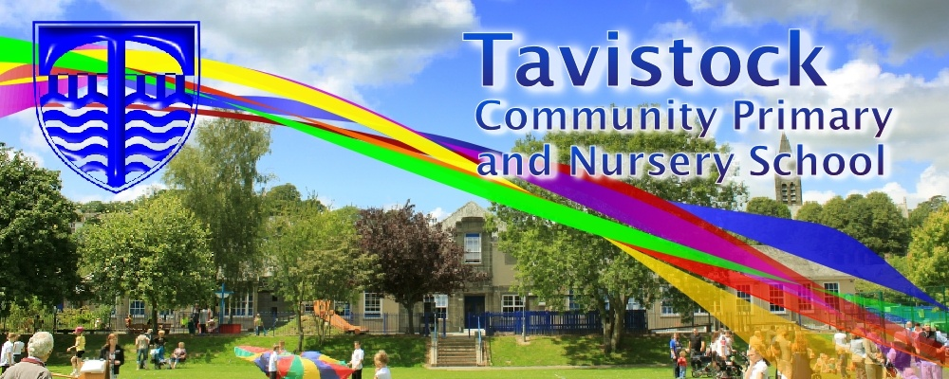[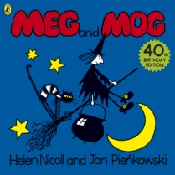](https://www.google.co.uk/url?sa=i&rct=j&q=&esrc=s&source=images&cd=&cad=rja&uact=8&ved=0ahUKEwiKjLXe55jXAhWK6xQKHcpXCOYQjRwIBw&url=https%3A%2F%2Fwww.amazon.co.uk%2FMeg-Mog-Helen-Nicoll%2Fdp%2F071819442X&psig=AOvVaw0AZDpKhhe2axot7Rkdxmh3&ust=1509468831512690)

**Dates for your Diary;**

**16/11/17Developing Early Literacy**

**23/11/17Maths in the Early Years**

**11/12/17 (pm) & 12/12/17 (am) Nativity Performance**

**14/12/17Christmas Church Service**

**7/12/17Visit to Theatre Royal**

**13/12/17 Jacolly Puppets**

**MATHS**: We are learning to count and order our numbers to 20 and solve maths related problems using the numbers we know. We are beginning to say one more and one less than a given number. We are using shapes and familiar objects to create patterns and we are ordering objects by length and size.

**OUR THEME THIS TERM:**

**Winter Festivals and Celebrations.**

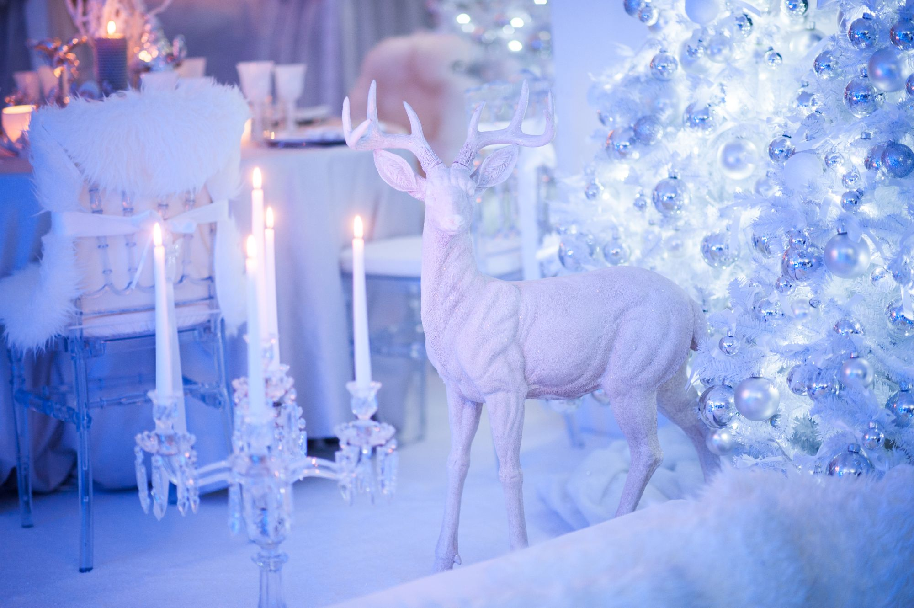

**LITERACY/COMMUNICATION AND LANGUAGE**

We will be developing our listening skills, listening to oral stories and developing our vocabulary. Some of the stories that we will be reading are;  **Meg and Mog, Pumpkin Soup, Stick Man, Father Christmas Needs a Wee, Penguin and The Nativity Story.**

We will be moving onto Phase 3 letters and sounds, please look in the front of your reading diaries.

***HOW CAN YOU HELP YOUR CHILD?***

* ***Read to your child regularly and talk about the pictures and what has happened in the story.***
* ***Support them to blend the letter sounds they know together.***
* ***Play number games, concentrating on numbers to 10 and 20***
* ***Look out for words, numbers, shapes and patterns in the environment.***

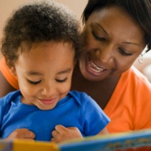

**Personal, Social and Emotional Development**

.

We will be learning to share resources and how to work co-operatively and recognising different emotions.

**Physical Development**

We will be developing confidence, control and co-ordination in large and small scale movements. We will be learning how to use tools safely.

[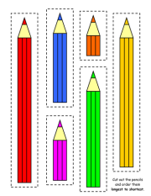](https://www.google.co.uk/url?sa=i&rct=j&q=&esrc=s&source=images&cd=&cad=rja&uact=8&ved=0ahUKEwjJqrei6pjXAhWCUhQKHXdFAcgQjRwIBw&url=https%3A%2F%2Fwww.tes.com%2Fteaching-resource%2Flength-worksheets-6229111&psig=AOvVaw3d8Su2nKZhPGHvz2wFjWqV&ust=1509469509138081)

**Understanding the World**

We will be talking about getting ready for celebrations and how they differ in our households. We will be looking at changes in the environment linked to the Seasons.

**Expressive Arts and Design**

We will be singing, dancing and acting to do with our topic, including learning our Christmas Performance.

We will be using different materials for specific purposes and looking at how they change.



**HOMEWORK: 10-15 minutes of daily reading, including tricky words and letter sounds labelled ‘Phase 2’ in the front of our reading diaries. Use the Phase 2 letter cards sent home with your child to make words – alien and real.**

Our **Skill for Success** this term is

Self-Belief