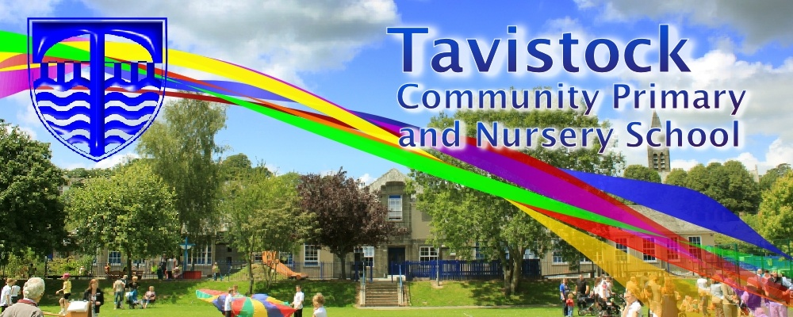

***HOW CAN YOU HELP YOUR CHILD?***

* READ with them EVERY night and TALK about the book – thoughts and understanding.
* SUPPORT them with their Maths homework by letting them SHOW YOU methods they have learnt at school.
* PRACTICE spellings daily, putting them into sentences to check understanding.
* **Talk, play and involve them with what you do. Always come and talk if you have any concerns.**

**Science**:

Environments and climate change

**Art:**We will be creating our own bird house

**Geography**:  
Map reading and navigational systems

**Music:**

Blackbird – The Beetles  
**PSHCE:**Risk taking – health, lifestyle and our bodies  
**Computing:**   
Isle of Tune  
Co authors of a website and creating a power point  
**MFL:** Forming full sentences and describing nouns

**English**

**The eye of the storm** – This term we are going to visit this animation and write both a poem and a story.

**READING & SPELLING**

* Children should **read for a**

**minimum of 15 mins** at home every

night – children should change their

books whenever they need to and record   
their reading in the Home School Diary.

PLEASE DISCUSS WITH YOUR CHILDREN WHAT THEY HAVE READ – ENCOURAGING THEM TO EXPAND ON THEIR THOUGHTS.

* **Spellings** sent home on **Fridays, spelling** **quiz** on **following Friday.** These are linked to our spelling, grammar and handwriting lessons. (Reading books & home/school diaries should come in every day).



**Children will have P.E. twice per week**

**KIT SHOULD STAY IN SCHOOL ALL WEEK: BLACK SHORTS, WHITE T SHIRT & TRAINERS.**

**Swimming and PE –** This term we will have swimming and a PE lesson.   
Swimming will be on a Wednesday.  
Please ensure your child has their full school PE kit in school all week.

**Dates**  
13th KS2 Sports day  
21st – Summer Fair  
2nd July – Multi Skills  
4th – Reports sent home  
19th – End of term assembly  
19th – Last day of term20th – Tavistock Carnival



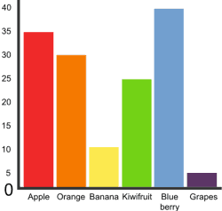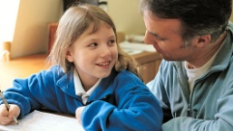

**Skill for Success** this term is

Risk Taking

**MATHS:**

This term we will be solving problems involving money.   
We will revisit multiplication and learn how to multiply 2 and 3 digit numbers.  
We will also explore which shapes are symmetrical and learn how to identify lines of symmetry.

**HOMEWORK**Set on Friday and needs returning by the following Wednesday. Phonics/spelling relationships will be practised in class and consolidated through homework. Reading homework will alternate with English homework.