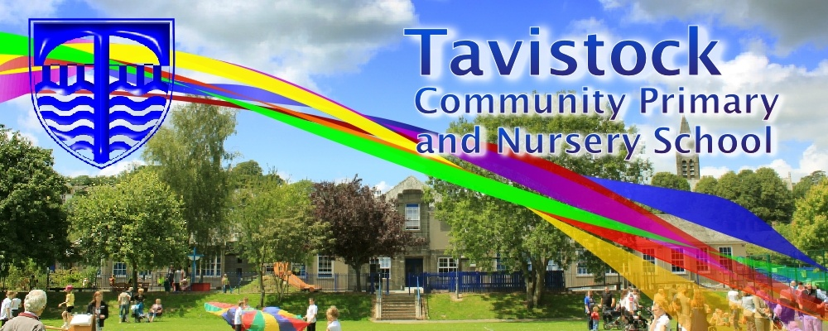

8th June Family Assembly

19th June KS2 Sports Day

22nd June Summer Fayre

3rd July Tavistock College Parents’ Meeting @ 5pm

5th July Reports home

11th July Move On Up day

24th Last day of term

**The Weather is our theme this term:**

**Science**: Living things and their habitats.

**Art/DT:** Bird houses

**History/Geography**: What does a captain need to navigate at sea?

**PSHCE:** Healthy eating, living in the wider world, and relationship education.

**MFL:** Nouns and adjectives in a sentence.

**Music:** Blackbird and other songs by the Beatles

**Computing:** We are co-authors.

**PE** Swimming, sports day practice and cricket

**English**

**The Catch –** To write a descriptive story based on an animation.

**Eye of The Storm –** This half term, we will be focusing on using dialogue to advance the plot of a story inspire by an animation.

**Maths**

**Multiplicative reasoning -** Pupils will be working on solving problems involving multiplication, division and fractions in different contexts.

**Geometric reasoning -** Pupils will be exploring and explaining how to find the perimeter and area of a shape and how to complete a symmetrical shape with a given line of symmetry.

**Reading and Spelling**

* Children should **read for a minimum of 15 minutes** at home every day.
* Reading books and home school diaries should come in every day.
* Children should know common words and target spellings.
* **Spellings** sent home on **Fridays, spelling** **quiz** on **following Friday.**

***Tell your children*** *to look out for these newly published books in the School Library****:***

***Sky song  
Dog Man unleashed  
The explorer***



**HOMEWORK**Set on Friday and needs returning by the following Wednesday.

Our **Skill for Success** this term is **Risk Taking**

Please ensure that your child has their PE kit.

Kit should stay in school all week: Black shorts, white t-shirt & trainers.